Camp 104 - Beela (Bela) River Camp, Milnthorpe, Westmoreland

Included in the 1945 ICRC camp list – Labour Camp. 104. Beela River Camp, Milnthorpe, Westmorland.

1947 Camp list
104(G.W.C.) | Beela River Camp, Milnthorpe, Westmorland | W. | Priswar, Milnthorpe | Milnthorpe 112 | Milnthorpe | Major E.Selby. | v/1452/2

Prisoner of War Camps (1939 – 1948) - Project report by Roger J.C. Thomas - English Heritage 2003
OS NGR | Sheet | No. | Name & Location | County | Cond’n | Type 1945 | Comments
SD 49 81 | 97 | 104 | Beela River (Bela River) Camp, Milnthorpe | Westmorland | 5 | German Working Camp

Location: NGR above is for Milnthorpe. NGR for the camp SD 513 803. About 2 km SE of Milnthorpe  Before the camp: Farmland  Pow Camp: Listed as Italian working camp / labour battalion to at least 1945, then a German Working Camp. The map indicates that the camp was laid out as a standard type with a main compound and with guards’ huts and offices at the front of the camp alongside the road.  There was an International Red Cross inspection on 3 June 1943 - Italian prisoners, capacity 750.  The work of Reverend Alexander Macleod Murray and relationships with the local area – “…the village of Beetham [about 2 km from the camp] on the edge of the Lake District set out to achieve reconciliation through ‘integration’. The vicar there was the Reverend Alexander Macleod Murray, a rare spirit… tall, scholarly, and high-church with an outgoing loving nature, he had also a shrewd knowledge of a man’s world; he bore the scars of the Kut campaign of 1915 and till recently had been chaplain to the Royal Tank Corps Depot at Warcop. Arriving at Beetham in January 1946 and discovering that Camp 104 at Bela River was within his parish, he simply regarded its inmates as his parishioners. He put it to the existing ones that here were cast-down and ostracised people living in their midst, prisoners of war as many British had been. Let Beetham become for them a ‘little sanctuary’, he said. As soon as regulations permitted and indeed long before, people responded. With young Mrs Murray playing her full part, the vicarage became a centre where Germans brought their loneliness and private troubles, or even their problems with their Commandant. When some prisoners told the vicar of a school teacher they knew in Germany who, though a good man and no Nazi, had been unjustly dismissed, he asked for a dossier on him which he sent to the local MP, William Fletcher Vane. He, in turn, passed it on to Lard Pakenham, then | 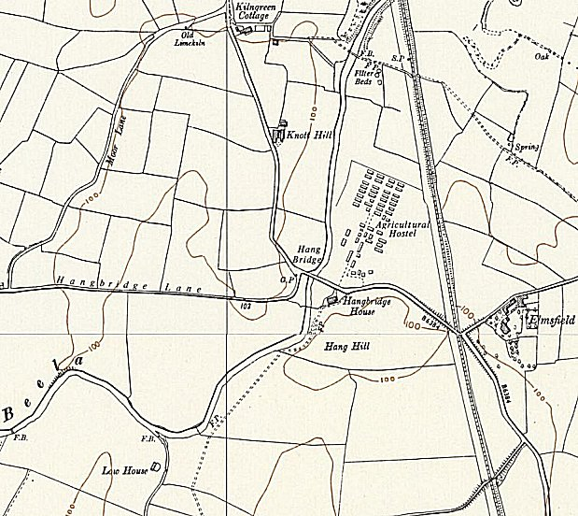
 | Ordnance Survey 1956
Minister for German Affairs. With astonishing speed, the case was reviewed, the teacher reinstated and his denouncers exposed. The vicar put a large box in the church to receive gifts, chiefly clothing and food, and Beetham for a time became probably the greatest parcel-sending centre for its size in England. When furniture was required for a quiet room in the camp, a three-ton truck was soon taking in two dozen old easy chairs and a settee. Later a billiard table was sent up. The beautiful church with its unique rose trellis walk to the south door was used for several joint services in two languages and for memorable concerts (among the Germans was a violinist once selected to play in Westminster Abbey at the 1936 Coronation). There was community singing, music-making in private houses, and the occasional discussion group. So swiftly did the spirit of reconciliation get going that for Christmas 1946 members of the Bela River Camp secretly prepared a surprise gift to the parish – a full set of carved and painted crib figures, with a dedication which read:
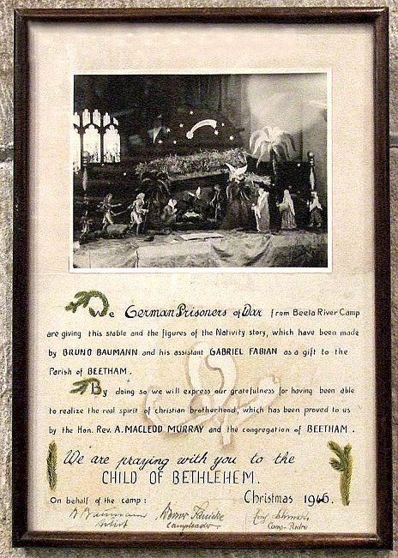 | “We German Prisoners of War from Beela River Camp are giving this stable and the figures of the Nativity story, which have been made by Bruno Baumann and his assistant Gabriel Fabian as a gift to the Parish of Beetham.  By doing so we will express our gratefulness for having been able to realize the real spirit of Christian brotherhood, which has been proved to us by the Hon. Rev. A. Macleod Murray and the congregation of Beetham  We are praying with you to the Child of Bethlehem.  On behalf of the Camp: Christmas 1946.  B.Baumann – Artist / Werner Janicke – Camp Leader / Erich Schmidt – Camp Padre”  (Extract from ‘Thresholds of Peace’, p278-9, Matthew Barry Sullivan, 1979, Hamish Hamilton).  Another visitor to this and other camps was Dr Margaret Rosenberg, a Jewess from Austria, called, ‘the Angel of the Lake District Camps’ – at least until she had a dispute and is reported to have boxed the commandant’s ears at Camp 104. After that she would appear at places where the pows were working to ask if she could get them anything.  One of the German pows, Wilhelm Hackl stated of the camp: “Here we were treated as humans, free from threats and humiliation.” (quoted in the Westmorland Gazette).  Hostel at Silecroft, Cumberland, (from ‘Leben und Lernen hinter Stacheldraht’).  Camp commandant c.1947 Major E Selby.  After the camp: Site used as an agricultural hostel for displaced persons, then an open prison. 2019 ‘Wings Residential School’.  Further Information:

