Camp 105 - Inchdrewer House, Colinton Camp, Midlothian

Prisoner of War Camps (1939 – 1948) - Project report by Roger J.C. Thomas - English Heritage 2003
OS NGR | Sheet | No. | Name & Location | County | Cond’n | Type 1945 | Comments
 |  | 105 | Inchdrewer House, Colinton, Edinburgh | Midlothian |  |  | Scotland

Location: Inchdrewer House is shown on the map. NGR NT 219 692  Before the camp:  Pow Camp: I have found just one minor detail for the camp. In a study of mail and diaries by German pows, Inchdrewer House is mentioned for two German pows held there between 28 May 1946 to 2 November 1946.  Postal items: POW letter-sheet 6 April 1944 in Italian to Italy  After the camp: Part of the Redford barracks and became the HQ for the Army School of Bagpipe Music and Highland Drumming. 2019 Future uncertain.  Further Information:  Canmore – lists the house but gives no details of it being a pow camp, other than to say it is in a list of camps. | 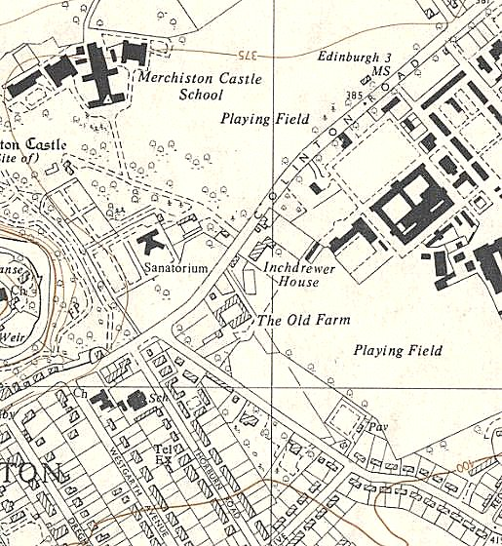
 | Ordnance Survey 1958

