Camp 84 - Sheet Camp, Sheet, Ludlow, Shropshire

Included in the 1945 ICRC Camp list – Labour Camp. 84. Sheet Camp, Ludlow, Salop.

1947 Camp List
84(G.W.C.) | Sheet Camp, Ludlow, Shropshire | W. | Priswar, Ludlow | Ludlow 344 | Ludlow | Lt.Col.N.A.Willis | v/1453/2

Prisoner of War Camps (1939 – 1948) - Project report by Roger J.C. Thomas - English Heritage 2003
OS NGR | Sheet | No. | Name & Location | County | Cond’n | Type 1945 | Comments
SO 5316 7408 | 137 | 84 | Sheet Camp, Sheet, Ludlow | Shropshire | 4 | German Working Camp | STANDARD type. Only the water tower remains extant

Location: Sheet is a small village just SE of Ludlow. The site next to Sheet House is shown on the map, however the shape of the buildings suggest it had been largely rebuilt by 1964.  Before the camp: Farmland.  Pow Camp: Italian pows up to 1945, then a German working camp. The site had a standard layout with a main pow compound, with guards’ huts and offices at the front. Common buildings and facilities at standard type camps included water towers, offices, officer's mess, a canteen, guard rooms, barrack huts, ablution blocks, cell blocks, a camp reception station (medical facility/hospital), a cookhouse, dining rooms, recreation rooms and living huts or tents.  Camp commandant c.1947 Lieutenant Colonel Nigel Addington Willis, from the Queen’s Royal, West Surrey Regiment. Born 1897. Injured at Delville Wood, losing his right arm. He was awarded an OBE in 1947.  Camp commandant c1947-1948 Lieutenant Colonel Terence O’Cahir Doherty, from the Essex Regiment. He moved from Merry Thought Camp 76 to become Commandant of Sheet Camp 84 for German POWs at Ludlow, Shropshire, a post he held until he was demobbed on 5th August 1948.  After the camp:  Further Information:  National Archives FO 939/164 84 Working Camp, Sheet camp, Ludlow, Shropshire. Dated 1945-1948 | 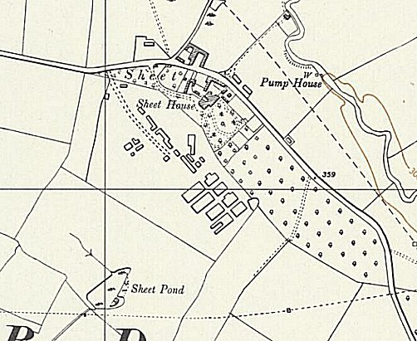
 | Ordnance Survey 1964

