Camp 138 - The Rectory Camp, Bassingham, Lincolnshire

Included in the 1945 ICRC camp list – Labour Camp. The Rectory, Bassingham, Lincoln.

Prisoner of War Camps (1939 – 1948) - Project report by Roger J.C. Thomas - English Heritage 2003
OS NGR | Sheet | No. | Name & Location | County | Cond’n | Type 1945 | Comments
SK 912 598 | 121 | 138 | The Rectory Camp, Bassingham | Lincolnshire | 5 | German Working Camp | Hostel

Location: The Rectory is shown to the W of the site marked.  Before the camp:  Pow Camp: Italian Pows until at least 1945, then a German Working Camp.  Postal items: POW Letter-sheet dated July 1945 in Italian to Italy.  After the camp: A school and hall are shown on the site.  Further Information: | 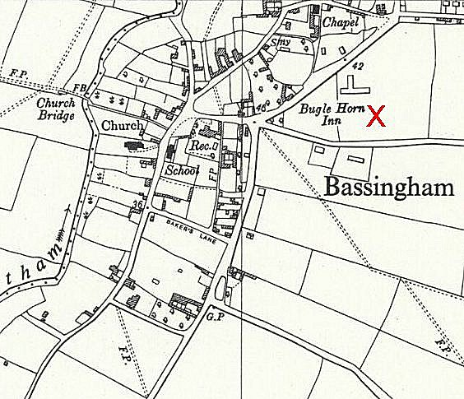
 | Ordnance Survey 1960

