Camp 140 - Racecourse Camp, Warwick, Warwickshire

Included in the 1945 ICRC camp list – Labour Camp. Racecourse Camp, Warwick.

Prisoner of War Camps (1939 – 1948) - Project report by Roger J.C. Thomas - English Heritage 2003
OS NGR | Sheet | No. | Name & Location | County | Cond’n | Type 1945 | Comments
SP 27 64 | 151 | 140 | Racecourse Camp, Warwick | Warwickshire | 5 | German Working Camp | Precise location not identified, there was a large camp at SP 257 648

Location: The NGR above is a general location. Warwick Racecourse to the right of the map – the ‘large camp’ to the left. Note Budbrooke Barracks also nearby, so the site may have been associated with them.  Before the camp: Horse racecourse  Pow Camp: Italian Pows until at least 1945, then a German Working Camp.  There is a brief reference; “There was an Italian prisoner of war camp on the racecourse, they wore a yellow circle on the back of their brown jackets. There was a German PoW camp at the corner of Myton Road with Banbury Road, where the prep school is today.” (By Tony Talliss -  ourwarwickshire.org.uk/content/article/wartime-warwick)  This confirms the pow camp within the racecourse – similar to other racecourse sites. The other pow site mentioned was at NGR SP 289 645, it is not the Budbrooke site – he does not mention that site at all for pows.  I have seen a racecourse club badge for 1947, so expect that racing had resumed in that year, if not the year before.  After the camp: Racecourse back in use. The Budbooke site is a residential area. | 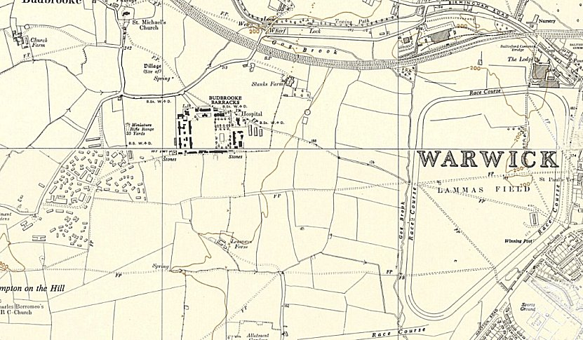
 | Ordnance Survey 1958

Further Information:

