Camp 146 - Newton Camp, Newton-with-Scales, Kirkham, Lancashire

Included in the 1945 ICRC camp list – Labour Camp. 146. Newton Camp, Kirkham, Preston, Lancashire.

Prisoner of War Camps (1939 – 1948) - Project report by Roger J.C. Thomas - English Heritage 2003
OS NGR | Sheet | No. | Name & Location | County | Cond’n | Type 1945 | Comments
SD 448 310 | 102 | 146 | Newton Camp, Newton-with-Scales, Kirkham | Lancashire | 4 | German Working Camp | Hostel

Location: On the A583, opposite where the map says MS. Another camp 168 Brookmill, Kirkham nearby.  Before the camp:  Pow Camp: Italian pows, then a German working camp.  After the camp:  Further Information:  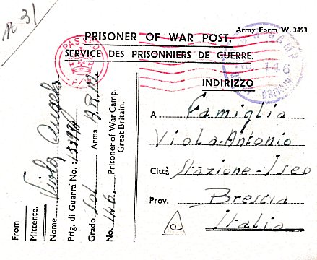  < Italian pow postcard August 1945 | 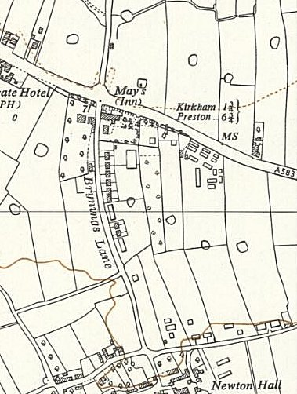
 | Ordnance Survey 1954

