Camp 188 Johnstone Castle Camp, Johnstone, Renfrewshire

Prisoner of War Camps (1939 – 1948) - Project report by Roger J.C. Thomas - English Heritage 2003
OS NGR | Sheet | No. | Name & Location | County | Cond’n | Type 1945 | Comments
 |  | 188 | Johnstone Castle Camp, Johnstone | Renfrewshire |  | Base Camp | Scotland

Location: NGR NS 433 624.  Before the camp: Housed various troops including Polish. A Polish soldier who died at the castle is buried in the nearby woods.  Pow Camp: “The camp, built within the former estate grounds, forms an irregular rectangle between the Castle and the Kings Road to the E. It is bounded by a single perimeter fence and visible on the photographs are at least 155 huts of different types. There are a further 26 huts outside the perimeter fence, presumably for staff accommodation. Entrance to the camp was from the Beith Road.” (Information from RCAHMS (DE), July 2005)  Memories - “…at the very end of the war it was fortified to hold captured troops, not German, but from some European ally of Germany.  These soldiers were badly treated for the first week of captivity in this camp. At the time I though they were being starved as punishment for the exposure of Belson, but on recollection I guess it was only impossible organisation at the war’s end. They received no supplies whatever for the first week in the camp. The school kids of Johnstone bartered loaves over the high barbed wire for all the petty possessions these pathetic creatures had, though when supplies did arrive, I remember a great side of beef being carved al fresco.  When they departed, the camp had a barrack block beautifully decorated as a chapel and an almost Olympic sized pool dug in the castle lawn.” (From BBC People’s War website – Memories of Harry Collins – Article A1989228 – 7 November 2003).  From this it would seem the camp held mixed nationalities for a while. However, this arrangement was not liked as it often led to troubles and later it was a German camp. | 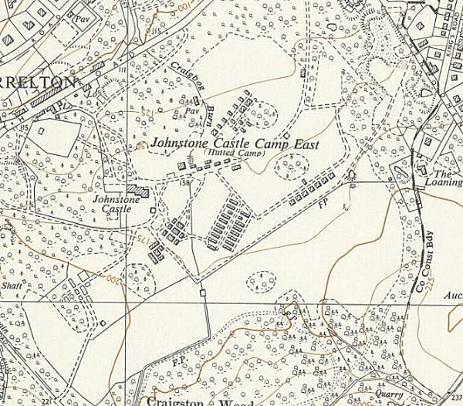
 | Ordnance Survey 1954

Pows worked at local farms and at the Bridge of Weir Tanneries.

A story in the Paisley Daily Express stated that a German pow died violently at the camp and was buried in the woods. Two totally conflicting stories about this – he was shot in an escape attempt / he was murdered as an informer. Although there is not a burial site now, this may mean that the body was reburied at the German Military Cemetery.

One of the German parachutists who rescued Mussolini in 1943 was held at Johnstone Castle. He later married and settled in Scotland.

Postal items: POW letter-sheets 2 December 1945 and 6 May 1946 in German to Germany.

After the camp: Recorded as a Polish Resettlement Corps camp with the first Polish troops arriving on 11 January, 1947. Used as emergency housing. 2020 residential area, including the castle.

Further Information:

National Archives FO 939/177 – 189 Working Camp, Marbury Hall Camp, Northwich, Cheshire. Also includes an inspector’s report (by James Grant, dated 11 October 1946) for 188 Working Camp, Johnstone Castle Camp, Johnstone, Renfrewshire. Dated 1946 – 1948

canmore.org.uk/site/273038/johnstone-castle-johnstone-castle-camp-german-working-camp-no-188

Vertical air photograph (106G/Scot/UK 140 [Pt.II], 5167-5168, flown 3 July 1946).

