Camp 159 (& 163) - Butterwick Camp, Boythorpe, Yorkshire

Prisoner of War Camps (1939 – 1948) - Project report by Roger J.C. Thomas - English Heritage 2003
OS NGR | Sheet | No. | Name & Location | County | Cond’n | Type 1945 | Comments
SE 995 719 | 101 | 159 | Butterwick Camp, Boythorpe | Yorkshire | 4 |  | Rectangular double wire enclosure with watchtowers, camp formed chiefly of tents. See Camp no.159 / 163
 |  | 163 |  |  |  | Base camp

Location: 17 km S of Scarborough. NOTE there were two BUTTERWICK camps in Yorkshire, this one and Camp 244.  Before the camp: Farmland  Pow Camp: I have seen three accounts by German pows sent from the reception camp at Kempton Park to Butterwick for short stays of just three days / one week, before being sent on to another camp. So, the site may have been used as a transit camp in its early months before becoming a Base Camp.  Memories of a tented camp - "I did not count the number of the British guards; they should have been up to 30 or 40 soldiers. We were about 5000 PoW’s shared out to three cages numbered A, B, C, per 2000 of us in cage A and B, l000 in cage C." Herbert Heinemann was based at this camp in 1945, he recalled having to dig trenches around the tents to prevent water coming inside – shortage of food – working at local farms. He is sure that during his time at the camp in Spring 1945 it was numbered 163.  www.hullwebs.co.uk/content/l-20c/conflict/ww2/memoirs/herbert/herbert-03.htm  Camp commandant c1945 – possible Major Harris – recalled by Herbert Heinemann. (Considering the size of the camp, a Lieutenant Colonel would be expected, though many majors were promoted to this rank when taking up their command).  There were three American Transit Camps located in and around Butterwick – Camp 8 Burrow Camp; 8A Butterwick Camp; 8B North Buxton Camp, Butterwick. | 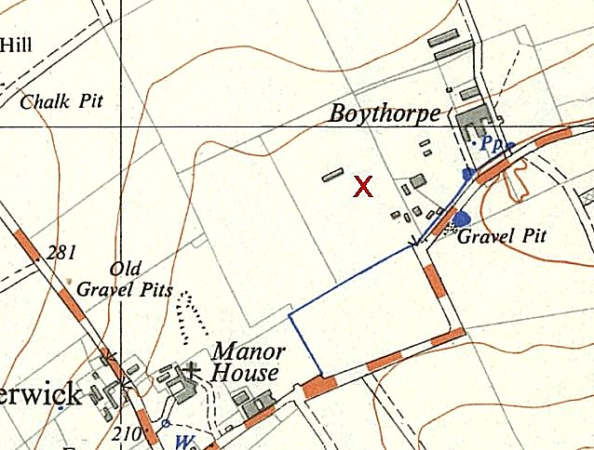
 | Ordnance Survey 1954

After the camp: 2019 farmland

Further Information:

National Archives WO 166/17819 – 163 Prisoner of War Camp (Eastern Command Cage) at Butterwick, Yorkshire. Camp moved from Lingfield, April 1945. German, Polish and Czech prisoners of war. 98 Allied nationals sent to other camps on 18 June 1945. Camp moved to Langtoft near Driffield, 11 September 1945. Dated Jan-Sept 1945.

