Camp 233 Summer House, Ravensbourne, Kent

Prisoner of War Camps (1939 – 1948) - Project report by Roger J.C. Thomas - English Heritage 2003
OS NGR | Sheet | No. | Name & Location | County | Cond’n | Type 1945 | Comments
TQ 407 691 | 177 | 233 | Summer House, Ravensbourne, Bromley | Kent | 5 |  | Site currently a college

Location: In the grounds around what was Stockwell Teacher Training College. During 2015 with a hot, dry summer, the outlines of the pow huts were clearly visible in the grounds.  Before the camp: Parkland belonging to the Bishop of Rochester. Stockwell Women’s College moved to this site in 1935. During the war, the college relocated to Devon until 1945.  Pow Camp: Italian and then German pows for a short time. The pow camp closed in 1945 (Findo Gask then being allocated camp number 233)  After the camp: The teacher training college returned to the site during 1945. 2020 Civic buildings.  Further Information:  National Archives FO 1120/233 – Re-educational survey visit reports for camps 230 to 235. Dated 1 January 1946 to 31 December 1948 | 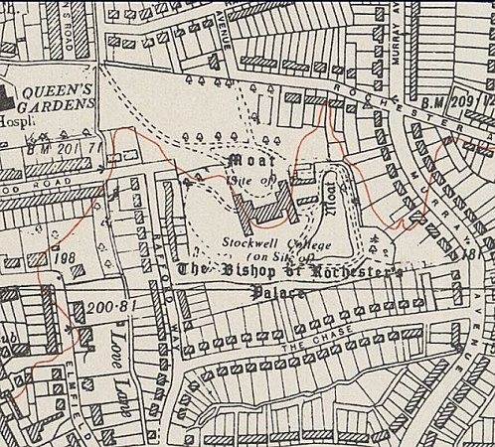
 | Ordnance Survey 1961

