Camp 244 / 245 Butcher Hill Camp, Horsforth, Leeds, Yorkshire

1947 Camp List
245(G.W.C.) | Butcher Hill Camp, Leeds 6 | N. | Priscamp, Leeds | Leeds 55146 | Leeds (City L.N.E.R.) Central (L.M.S.) | Lt.Col.W.E.Thompson | v/1453/2

Prisoner of War Camps (1939 – 1948) - Project report by Roger J.C. Thomas - English Heritage 2003
OS NGR | Sheet | No. | Name & Location | County | Cond’n | Type 1945 | Comments
SE 257 377 | 104 | 244 / 245 | Butcher Hill, Horsforth, Leeds | Yorkshire | 5 | German  Working Camp | Precise location not identified, NGR  given for approx feature centre of Butcher Hill.

Location: “The camp entrance is where the Co-operative store at the top of Butcher Hill is today” – with thanks to Abbey Grange School: www.projectinspire.co.uk/butcher-hill-pow-camp.html This is at the end of Butcher Hill where it meets Spen Lane – NGR SE 2617 3747  Not sure why this camp was listed with two numbers in the English Heritage report.  Before the camp: Farmland.  Pow Camp: A large camp. Believed to have opened in 1944.  The camp facilities included a library, theatre, wireless. A choir was formed by Hans Eisermann, who wrote a mass that was sung to great praise at St Mary’s Catholic Church in Horsforth. A series of lectures were held at the camp as a part of the re-education process, there were also educational classes including English, mathematics, book keeping and shorthand. Films were sometimes shown at the camp.  The camp had its own magazine – “Die Bruccke was produced on a weekly basis from about mid-1946 onwards, printing in the region of thirty copies every Saturday. The magazines title is an alternative or misspelling of ‘Die Brücke’, meaning ‘The Bridge’.“ (Abbey Grange School).  Satellite Camps / hostels:  Huddersfield Hostel  Post Hill Hostel  Westfield Hostel  Camp commandant c 1947 Lieutenant Colonel W E Thompson  After the camp: Residential area / shop.  Further Information: | 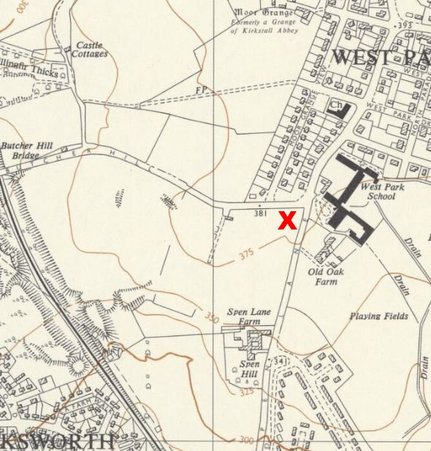
 | Ordnance Survey 1956

National Archives FO 1120/235 – Re-educational survey visit reports for camps 240 to 246. Dated 1 Jan 1946 – 31 Dec 1948
National Archives FO 939/313 – 245 Working Camp, Butcher Hill Camp, Leeds, Yorkshire. Dated 1946-1948.

