Camp 260 Hardwick Heath Camp, Bury St Edmunds, Suffolk

1947 Camp List
260(G.W.C.) | Hardwick Heath, Bury St.Edmunds, Suffolk | E. | Priswar, Bury St.Edmunds | Bury St. Edmunds 1074 | Bury St.Edmunds | Lt.Col.F.V.Oborne | v/1453/2

Prisoner of War Camps (1939 – 1948) - Project report by Roger J.C. Thomas - English Heritage 2003
OS NGR | Sheet | No. | Name & Location | County | Cond’n | Type 1945 | Comments
TL 845 626 | 155 | 260 | Hardwick Heath, Bury St Edmunds | Suffolk | 4 | German Working Camp | Site coccupied by a hospital.

Location: Camp, and now hospital site is NGR TL 853 626  Before the camp:  Pow Camp: German pows. Approximately 64 huts.  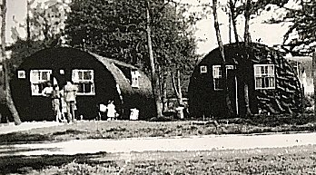  < Nissen huts at the camp – picture taken when the site was in use for emergency housing.  “Parties of prisoners were collected by local farmers to work on the land, and Borough Council accounts show that some of the roads for the new Mildenhall Road estate were built by prisoners of war. A dozen or so POWs were regularly delivered for duties at Gibraltar Barracks, where they worked in the messes, cookhouse, Quartermaster's Stores, and did odd jobs such as woodcutting and gardening... The German prisoners at Hardwick Heath had their own newsletter called "Lagerecho", which continued to be produced up to February 1948.” Details from; www.stedmundsburychronicle.co.uk/Chronicle/1946-2000.htm | 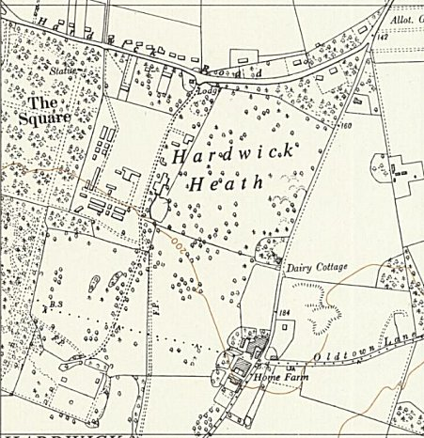
 | Ordnance Survey 1957
On 4 December 1947 it was reported that; “In recognition of his bravery in rescuing a Lawshall man from an attack by a bull, a German P.O.W., Godfrey Dappert of No 260 P.O.W. Camp, Hardwicke, has received an illuminated address from the Carnegie Trust and a watch suitably inscribed, the presentation was made by Brigadier J Slater OBE, Deputy Commander of the East Anglian District at a ceremony on Hardwicke Heath.” (Article in Suffolk Free press).
After the camp: Huts used for emergency housing
Further Information:
National Archives FO 1120/239 – Re-educational survey visit reports for camps 260 to 263. Dated 1 January 1946 – 31 December 1948

