Camp 263 Leckhampton Court Camp, Leckhampton, Gloucestershire

1947 Camp List
263(G.W.C.) | Leckampton Court Camp, Cheltenham, Glos. | S | Priswar, Cheltenham | Cheltenham 52363 | Cheltenham | Lt.Col.F.S.S. Lamprey | v/1453/2

Prisoner of War Camps (1939 – 1948) - Project report by Roger J.C. Thomas - English Heritage 2003
OS NGR | Sheet | No. | Name & Location | County | Cond’n | Type 1945 | Comments
SO 9440 1948 | 163 | 263 | Leckhampton Court Camp, Leckhampton, Cheltenham | Gloucestershire | 4 | German Working Camp

NOTE – there is an excellent chapter about this camp in ‘Inside The Wire’ by Ian M C Hollingsbee, The History Press, 2014. It has details of inspection reports, a camp plan, aerial photograph and details of the sub-camps. I therefore only give an outline and some further details here:

Location: Leckhampton is a district in south Cheltenham. The camp was in the grounds of the court.  Before the camp: Leckhampton Court was requisitioned in 1939. The court and estate housed the Durham Light Infantry, and from July 1942, the US Army Signal Corps.  Pow Camp: Opened on 7 September 1945 for German pows. Capacity 450 in 39 Nissen huts.  An article in the Cheltenham Chronicle, 24 August 1946 was headlined; 'No Complaints from P.O.W.s at Leckhampton'. It noted that the pows were supplied with plastic token money to buy items from the camp canteen. The description of the camp remarked on how well maintained it was, (also noted in ref 2 below) with a 'delightful little pool of running water with a fountain, ringing by a bed of flowering pansies, built by the German prisoners of war'.  [Ref 1] Memories of Karl Wolf who became camp leader – 250 pows of mixed category in Nissen huts. Guards were accommodated in the Court. Gradual relaxation of non-fraternisation rules. Hut converted to a chapel. Camp orchestra and choir gave concerts.  [Ref 2] Italian and German pows. Small water gardens and miniature windmills around some of the huts.  [Ref 3] On the day before the camp closed down all the outlying POWs were brought in – date of departure was 22 May 1948 (gradual repatriation had started from the camp in 1947). A photograph of the pows about to board a train at Leckhampton is reproduced in ‘Leckhampton in the Second World War’. Major Harris had been a commandant at the camp.  [Ref 4] No documentary evidence that Italians were held in the camp, just memories of a few, though others dispute this. US troops from July 1942 to September 1944. The camp was said to be empty when the Germans | 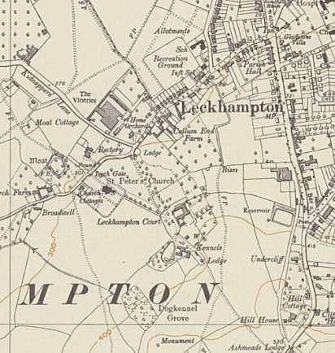
 | Ordnance Survey 1954
arrived in September 1945. (This may be another case where Italian pows, working with the Pioneer Corps, were used for a short time to convert the troop camp to a pow camp).

A fountain made by the pows is not far from the church boundary.

Camp commandant 1945 Major A Harris. Previously at Sudeley Camp 37.
Camp commandant c1946-1947 Lieutenant colonel F S S Lamprey.

The camp closed in May 1948.

After the camp: Leckhampton Court is a Sue Ryder Hospice

Further Information:

National Archives
FO 939/183 – 263 Working camp, Leckhampton Camp, Cheltenham, Gloucestershire. Dated 1946 – 1948.
FO 1120/239 – Re-educational survey visit reports for camps 260 to 263. Dated 1 January 1946 – 31 December 1948

Leckhampton Local History Magazine – ‘Smoke Signal’ – [1] 4/1-2; [2] 7/3; 20/2; [3] 27/2; [4] 37/2; 69/4

Vertical aerial photographs - RAF/106G/UK/1354 V 5422-5423 02-APR-1946 and RAF/58/377 V 5271 04-MAY-1950

