Camp 273 Flixton Airfield, Flixton, Suffolk

Prisoner of War Camps (1939 – 1948) - Project report by Roger J.C. Thomas - English Heritage 2003
OS NGR | Sheet | No. | Name & Location | County | Cond’n | Type 1945 | Comments
TM 3057 8591 | 156 | 273 | Flixton Airfield, Flixton, Bungay | Suffolk | 5 | German  Working Camp | Former RAF Bungay (Station 125). Precise location not identified, NGR given for approx centre of the numerous dispersed accommodation sites.

Location: The NGR above is located at ‘X’. However, the English Heritage ‘Pastscapes’ website listed the camp at TM 325 866 ‘Y’. The aerial photographs show many hutted areas – several of which may have been used. About 4 km S of Bungay. Flixton Airfield was also known as Bungay Airfield.  Before the camp: Used by USAAF from 1942 to June/July 1945.  Pow Camp:  There was a camp newspaper ‘Lagerspiegel Antifaschistische POW – Zeitung Des Camp 273’ (Camp Mirror, anti-fascist POW newspaper for Camp 273).  After the camp:  Further Information:  National Archives FO 1120/240 – Re-educational survey visit reports for camps 266 to 276. Dated 1 January 1946 – 31 December 1948  IWM has a copy of the camp newspaper dated March 1947. Catalogue LBY E.J. 382 | 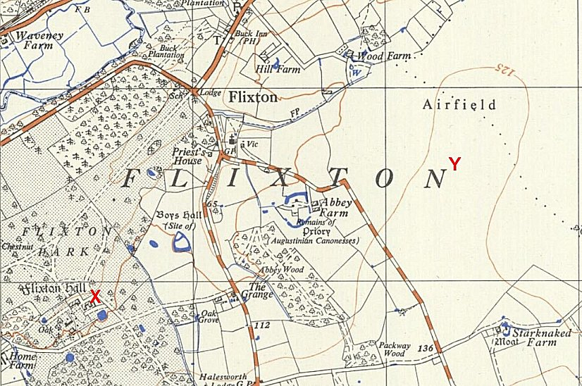
 | Ordnance Survey 1956

