Camp 277 Recreation Ground, South Littleton, Evesham, Worcestershire

1947 Camp List
277(G.W.C.) | Recreation Ground, South Littleton, Evesham, Worcester | W | Priswar, Badsey | Badsey 326 | (Blank) | Lt.Col.P.J.McKevitt | v/1453/2

Prisoner of War Camps (1939 – 1948) - Project report by Roger J.C. Thomas - English Heritage 2003
OS NGR | Sheet | No. | Name & Location | County | Cond’n | Type 1945 | Comments
SP 0749 4616 | 150 | 277 | Recreation Ground, South Littleton, Evesham | Worcestershire | 4 | German  Working Camp | 24 huts sited along the eastern and northern boundaries of the recreation ground.

NOTE – Camp 277 (South Littleton) was used for a while as the postal address for Camp 665 (in Honeybourne). The English Heritage report therefore gave them very similar NGRs – however, these were separate camps in different locations.

Location: ‘Adkin’s Recreation Ground’ in South Littleton. Huts still shown on 1954 OS map.  Before the camp:  Pow Camp:  The use of camps 277 and 665 was questioned in the House of Commons in 1946:  “Mr. De la Bère asked the Minister of Works whether he will indicate the approximate date on which he will be de-requisitioning the Littleton Recreation Ground in Worcestershire; and what steps he is taking with the Ministry of Labour to make some other arrangement for the utilisation of the Honeybourne Camp for the Resettlement Corps.  “Mr. Tomlinson - I regret I cannot say when it will be possible to give up the ​ camp at Littleton, at present occupied by German prisoners of war doing agricultural work. As regards the second part of the Question, Honeybourne Camp is to be occupied for some time to come by members of the Polish Resettlement Corps.” (Hansard, 25 November 1946, Volume 430).  There was a camp newspaper; Der Kieker: Zeitung Des K.G. Lagers 277 (Kieker = Telescope or binoculars).  After the camp: Reverted back to a recreation ground.  Further Information: | 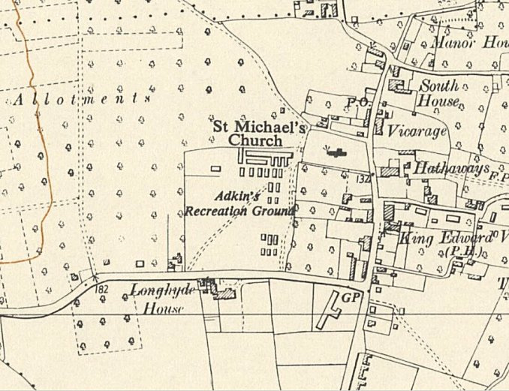
 | Ordnance Survey 1954
National Archives FO 1120/241 – Re-educational survey visit reports for camps 276 to 278. Dated 1 January 1946 – 31 December 1948
IWM have a copy of the camp newspaper dated March / Easter 1947. Catalogue LBY E.J.372

