Camp 291 Kitty Brewster Farm, Blyth, Northumberland

Prisoner of War Camps (1939 – 1948) - Project report by Roger J.C. Thomas - English Heritage 2003
OS NGR | Sheet | No. | Name & Location | County | Cond’n | Type 1945 | Comments
NZ 2838 8209 | 81 | 291 | Kitty Brewster Farm, Blyth | Northumberland | 4 | German Working Camp | Former Heavy Anti-aircraft battery (HAA Bty). Site occupied by industrial estate.

Location:  Before the camp: Farmland  Pow Camp: Italian and then German pows.  Listed as a hostel for Darras Hall Camp 69 in April 1946.  After the camp: Possibly used as a hostel for homeless families.  Further Information:  National Archives FO 1120/243 – Re-educational survey visit reports for camps 286 to 293. Dated 1 January 1946 – 31 December 1948  The book ‘Blyth Memories Part 2’ by Jim Harland (Summerhill Books – 2011) contains some details about this camp, but I have not read the book. | 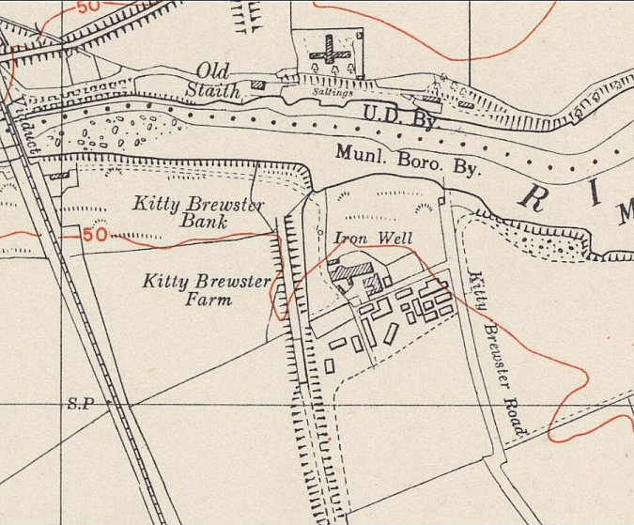
 | Ordnance Survey 1951

