Camp 298 Parkgate, Wirral, Cheshire

Prisoner of War Camps (1939 – 1948) - Project report by Roger J.C. Thomas - English Heritage 2003
OS NGR | Sheet | No. | Name & Location | County | Cond’n | Type 1945 | Comments
SJ 27 78 | 117 | 298 | Parkgate, Wirral | Cheshire | 4 |  | Former Heavy Anti-aircraft battery (HAA Bty)

Location: Still trying to find this camp. Looking for HAA nearby has brought up – “33 AA Brigade Diary (27th Jan 1941) records a site at Ashfield Hall, Neston, Wirral manned by 93HAA at grid reference 755005 which when put into the coordinate translator comes out at roughly SJ 29076 79118” marked ‘X’ on map.  BUT, there was also a nearby ‘Mersey XX H35 Raby’  Before the camp:  Pow Camp:  After the camp:  Further Information:  National Archives FO 1120/244 – Re-educational survey visit reports for camps 294 to 298. Dated 1 January 1946 – 31 December 1948 | 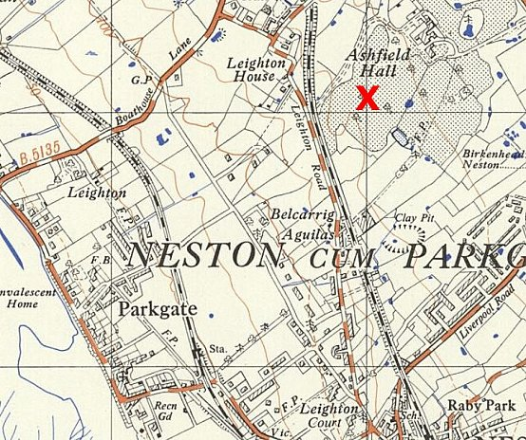
 | Ordnance Survey 1958

