Camp 406 Scarnecross Camp, Launceston, Cornwall

Prisoner of War Camps (1939 – 1948) - Project report by Roger J.C. Thomas - English Heritage 2003
OS NGR | Sheet | No. | Name & Location | County | Cond’n | Type 1945 | Comments
SX 3341 8346 | 201 | 406 | Scarnecross Camp, Launceston | Cornwall | 4 | Base Camp | Site occupied by an industrial estate and housing

Location:  Before the camp: British and then US troops located in the area – possibly the same camp.  Pow Camp:  After the camp:  Further Information: | 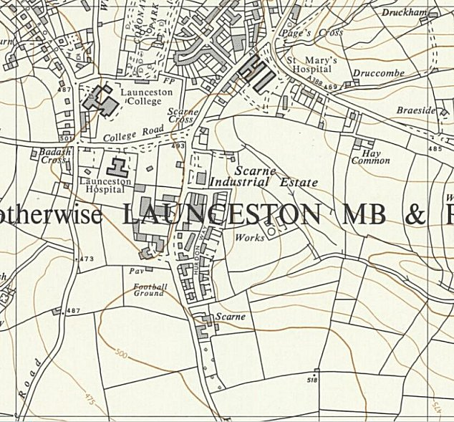
 | Ordnance Survey 1963

