Camp 412 Langdon Barracks, Dover, Kent

1947 Camp List
412(G.W.C.) | Langdon Barracks, Dover | E | Priswar, Dover | Dover 185 (Ex.259) | Dover | Major S.H.Cooles | v/1452/2

Location: The area marked on the map between Fox Hill and the Ferry terminal. NGR TR 335 422.  Before the camp: Langdon Prison, then Langdon Barracks.  Pow Camp: Became a pow camp at the end of the war.  Two cases arose at the end of 1946 of pows breaking the laws on fraternisation. One pow, Hans Guddley was charged with conduct prejudicial to good order and military discipline for associating with a 19-year old girl, to which he pleaded guilty.  The other case was more serious. Pow Walter Wietkamp was charged with offences against a 13-year old girl. He pleaded not guilty and due to objections regarding the evidence, the trial was adjourned until February 1947. The Dover Express then reported on 7 February 1947;  “COURT MARTIAL ON PRISONER OF WAR. A twenty-three-year-old German prisoner of war, Walter Weitkamp, appeared before a Court Martial at Langdon Barracks last week on six serious charges of offences against a 14-year-old Dover girl. The prisoner, who was defended by Mr. G. R. M. Brydone, of the firm of Messrs. Stilwell and Harby, pleaded not guilty. He was acquitted on five of the charges, but found guilty of indecent assault, for which sentence will be promulgated. The prisoner's defence was that he had reasonable cause to believe that the girl was over sixteen years of age at the time. The girl, under cross-examination, admitted that she had several friends among the prisoners, that she smoked, and used make-up, and that she had written an affectionately worded letter to the accused. At a Dover Children's Court in December the girl had been put on probation as being in need of care and protection.”  The camp was included in the re-education programme for pows. However, a report from June 1947 stated that the Commandant wished the visits from lecturers should cease as they were of poor quality. The complaint was investigated, but lecturers did continue to visit. | 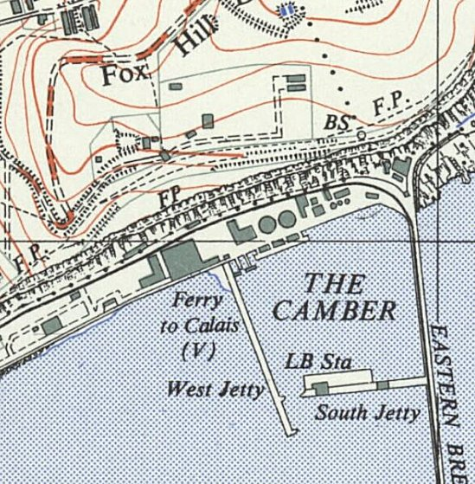
 | Ordnance Survey
There was a fire at the barracks in July 1947. It occurred in a building that was used as part bakehouse and part recreation room. The fire brigade managed to confine the main damage to the bakehouse.

19 September 1947, 50 pows from the camp attended the Dover Music Club. One of the pows, Kurt Knopf, a doctor of music, played some piano pieces. He gave a much larger performance later in the year, reported in the Dover Express on 24 October, 1947:
“P.O.W. GIVES PIANO RECITAL. Over two hundred people, including the Mayor (Alderman A. T. Goodfellow) and members of the Council, attended a piano recital at the Town Hall on Tuesday evening, given by Dr. Kurt Knopf, a German prisoner, stationed at No. 412 P.O.W. Camp, Langdon Barracks. For nearly two hours Dr. Knopf delighted his audience with his accomplished renderings of classical and romantic music, and it is not difficult to believe that he was a well-known professional musician in his own country. Contingents from Dover College and the County Grammar School for Girls, as well as a number of prisoners from the camp, were among the audience.”

Camp commandant c1947 Major S H Cooles. I think he was from the Pioneer Corps.

Two hostels –

Goodnestone (probably in the grounds of Goodnestone House)

Wootton Court, in the old manor house. Later used to house displaced persons. Demolished in 1952.

The camp was closed in 1948.

After the camp: In the early 1950’s the site was cleared with the exception of two buildings. 2020 park.

Further Information:

National Archives FO 939/319 – 412 Working Camp, Langdon Barracks Camp, Dover, Kent.. Dated 1946 – 1947

