Camp 559 Abbeycraig Park, Causeway Head, Stirling

Included in the 1945 ICRC Camp list – Labour Camp. 559. Abbey Craig Park, Causewayhead, Stirling.

Prisoner of War Camps (1939 – 1948) - Project report by Roger J.C. Thomas - English Heritage 2003
OS NGR | Sheet | No. | Name & Location | County | Cond’n | Type 1945 | Comments
 |  | 559 | Abbeycraig Park, Causeway Head, Stirling | Stirlingshire |  |  | Scotland

Location: NGR NS 8068 9575 just N of Abbeycraig Park, beside Hillfoots Road.  Before the camp: Large house and grounds.  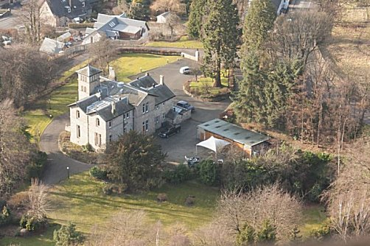  Pow Camp: Not sure if the camp was within the large house or in the grounds, or both.  International Red Cross visit - 17 May 1944 - Italian prisoners, capacity 250.  After the camp: 2020 private residence.  As a child I was often taken to Abbeycraig Park to play. There was a shop which sold Italian ice cream nearby and I was told it was opened by an ex-pow who had settled in Scotland.  Further Information:  Photograph - https://www.flickr.com/photos/tags/abbeycraigparkhouse | 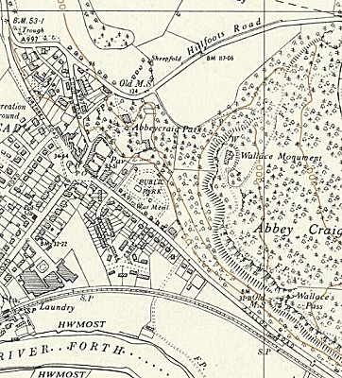
 | Ordnance Survey 1958

