Camp 567 Oldfield Villa, Market Street, Craven Arms, Shropshire

Location: Location of Oldfield Villa shown on map at SO 434 827  Before the camp:  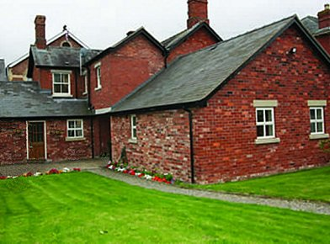  Pow Camp: Likely to be a satellite camp or hostel for a larger camp.  < Oldfield Villa  After the camp:  Further Information:  Probably linked with Camp 567 The Mount, Whitchurch, Shropshire | 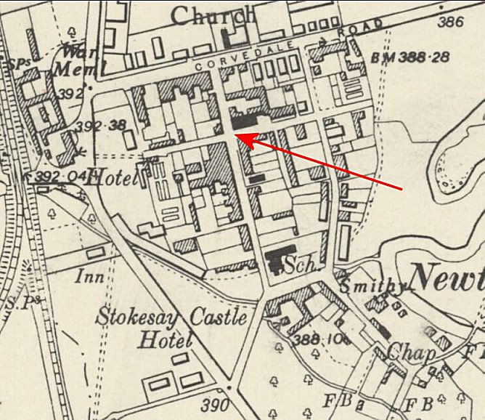
 | Ordnance Survey 1953

