Camp 579 (& 594, 781) Marlborough Farm Camp, Radway Extension, Kineton, Warwickshire

Included in the 1945 ICRC Camp list – Labour Camp. 579. Marlborough Farm Camp, Rodway Extension, Kineton, Warwick. Also - Labour Camp. 594. Address non communiqué. Presumably the camp was changing its number at the time the ICRC list was being compiled. Also 781. Marlborough Farm, Kineton, Warwick.

Prisoner of War Camps (1939 – 1948) - Project report by Roger J.C. Thomas - English Heritage 2003
OS NGR | Sheet | No. | Name & Location | County | Cond’n | Type 1945 | Comments
SP 3773 5174 | 151 | 579 | Marlborough Farm Camp, Radway Extension, Kineton | Warwickshire | 5 |  | Precise location not identified, NGR given for Marlborough Barracks, Marlborough Farm however was at SP 3751 5157.

Location: Within large troop barracks area and railway loop.  Before the camp: Farmland up to the start of WW2. The site looks very different on the 1955 map from today - or even as it actually was from 1941 when the site was started to be developed.  Pow Camp: Found one reference to Italian pows living in a couple of sheds at the railway depot.  After the camp: The large Marlborough Barracks and railway loop covers the area.  Further Information: | 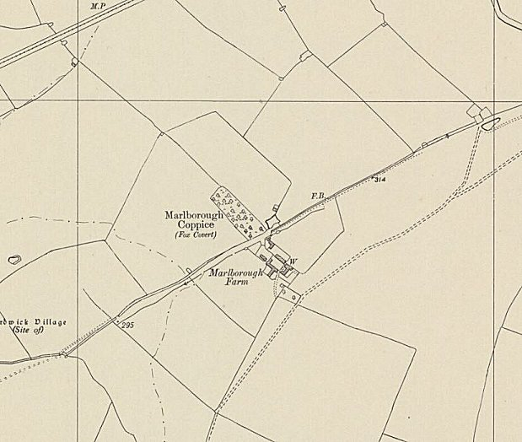
 | Ordnance Survey 1955

