Camp 585 Searchlight Site Camp, Husthwaite, Easingwold, Yorkshire

Included in the 1945 ICRC Camp list – Labour Camp. 585. Searchlight Site, Easingwold, York.

Prisoner of War Camps (1939 – 1948) - Project report by Roger J.C. Thomas - English Heritage 2003
OS NGR | Sheet | No. | Name & Location | County | Cond’n | Type 1945 | Comments
SE 525 746 | 100 | 585 | Searchlight Site Camp, Husthwaite, Easingwold | Yorkshire | 4 |  | Farmland

Location: Husthwaite is about 4km N of Easingwold. NGR above marked on map.  Before the camp: Wikipedia information about 344 Searchlight Battery – “By the end of 1943, Battery HQ was stationed at Oadby in Leicestershire and formed part of 74 AA Bde (another Overlord formation). On 1 January 1944, Major R.H. Taylor assumed command of the battery. In February and March, it practised air cooperation at Cleethorpes on the Lincolnshire coast and at Easingwold in East Yorkshire, transferring to the command of 105 AA Bde.  Pow Camp: Italian pows recorded in 1945.  After the camp: Farmland  Further Information: | 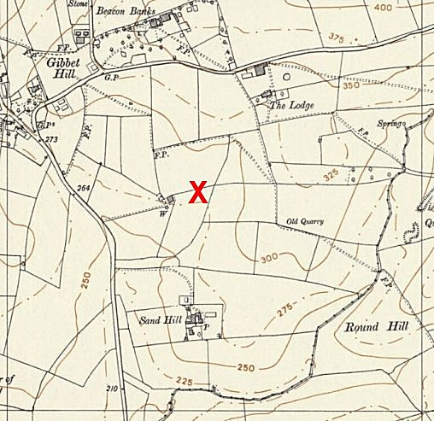
 | Ordnance Survey 1958

