Camp 591 (& 626) Wilcott Camp, Nesscliffe, Shropshire

Included in the 1945 ICRC Camp list – Labour Camp. 591. Wilcott Camp, Nesscliffe, Shrewsbury, Salop. Also ICRC – Labour Camp. 626. Same address – presumably the camp was changing number as the list was compiled.

Prisoner of War Camps (1939 – 1948) - Project report by Roger J.C. Thomas - English Heritage 2003
OS NGR | Sheet | No. | Name & Location | County | Cond’n | Type 1945 | Comments
SJ 3749 1831 | 126 | 591 | Wilcott Camp, Nesscliffe | Shropshire | 2 |  | Pre-existing camp serving an ordnance depot. Presenty used by the army as Nescliffe Training Camp

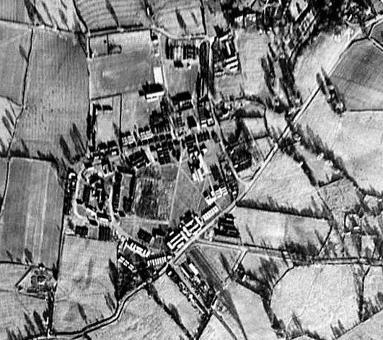 | Location: Site not shown on 1958 map.  Before the camp: Army camp for ordnance depot  Pow Camp:  Closed 1948  After the camp: 2020 Nesscliffe Training Camp  Further Information: | 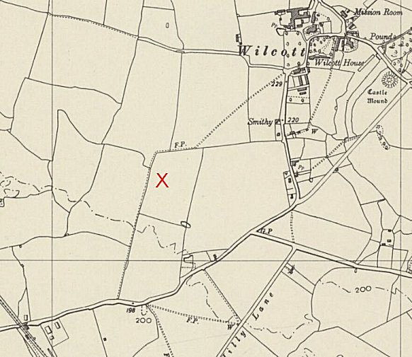
© MoD No. 541/214 frame 3036. |  | Ordnance Survey 1958

