Camp 595 Burstwick Camp, Hull, Yorkshire

Included in the 1945 ICRC Camp list – Labour Camp. 595. Address non communiqué.

Location: Burstwick is a village about 13km E of Hull.  Before the camp:  Pow Camp:  After the camp:  Further Information: | 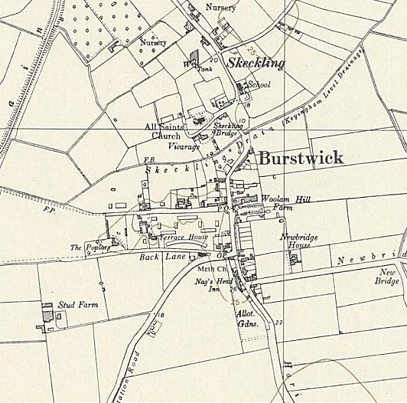
 | Ordnance Survey 1958

