Camp 612 Canonbie Camp, Canonbie, Dumfriesshire

Included in the 1945 ICRC Camp List – Labour Camp. 612. Canonbie Camp, Dumfriesshire.

Location: About 3 km N of the England-Scotland border.  Before the camp:  Pow Camp: Italian labour camp.  After the camp:  Further Information:  Possibly linked with Camp 612 at Kirkpatrick Flemming | 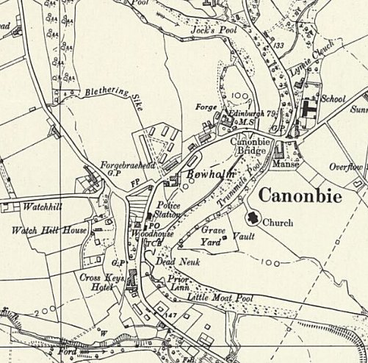
 | Ordnance Survey 1957

