Camp 614 Stoneham Camp, Eastleigh, Hampshire

1947 Camp List
614(G.W.Coy) | S | Stoneham Camp, Eastleigh, Hants | Chandlers Ford 2561 | 30(W.O.) | V/1270/3

Prisoner of War Camps (1939 – 1948) - Project report by Roger J.C. Thomas - English Heritage 2003
OS NGR | Sheet | No. | Name & Location | County | Cond’n | Type 1945 | Comments
SU 4570 1729 | 185 | 614 | Stoneham Camp, Eastleigh | Hampshire | 5 |  | Precise location not identified, NGR given for camp to the north eastern end of Eastleigh airport.

Location: Map shows the location of the NGR above. However, the camp could also have been in Stoneham Park, Stoneham House, the Golf club….  Before the camp:  Pow Camp: German pows. The War Establishment number would indicate a camp with an approximate capacity of 500 pows.  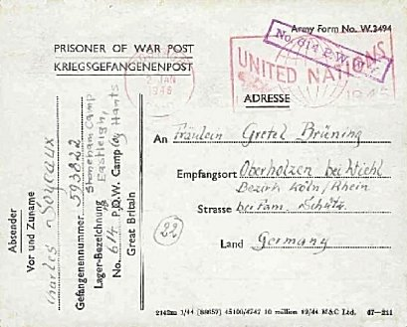  Postcard dated 2 JAN 1945 to Germany.  (Shown in ‘The London 1945 United Nations Slogan Cancellation’ by Clayton Wallace).  After the camp:  Further Information: | 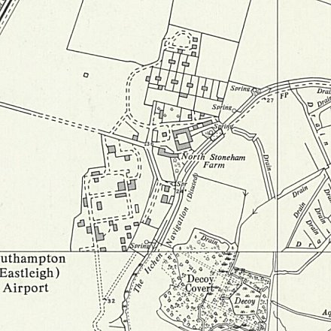
 | Ordnance Survey 1963

