Camp 6 (& 578, 580, 685) - Long Marston Camp, Warwickshire

Included in the 1945 ICRC Camp list – Labour Camp. 578. No 9 Camp, E.S.C.D. Long Marston, Stratford-on-Avon, Warwicks.
Included in the 1945 ICRC Camp list – Labour Camp. 580. No 5 Camp, E.S.C.D. Long Marston, Stratford-on-Avon, Warwicks.

Prisoner of War Camps (1939 – 1948) - Project report by Roger J.C. Thomas - English Heritage 2003
OS NGR | Sheet | No. | Name & Location | County | Cond’n | Type 1945 | Comments
SP 15 48 | 151 | 6 | Long Marston Camp | Warwickshire | 5 |  | Ordnance Depot
SP 160 470 | 151 | 685 | No.3 Camp, ESCD, Long Marston | Warwickshire | 5 | German  Working Camp | Precise location not identified. NGR for centre of complex. Central Engineering Park.

1947 Camp List
685(G.W.Coy) | N | No.3 Camp E.S.C.D., Long Marston, Stratford-on-Avon | Stratford-on-Avon 3249 | 25(W.O.) | V/1270/4

NOTE: I do NOT know that these were the same camp / sub-camps or separate, but they were all based around the railyards and depot at Long Marston.  Location:  NGR for 6 and 685 shown on the map – but neither has been identified for certain.  No information where No 5 and 9 Camps were.  The site was a very large railway loop, with sidings, storage sheds and warehouses.  E.S.C.D. – The Royal Engineers Supply Depot was based at this site – C may be ‘Central’, but the exact definition of ‘ESCD’ is uncertain.  Previous Use: Farming land. The Ministry Of Defence purchased the site in 1940.  POW Camp: Were the pows employed on the farms around the camp, or actually inside the depot? If in the depot this would contravene the Geneva Convention on acceptable work for pows.  After the camp: Continued to be used as an army storage depot up to 2004. Polish demobilised soldiers recorded as working here from 1948 to 1968. | 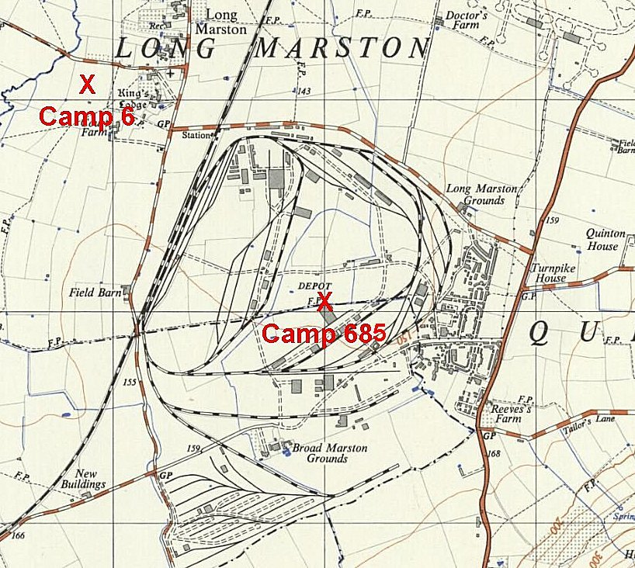
 | Ordnance Survey 1958

