Camp 631 Seafield School, Cooden Down, Bexhill, Sussex

Prisoner of War Camps (1939 – 1948) - Project report by Roger J.C. Thomas - English Heritage 2003
OS NGR | Sheet | No. | Name & Location | County | Cond’n | Type 1945 | Comments
TQ 71 07 | 199 | 631 | Seafield School, Cooden Down, Bexhill | Sussex | 5 |  | Precise location not identified, NGR given for Cooden.

Location: Seafield School was located at NGR TQ 7158 0746 just off Collington Lane in SW Bexhill.  Before the camp: School for boys aged 8 to 13. At the start of WW2 the school re-located to the Two Bridges Hotel, Dartmoor. The school building was requisitioned by the War Ministry. Wikipedia – “Seafield itself was used as quarters for a Canadian Anti Aircraft Battery that was serving in defence of Bexhill and Cooden Beach during the Second World War”.  Pow Camp: Mainly German pows. From the late summer of 1944 to early 1945 the camp held Soviet pows, presumably not at the same time as Germans.  It seems that Canadian troops remained at the camp while it was used for pows, see * below.  In the book ‘Victims of Yalta’ it details how a local couple, Mr and Mrs Backshall were frequently visited by Soviet pows from the camp. Towards the end of 1944, Mr Backshall wrote on behalf of some asking if they could remain in this country as they feared the consequences if they were returned – Soviet citizens who surrendered were regarded as traitors. They were unaware that the decision had already been made. Some of the pows also signed a petition.  A War Office official (‘Major James’) wrote to the Foreign Office;  “….I am enclosing herewith a translation of a petition signed by 42 Soviet nationals of No.631 Working company asking for the protection of the British Government against their repatriation to Russia… As these men are admittedly Soviet Nationals, we presume that they will be repatriated to Russia whether they like it or not.  Meanwhile the only course appears to be to keep them as a separate party in the above Working Company as is being done at present.” | 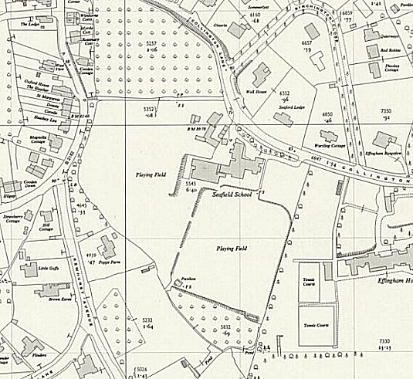
 | Ordnance Survey 1955
John Galsworthy in the Foreign Office replied to Major James:

“…As Soviet nationals, these men must, of course, be repatriated to the USSR when opportunity arises, irrespective of their wishes. Moreover, they admit to having gone over to the enemy to fight against the allies and we have presumably no proof that their statement that they gave themselves up voluntarily is true. They seem to us to deserve no sympathy and we think our principal aim where they are concerned should be to ensure that they cause no trouble between us and the Soviet authorities over here.
If there is any danger of such trouble or of the prison camp authorities showing them any sympathy we think the prison camp authorities should be instructed accordingly.”

On 5 February 1945, the Backshall’s son, Roland, cycled to the camp and found they had gone. * “They were not to be seen, and when he enquired of the Canadian sentry at the gate, he was laconically handed a note.” The note was from a Russian pow saying they had been moved to a camp 50 miles away.

The Soviet Military Mission in London had been informed of the petition and had stated the pows should be returned on the next repatriation voyage. The War office directed that:

“The 41 [41 or 42?] Soviet Nationals in 631 Working Coy who have refused to return to the USSR will not be informed of the impending repatriation but will be transferred immediately to No.9 P.W. Reception Camp.” (This was at Kempton Park in Surrey).

The pows were shipped back to Russia a few days later in mid-February. It is not known what happened to them on return to the USSR, but it is believed that all were executed.

After the camp: Re-opened as a school. The school closed in the early 1970’s. 2020 residential area.

Further Information:

Victims of Yalta – Nikolai Tolstoy – Hodder and Stoughton – 1977.

