Camp 670 St Radegund’s Camp, Dover, Kent (aka Radigund’s / Radigrund’s)

1947 Camp List
670(G.W.Coy) | E | St.Radigunds Camp, Dover, Kent | Dover 816 | 33(W.O.) | V/1270/4

Prisoner of War Camps (1939 – 1948) - Project report by Roger J.C. Thomas - English Heritage 2003
OS NGR | Sheet | No. | Name & Location | County | Cond’n | Type 1945 | Comments
 | 179 | 670 | St Radigrund's Camp, Dover | Kent | 5 | German Working Camp | Unresolved four possible sites.

Location: The kentonline website states that the camp was in the grounds of St Radegund’s Abbey at NGR TR 275 418.  (St Radigund’s is also a ward in Dover).  Before the camp: D4 heavy anti-aircraft site was located on high ground to the N of the Abbey site.  Pow Camp:  Postal item from May 1947 identified.  After the camp: The site is shown as St Radigund’s Abbey Farm.  Further Information: | 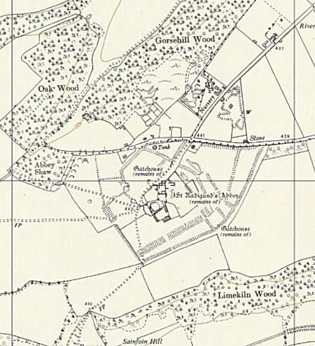
 | Ordnance Survey 1962

