Camp 677 New Inn Camp, Pontypool, Monmouthshire (Gwent)

1947 Camp List
677(G.W.Coy) | W | New Inn Camp, Pontypool, Mon | Griffithstown 115 | 29(W.O.) | V/1270/4

Prisoner of War Camps (1939 – 1948) - Project report by Roger J.C. Thomas - English Heritage 2003
OS NGR | Sheet | No. | Name & Location | County | Cond’n | Type 1945 | Comments
 |  | 677 | New Inn Camp, Pontypool | Monmouthshire (Gwent) |  | Wales

Location: NGR ST 300 998  Before the camp: Next to a site called the Polo Ground. The Wanderers Polo team played there and then it was used for coursing, pony racing and greyhound racing and as a sports ground. Military use from the start of the war.  Pow Camp: Italian and then German pows.  After the camp: Used as temporary housing. 2020 ‘Polo Ground Industrial Estate’.  Further Information: | 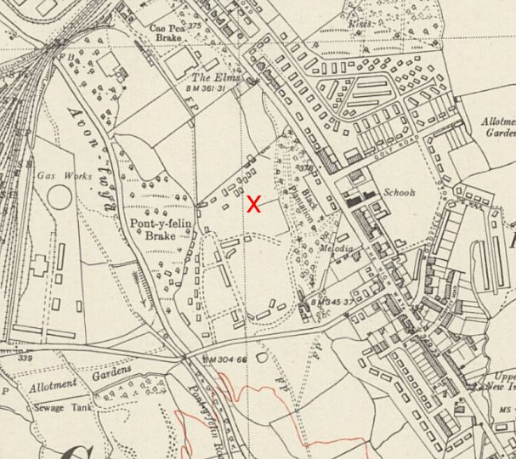
 | Ordnance Survey 1954

