Camp 687 Shotover House, Wheatley, Oxfordshire

1947 Camp List
687(G.W.Coy) | S | Shotover House, Wheatley, Oxford | Oxford 3108 | 52(W.O.) | V/1270/4

Prisoner of War Camps (1939 – 1948) - Project report by Roger J.C. Thomas - English Heritage 2003
OS NGR | Sheet | No. | Name & Location | County | Cond’n | Type 1945 | Comments
SP 583 067 | 164 | 687 | Shotover House, Wheatley | Oxfordshire | 4 | German Working Camp | Parkland and road widening.

Location: About 7km to the E of Oxford.  Before the camp:  Pow Camp:  Pow mail seen for March 1947.  After the camp:  Further Information: | 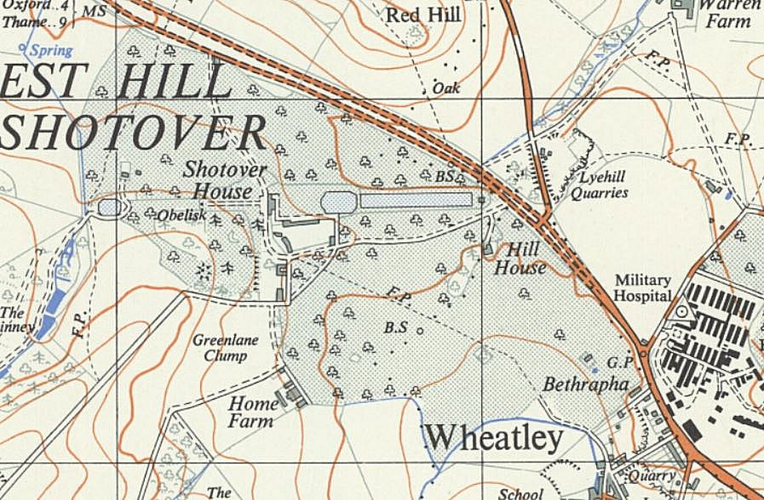
 | Ordnance Survey 1964

