Camp 147 - Boar's Head Camp, Walgherton, nr Nantwich, Cheshire (aka Walgherton)

Included in the 1945 ICRC camp list – Labour Camp. 147. Boars Head Camp, Walgherton, Nantwich, Cheshire.

Prisoner of War Camps (1939 – 1948) - Project report by Roger J.C. Thomas - English Heritage 2003
OS NGR | Sheet | No. | Name & Location | County | Cond’n | Type 1945 | Comments
SJ 701 485 | 118 | 147 | Boar's Head Camp, Walgherton, Nantwich | Cheshire | 4 | German Working Camp | Former Heavy Anti-aircraft battery (HAA Bty)

Location: In the centre of the map off the A51 London Road. The Boar’s Head Public House is seen to the N. NGR SJ 7010 4852.  Before the camp: Fields. HAA Battery (Crewe H4) was there 1941-1942.  Pow Camp: Italian and then German pows.  1 August 1945 an urgent memorandum was sent to this camp, and others, about maintaining records of Italians who were classed as ‘co-operators’. At this point many, sometimes all, of the Italian pows were in hostels / billets.  15 September 1945 hostels listed, (WO 32/10737):  Marbury, Whitchurch, Salop (Was this what became the main Marbury Camp 180 – or a smaller site, or, possibly Comberbach?).  Sandbach, Cheshire  Warmingham, Sandbach, Cheshire  Mid-1946 Boar’s Head Camp became a hostel for Tarporley Camp 74. After this it was usually called Walgherton hostel.  May 1947 Tarporley and its hostels, including Walgherton, were transferred to Camp 189 Marbury Hall.  May 1947 Hostel leader – Uffz. Erich Hildebrandt (A)  August 1947 Hostel leader – Ogfr. Zeh (B+). He was still there in February 1948. It was noted that about 60% of the pows were under-25.  The camp closed in 1948  Postal items: Pow mail to Italy dated December 1945 | 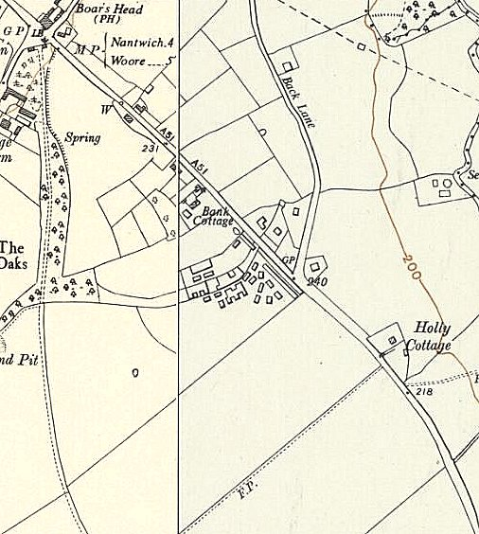
 | Ordnance Survey 1953

No. of pows | As Camp 147 | With Tarporley Racecourse Camp 74 |  |  |  | With Marbury Camp 189
 |  | 7/46 | 10/46 | 1/47 | 3/47 | 5/47 | 8/47 | 10/47 | 2/48
Walgherton (Boar’s Head) | ? | 280 | 186 | 156 | 123 | 103 | 92 | 152 | 55

After the camp: A later OS map marks the site as a hostel. 2019 fields.

