Camp 270 Luton Airport Camp, nr Luton, Bedfordshire

1947 Camp List
270(G.W.C.) | Luton Airport Camp, Luton, Bedfordshire | E | Priswar, Luton | Luton 4162 | Luton | Lt.Col.M.F.F.Buszard | v/1453/2

Prisoner of War Camps (1939 – 1948) - Project report by Roger J.C. Thomas - English Heritage 2003
OS NGR | Sheet | No. | Name & Location | County | Cond’n | Type 1945 | Comments
TL 118 211 | 166 | 270 | Luton Airport Camp, Luton | Bedfordshire | 5 | German Working Camp | Precise location not identified, NGR given for approx centre of airfield.

Location: Entries from websites place the camp at;  ‘Eaton Green Road’, which runs along the N of the airport.  ‘..14 Nissen huts on the west side of the drive leading to Putteridge Bury House, the one by the airport entrance which was the biggest, and one each for Lilley and Breachwood Green’.  The information from postal items / pow memories indicate there was a main camp by the entrance (TL 150 220 alongside Eaton Green Cottages on the map), with at least three smaller camps nearby.  Before the camp:  Pow Camp:  There was a camp magazine called ‘Die Brucke’ (The Bridge).  Camp number included in an ‘Urgent Memorandum’ of 14 November 1947 (FO 939/270) regarding inspection of food parcels.  Camp commandant c1947 Lieutenant Colonel M F F Buszard, from the Northamptonshire Regiment.  After the camp:  Breachwood Green site was used for emergency housing. | 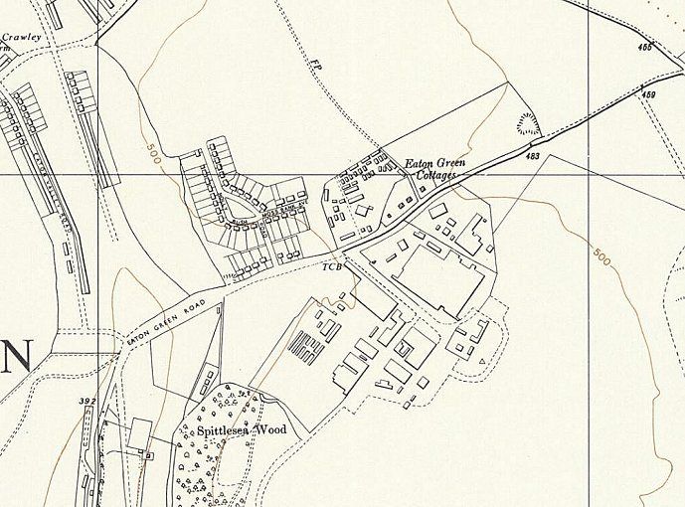
 | Ordnance Survey 1960

DIE BRUCKE

DIE BRUCKE

DIE BRUCKE
Further Information:
National Archives FO 1120/240 – Re-educational survey visit reports for camps 266 to 276. Dated 1 January 1946 – 31 December 1948

IWM has a copy of the camp magazine for Christmas 1946. Catalogue LBY E.J.341

Hostels

Breachwood Green  The Breachwood Green camp was located in Pasture Lane, just below Bailey’s Farm (TL 1534 2158). Location identified with thanks to Roger Virtigo. | 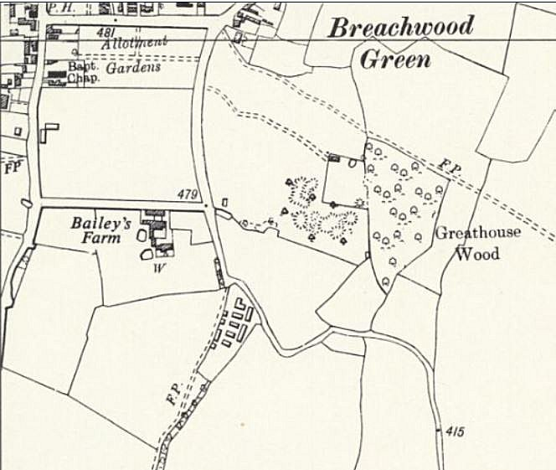
 | Ordnance Survey 1960

