Camp 1026 Raynes Park Camp, Bushey Road, Wimbledon, Surrey

1947 Camp List
1026(G.Wkg.Coy) | L.D. | Raynes Park Camp, Bushey Road, Wimbledon, S.W.20 | Liberty 5479 | 17 | V/1270/4

Prisoner of War Camps (1939 – 1948) - Project report by Roger J.C. Thomas - English Heritage 2003
OS NGR | Sheet | No. | Name & Location | County | Cond’n | Type 1945 | Comments
TQ 230 687 | 176 | 1026 | Raynes Park Camp, Bushey Road, Wimbledon | Surrey | 5 | German Working Camp | Precise location not identified. NGR for approx centre of Raynes Park.

Location: The camp was located in Prince George’s Playing Fields off Bushey Lane. Centred NGR TQ 2346 6889. The map may show the camp at the top of the field as these small buildings do not appear on pre-war or later maps. In a letter from the camp commandant in August 1946 the address was given as – ‘Raynes Park Camp, 18 A.A. Site., Bushy Road, London, S.W.20.’  Before the camp: Playing field. Anti-aircraft site.  Pow Camp: One memory of the camp was about Italian pows being held there prior to 1946.  Nissen huts.  20 July 1946 – pow Camp 681 at Kempton Park closed, and the staff and German pows were transferred to Osterley Park (460 pows) and Raynes Park (500 pows). Osterley was regarded as the HQ with Raynes Park classified as a hostel. This was only a temporary arrangement as the two camps were being set-up.  23/25/26 July 1946 – Mr R A B Young visited Osterley Camp (681) to carry out a Survey of Re-education – he also visited Raynes Park. Strength at Raynes Park: 500 ORs.  OC – Captain W G French.  Camp spokesman - O.Fwbl Koch (B+). This was Gottfried Koch who was previously Deputy C/L at Camp 681 Kempton Park German Working Camp.  There were limited re-education activities due to the change of location.  August 1946 – political screening visit to Osterley Camp 681 and Raynes Park. Strength at Raynes – 600 ORs. | 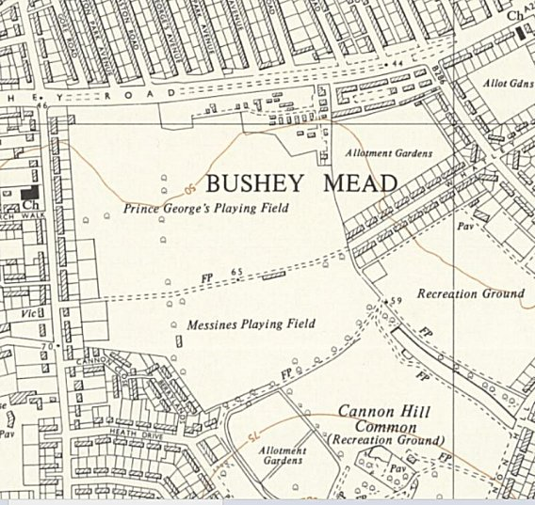
 | Ordnance Survey 1957

Political screening: | A+ | A | A- | B+ | B | B- | C | C+ | Not known
 | 4 | 69 | - | 162 | 283 | 61 | 13 | 2 | -
(Figures add to 594, not 600)

Camp Leader at Raynes Park: Gottfried Koch.

11 of the Raynes Park pows were stationed at Wimbledon. From other notes for Osterley Park – they were probably at the Beltane School – a special interrogation centre for German scientific and technical personnel.

Raynes Park was listed in this report as a hostel for Osterley, but this was a temporary arrangement as Raynes soon had its own separate administration as Camp 1026.

17 June 1947 - There was a brief description of the camp and detail of when it closed: “Recently, it has been used to house 500 prisoners of war who have been doing essential work, and for whom there was no other accommodation. When I tell the House that the extent of this camp is 33 Nissen huts, it will become apparent that it is not under-populated with 500 prisoners of war. The prisoners of war were evacuated from this camp permanently at the beginning of April.” [Hansard, Commons, 17 June 1947, Vol 438].

There was a camp magazine – Die Glocke Von Raynes Park 1026 (The Bell of Raynes Park 1026). One copy described as 10 pages of duplicated typescript with some cartoons.

After the camp: Used by squatters after the war, then arrangements made for them to live here officially on a temporary basis. The camp was demolished c1957.
Further Information:
National Archives – FO 939/330 – 1026 Working Camp, Raynes Park Camp, Bushey Road, Wimbledon, London SW20. Dated 1946-1947.
IWM have a copy of the magazine dated February 1947. Ref LBY E.J. 362

