Camp 562 & 681 Osterley Park Camp, Wyke Green, Isleworth, Middlesex

Included in the 1945 ICRC Camp list – Labour Camp. 562. Osterley Park Camp, Isleworth, Middlesex.

1947 Camp list
681(G.W.Coy) | L.D. | Osterley Park Camp, Osterley, Middlesex | Hounslow 6163 | 17(W.O.) | V/1270/4

Prisoner of War Camps (1939 – 1948) - Project report by Roger J.C. Thomas - English Heritage 2003
OS NGR | Sheet | No. | Name & Location | County | Cond’n | Type 1945 | Comments
TQ 1517 7795 | 176 | 562 | Osterley Park camp, Wyke Green, Isleworth | Middlesex | 4 |  | 19 gable-roofed huts and a pair of parallel dining hall with a central kitchen range (24ft-span Nissen). See Camp no.562/681.
 |  | 681 |  |  |  | German Working company

Location: Various traces found around the spot marked ‘x’ in a field known as ‘Triangular Clump’.  TQ 1506 7784 – brick footings from a barrack block  TQ 1508 7778 – slight earthworks defining edge of pow camp.  Before the camp: Georgian country house and estate. For a short time from mid-1940 to 1941 the grounds were used for Local Defence Volunteer training.  Pow Camp: Opened in 1943 for Italian pows, then from mid-1946 held German pows.  The camp was listed as an Italian Labour Battalion under the London District Command area in May 1944, (WO 32/10737) with the camp number 562.  NT Heritage records – “Oral testimony suggests that the Italian POWs were accommodated in tents in the western half of the field, whilst the German POWs were housed in a more permanent camp, consisting of barrack blocks, in the eastern half of the field. Examination of aerial photographs at the NMR (Swindon) suggests that the buildings forming the German POW camp consisted of approximately 14 huts arranged in a rather ad hoc manner in the north-east corner of the field. Comparison of photographs suggests that the huts had been removed by 1955. The Italian camp had been removed at a much earlier date - 1944 (?).”  Entry from www.pegasusarchive.org: “Some of these [pows] were put to work in the Crown Cork's plant on Scotts Road, to make up for the shortages in staff owing to former workers being enlisted in the Armed Forces.  The following are the recollections of Don Fuller: "As a schoolboy during the war I spent many hours in Osterley Park with my chums. Initially the park was used as a camp for British and American troops but after the capitulation of Italy part of the park was utilised as a POW camp for Italian prisoners. The interns were allowed out of the camp and I recall, on a number of occasions, sitting near the main entrance with a group of prisoners whilst they strummed their guitars and sang of Sorento. They were issued with coarse Fairey soap to wash | 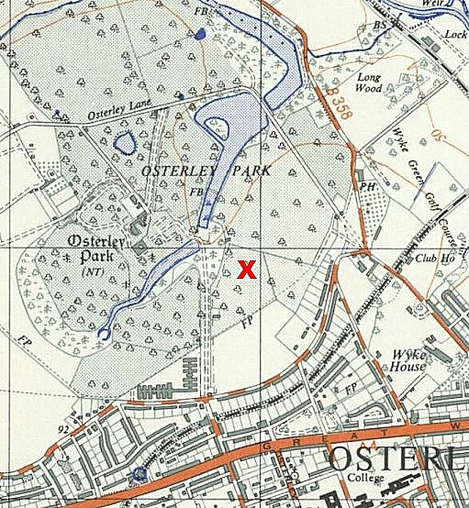
 | Ordnance Survey
with, so I used to pinch toilet soap from home to exchange for buttons and badges. Apart from the soap their only other interest seemed to be 'whether we had any older sisters' plus a longing to return to their native Italy. After the Italians left, we had German POW's who were less friendly. After a while they were also allowed out of the camp wearing dark brown clothing with a large orange circle on the back of the blouse. I only recall one being affable and I used to buy a bottle of brown ale for him from the local off licence, the licensee thought they were for my father. Finally, the camp was used to house German officers only, who were confined to the camp so my 'fraternising with the enemy' ceased."
Mid 1946 - Recollections of a German pow who was moved to Osterley at this time – “.. a park with big, old trees, surrounded by a high brick wall. Between the trees stood barracks, into which four-hundred of us moved. They had cement floors and were empty except for iron bunk beds with thin mattresses and rough blankets. The latrine was outside on a porch; under the toilet seats were tin buckets. When they were full, they were taken to a remote corner, poured in a large pan, covered with gasoline and set afire. The washrooms and showers were good, always with enough warm water at our disposal.

The English camp commandant was an older captain, a calm, almost amiable, plump little man with a typical moustache. He picked out a good-looking young fellow from our ranks to serve as his aide and all-round servant, from whom we then learned all the news of the camp and our imprisonment. During the war, this camp had been used by English soldiers who had manned anti-aircraft guns against German planes.” (From ‘German POW in New Mexico’ - Wilfried Schmid, Richard Rundell, et al – 2005 - Historical Society of New Mexico Publication Series).

It would seem from the notes above and records below that the mainly tented Camp 562 for Italians was closed down in 1945. I have seen Italian pow mail dated October 1945 – this late date may indicate that Italian pows were kept on to build the more secure German camp. The Park was re-used to site huts for Camp 681 German Working Company in 1946.

20 July 1946 – pow Camp 681 at Kempton Park (Working Company, not the Reception Camp 9) closed, and the staff and pows were transferred to Osterley Park Camp which was then re-numbered as 681. Of the 960 pows who had been at Kempton, 460 went to Osterley Park and 500 to Raynes Park. Osterley was regarded as the HQ of the two camps. Raynes Park was not at first listed as a hostel; the two camps were referred to as ‘sections’.
23/25/26 July 1946 – Mr R A B Young visited the camp to carry out a Survey of Re-education. Strength: 960 ORs of which 500 were at Raynes Park.

Commandant: Major Sanders [from the Pioneer Corps] Camp Leader: Hfwbl. [Karl] Brechtel (B+) [Previously C/L at Kempton Park]
Interpreter: Sgt Sales Deputy C/L: none
German M.O.: none

Only half of the pows had been politically screened. Overall camp complexion was stated as ‘grey/white’. “There is no communism and no obtrusive Nazi element…. There is considerable opposition to the wearing of badges of rank ‘as it is undemocratic’.”

Accommodation was recorded as being in barracks. The democratically elected committees which ran affairs at Kempton Park were retained.

Morale was recorded as bad and likely to further deteriorate. The main reason was lack of information about repatriation. 9 of the pows were aged over 50 and were said to be depressed. A suicide was recorded, but the date is unclear as to whether this occurred at Osterley or Kempton Park.

Standard list of re-education activities:

Wochenpost – 200 copies received.

Ausblick – none since January

English For All – “the greater part of the material is above the capacity of those studying”

Newspapers – Chronicle, Herald and Express at HQ. Some Swiss newspapers, irregular German papers.

Library – shortage of light reading.

Lectures – none for four weeks.

Discussion groups – due to re-start.

Films – none since 5 July.

Wireless – none at HQ, but a set being requested. There was one at Raynes Park.

Camp magazine – to be produced at Raynes Park, but the duplicator had broken down.

Press review – starting this week.

English Instruction – still disorganised after the move.

Other activities:

Religion – protestants had a resident padre (Kuhne B+). A RC padre was being arranged. Bible classes were held at Osterley.

Education – classes to be resumed: French, Russian, maths, natural history, economics, arithmetic and book-keeping. Problems with a lack of accommodation for classes.

Theatre – being re-organised.

Orchestra – instruments needed for orchestra at HQ. Choir taking place at HQ.

2 – 6 August 1946 - 5 members of the Segregation Section visited Camp 681 Osterley Park and Raynes Park to look at political screening of the pows. Strength – 1078 ORs – 478 Osterley / 600 Raynes Park.

Commandant: Major F J Sanders Camp Leader: Hfwbl. [Karl] Brechtel (A) [Previously C+, then B+].
Interpreter: Sgt Sales (R.E.M.E.) Deputy C/L: none
German M.O.: none

Political screening: | A+ | A | A- | B+ | B | B- | C | C+ | Not known
 | 2 | 59 | - | 124 | 176 | 51 | 9 | 1 | 56

Raynes Park was listed as a hostel for Osterley in this report, but this was to be a temporary arrangement as the camps were set-up. Raynes soon had its own separate administration as Camp 1026.

Most of the pows were from Kempton Park Working Company and other UK camps – some had come from the USA and camps in Belgium and Germany.

Pows from Kempton Park had already been part of a camp with a democratic committee and wide-ranging re-education activities. Many of these pows had been re-assessed and politically upgraded – “no more that 5% are still tainted with Nazi ideology. A strong anti-communist view prevails in the camps despite the presence of a fair sprinkling of old members of the K.P.D.” [Kommunistische Partei Deutschlands].

17/18/30 December 1946 – R A B Young visited to conduct a Survey of Re-education. Strength – 1 officer; 428 ORs.

Raynes Park was no longer listed as a hostel, having its own administration.

Included in the 429 pows –
12 were detached at 1020 camp. [Shooter’s Hill, London]
22 were detached at 669 camp. [West Ridge Camp, Greenford, Middlesex]
11 were detached at Beltane School, Wimbledon. [Special interrogation centre for German scientific and technical personnel].

Commandant: Major F J Sanders Camp Leader: O/Fwbl Nonnast (A)
Interpreter: Sgt Sales (R.E.M.E.) Deputy C/L: none
German M.O.: Trupp/Arzt Januschke (B).

Screening figures: | A | B | B+ | B- | C | Unscreened
 | 4 | 189 | 119 | 43 | 24 | 50

72 pows were appealing against their grading and more were expected – lower grades resulted in earlier repatriation. 67 pows had been repatriated to date.

The new camp leader was described as; “Active soldier; bright and an asset to re-education. Has full confidence of Commdt. And support of German staff and P/W”.

Morale was recorded as: “steady with a tendency to fall.” Negative aspects were conditions in Germany and slow repatriation.

Standard re-education activities:

Wochenpost and Ausblick – separate appendix.

Newspapers – A range of English papers. Some Swiss newspapers and German papers. A reading room was being prepared.

Library – shortage of light reading books – as before.

Lectures – regular.

Discussion groups – regular, organised by a democratic committee.

Films – adequately served.

Wireless – one camp wireless and four having been made by pows.

Camp magazine – a 25-page monthly magazine with a print run of 100. Editor – Schaefer (A). There was a shortage of paper and stencils.

Press review – weekly organised by Paul Alex. 50/60 average attendance.

English Instruction – separate appendix.

Information room – none, but interest shown in developing one.

Other activities:

Religion – protestant padre (Kuehne A) and a visit to the local church every three weeks. A camp church was under construction. RCs visited a local church every Sunday. There was also a lay reader, Heecke (B) who “does good work in the camp”.

Education – classes: French, Spanish, maths, business training; carpentry (to start). Pows were being urged to start more classes for other subjects.

Football matches were played including some against other camps.

An excellent theatre group of 10/12 pows. Operettas had been produced and visits made by 1003, 1020 and 1026 pow companies. 35 pows visited Camp 1003 to see a play there.

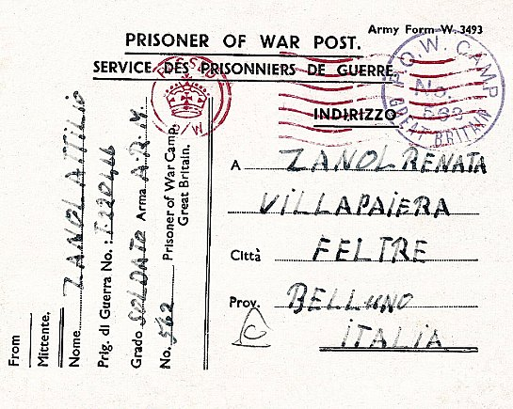 | Postal items seen –  <<< As camp 562 postcard 25 October 1945 to Italy  As camp 681 letter-sheet 28 December 1946 to Germany.  After the camp: Camp demolished between 1955 and 1960. 2020 site owned by the National Trust. Some evidence of the camp remains including concrete fence post and gates, concrete base, brick footings and earthworks.  Further Information:  https://heritagerecords.nationaltrust.org.uk/HBSMR/MonRecord.aspx?uid=MNA130450 – map and archaeological references.  FO 939/323 – 681 Working Camp, Kempton Park Camp – dated 1945-47 (This file also contains records for Osterley / Raynes Park - Used above).

