Camp 274 Errol Airfield Camp, Errol, Perthshire

Prisoner of War Camps (1939 – 1948) - Project report by Roger J.C. Thomas - English Heritage 2003
OS NGR | Sheet | No. | Name & Location | County | Cond’n | Type 1945 | Comments
 |  | 274 | Errol Airfield, Errol | Perthshire |  | German Working Camp | Scotland

Location: On the N bank of the Firth of Tay between Perth and Dundee. The Canmore site gives NGR NO 27200 24270 which is the middle of the airfield.  Before the camp: Farmland. Airfield opened in 1943 as an RAF training unit. At the end of the war the site was used by No.260 RAF Maintenance Unit as a storage area until the summer of 1948.  Pow Camp: No record of Italian pows.  Probably opened late 1945 with German pows.  References to German pows being used to help load and unload Douglas Dakota transport aircraft after the end of the war and up to 1948.  April 1947 – recorded as a hostel (see Balhary Camp 3 / 63) until closure in Spring 1948.  January 1948 - being used mainly as a transit camp prior to repatriation  After the camp: Mixed small businesses.  Further Information:  National Archives FO 1120/240 – Re-educational survey visit reports for camps 266 to 276. Dated 1 January 1946 – 31 December 1948  Canmore - http://canmore.org.uk/site/30473 | 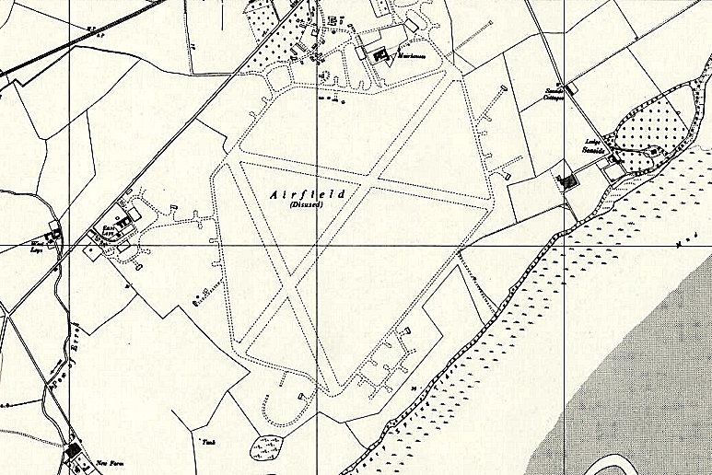
 | Ordnance Survey 1958

