Camp 30 - Carpenters Road Camp, Stratford, London E15

Included in the 1945 ICRC camp list – Labour Camp. 30. Carpenters Road Camp, Stratford, Ldn E15.

1947 Camp List
30(G.W.C.) | Carpenters Road Camp, Stratford, London, E.15 | LD. | Priswar, Stratford London | Amhurst 6161/2 | Stratford | Lt.Col.R.H.Haswell, M.M. | v/1453/2

Prisoner of War Camps (1939 – 1948) - Project report by Roger J.C. Thomas - English Heritage 2003
OS NGR | Sheet | No. | Name & Location | County | Cond’n | Type 1945 | Comments
TQ 38 84 | 177 | 30 | Carpenters Road Camp, Stratford, London E15 | London | 5 | German Working Camp

Location:  POW Camp: Possibly opened 1944 - Italian pows were certainly recorded in April 1945 when an Interpreter Officer was recorded as being transferred from Pabo Hall Camp 119 to an Italian labour Battalion here.  Italians replaced by German pows during Summer 1945.  Oral history of pow Albert Arndtz at Carpenters Road and Chingford hostel – Reels 10 (from c.11’00”) and 11 - www.iwm.org.uk/collections/item/object/80028273  Talks about his time at the camp, describes the site, building sites at Romford and Chingford, making ships in bottles (and other toys) to sell in order to get sterling rather than camp money, going outside the camp, repatriation.  Oversight and development of re-education activities and English teaching for German pows was carried out by PID (Political Intelligence Department of the Foreign Office) / COGA (Control Office for Germany and Austria – UK). Visits and reports were made. The standard of the reports varied greatly. The visitors took little interest, if any, in activities other than re-education. They rarely mentioned welfare, sports, games, pastimes, crafts, etc of the pows.  1946 – at some point the British staff moved to be based at the Lippits Hill pow hostel where conditions were far better – however, Carpenters Road remained the main HQ camp. | 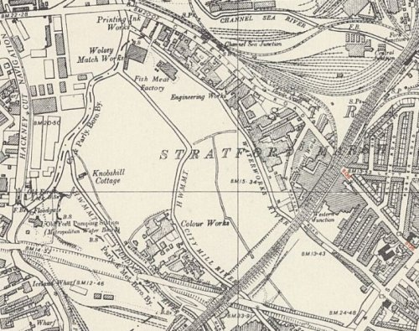
 | Ordnance Survey 1951
8 February 1946 – Mr J H Dagnall inspected English teaching at the main camp and the hostel at Woodford. He gave a brief report.

The English teacher was absent attending a course at Wilton Park Camp 300, and lessons had ceased. There was very little interest in learning English shown by the pows. The Interpreter Officer pointed out that many pows were involved in constructing pre-fabricated homes some distance away in Essex – the pows were then too tired on their return to the camp to begin studies.

31 July 1946 – Mr Dagnall returned. Total strength – 2545 at main + 8 hostels.

Commandant: Lt Col Haswell Lagersprecher: Schmidt

There were just 3 classes with 34 pupils studying English in the main camp. The camp and hostels were short of teaching equipment. The inspector regarded the British Staff to be; “non-co-operative as far as English studies are concerned.” He went on to state that in general; “The Camp feeling seems none too happy.”

“The camp has the misfortune to be in the East End, surrounded by chemical factories. The air is never free from the stench and both Staff and prisoners suffer accordingly.”

Many of the pows had been transferred from the USA and Canada. Pows from the USA had been incorrectly informed in the States that they were to be returned to Germany – on finding out this was not the case their morale was very low. Pows from Canada had mostly been captured in the earlier years of the war – many were regarded as politically C class – ‘Nazis’.

22 July – 10 August 1946 – A survey / revision, of political gradings was carried out by ‘Messrs Dixson, Wohlrab, Bontemps’ from the Segregation Section.

Commandant: Lt Col R H Haswell R.A. *Chief Camp Leader: Ob.Feldw.Kroetke Martin A+
Interpreter: Captain A Heathcote *Lagersprecher: Feldw Schmidt Herbert A+

* The Chief Camp Leader was the German pow representing all the sites (HQ and hostels) – the Lagersprecher, was the spokesperson at the Carpenters Road Camp.

Political screening:

A+ | A | A- | B+ | B | B- | C | C+ | Not known
7 | 56 | 0 | 318 | 1458 | 368 | 237 | 27 | 32
[Total = 2503; 1 pow seems to be missing as the strength was stated as 2504]

There was a clear clash between the visitors and the British staff: “Our reception was openly hostile. The Commandant said that he thought that screening was utterly useless and a waste of time and also that we were utterly incompetent. He knows no German, and has little knowledge of the German political scene; he, however, claimed to be an expert at knowing ‘his Germans’.”

There was also a clash with the I.O. who was; “…obstructive, discourteous and inefficient” – and if that was not bad enough – “He knows no German.”

The Commandant and IO were recorded as having a complete lack of interest in re-education. This was not uncommon, however in most cases when this occurred the Commandants paid lip-service to the ideas and activities, and then ignored them. A hostile reception was not usually shown, even if felt. It demonstrates the weakness of the visitors sent by COGA (Control Office Germany and Austria – London), a Foreign Office department – while the camps were under the control of the Ministry of War and others whose priority was not re-education, but controlling and utilising the pows as additional manpower).

The Chief Camp Leader (Oberlagerfűhrer) was described as – “A most outstanding personality. Very keen and efficient in his job, which he had been doing for over a year…. Speaks excellent English and is really democratic in outlook. His intelligence and education are excellent.” Aged 31, a forester – “spent four years in Jersey”, but it does not say if this was before or during the war.

The Camp Leader (Lagerfűhrer) – aged 32, was a - “merchant of Jewish antecedents. A fervent anti-Nazi, and keen democrat. He is more politically conscious than Kroetke, though lacks his personality. The two are close friends and both exercise a very healthy influence in the camp.”

The Camp Doctor, Silvester Hansen, aged 31, was politically graded as C. “A most unsatisfactory personality. Born in Copenhagen and only took up German nationality in 1936… he is impregnated with Nazi racial doctrines and is a great believer in the superiority of the Nordic race. …he believes in euthanasia and sterilisation. He is a bad influence in the camp.” He was not replaced until he was repatriated in the final months of the camp.

Overall morale was recorded as ‘somewhat low’ – the main reasons being; uncertainty of repatriation, lack of news from home, and “The extraordinary unpleasant situation of the main camp.” I think this meant the environmental situation, rather than the situation created by the Commandant. Pows from the Russian zone were particularly anxious.

31 December 1946 – 6 January 1947 – a further visit by members of the Segregation Section, A Frank and J M Crouch.

The principal objective was to hear appeals against political gradings - the better the grading, the sooner repatriation would occur. 162 appeals were heard, mainly from those graded ‘C’, resulting in 112 up-gradings and 1 down-grading, (49 unchanged).

There were no changes to senior British or German personnel.

Reception by the Commandant was described as “hostile in the extreme.” With nearly 70% of appeals upheld, he would no doubt have felt vindicated about his attitude towards screening. (This was actually a low %, in many camps 100% of appeals were successful).

The section on the report about re-education was not surprisingly highly critical; “Here we must make the severest statements. Re-education is virtually non-existent in all the hostels.” One pow stated that, “he had the impression that political re-education is suppressed by the commandant.” There were no arrangements for young pows who were, “left to rot in their Nazi stew.” The visitors had the impression that, “re-education was viewed with cynical contempt as intellectual rubbish by the Commandant and the I.O.”

Another pow complained of the lack of books and newspapers, and went on to say; “He hears it said among the youth [under-25] at Fairlop Hostel that they would like to carry out sabotage in Germany and to work up an underground movement in Germany against the occupying powers.”

Despite the ‘severe’ statements – very little would change. The Commandant’s lack of co-operation was not necessarily bad for the pows, it depended on his attitude towards other activities and their overall welfare. Education courses, (e.g. maths, history, technical courses, etc.), sport and entertainment were all regarded as separate from the activities that made-up ‘re-education’. Some Commandants managed very ‘happy’ camps with a wide range of courses and activities for the men, but paid little attention to re-education, much to the annoyance of visitors from the Foreign Office. Some left it entirely up to interested British staff to develop activities. However, in this instance – and especially with a non-German speaking, negative I.O. - there is little evidence of other activities taking place. The visitors talk of “neglect and indifference”.

8 days January and February 1947 – R A B Young carried out a Re-education survey. Total strength - 2 officers; 1941 O.R.  No changes to the senior British or German staff. Recommendations had been made for the non-German speaking Interpreter to be removed, but he was still in place, and would remain so until the camp closed. The German M.O. previously recommended for transfer was also still in place.  Simplified screening figures were being used by this date: A – 14; B- 1776; C – 153. The visitor believed that if they were rescreened, 2-300 B category pows would be reclassified as A.  The visitor was received with less hostility from the Commandant, however the I.O. continued to raise, “the usual querulous criticisms” of COGA.  Morale was recorded as exceptionally low. The main reason given was that the Commandant had given an, “optimistic announcement” last October that all pows would be home in 6 to 9 months, whereas repatriations were proceeding very slowly. “The men blame their extended retention on Britain’s man-power shortage” – they were totally correct to do so, that is exactly why repatriations were slow.  Other complaints included lack of work, (no work, no pay), and harsh treatment by civilian employers. With no work, | 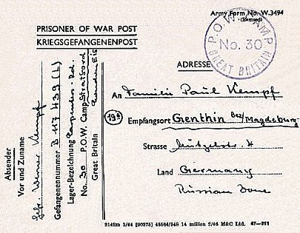
 | POW Postcard – January 1947
the camp welfare fund, usually built up from the sale of goods to pows, was nil. The welfare fund was supposed to be used for buying books, papers, etc. and subsidising additional food.

50-55% of the pows were ‘youth’ (under-25). There was no record of any special provision for these pows.

There were few re-education activities, but there were some signs that the Commandant was prepared to be less obstructive. The standard list of activities was given:

Wochenpost and Ausblick – separate appendix.

Newspapers – 20 English papers a day were sent to the main camp by COGA – and then passed on to hostels up to 3 days late and often with interesting articles cut out. Even this unsatisfactory arrangement was due to end - pows would then have to depend on British staff passing on occasional papers. Some German papers were obtained, but the hostels only received 2-3 copies for a couple of days.

Press reviews – only at HQ and Chingford. The visitor hoped to encourage more to start up.

Library – No description of the library at the main camp. The hostels sometimes received a box of about 80 books to be kept for 6 weeks – the interval between receiving these boxes was up to 10 weeks, and in one case (Woodford) 6 months went by without any books. The books themselves were criticised as not just old and uninteresting, but some were for children.

Lectures – these were taking place, but attendance was declining. It was recommended that lectures about the current state of Germany should be given.

Discussion groups – it was hoped that groups would be developed using materials sent to the camp and its hostels. This stimulus would then lead to discussions about various topics concerning Germany’s future. The visitor believed that the hostels would take up this idea, but not in the main camp – “Here I ran up against complete apathy, and no arrangements were made.”

Films – Films from the YMCA and Gaumont British at the main camp, but irregularly at the hostels. Gaumont films charged 6d and were therefore not watched by many.

Wireless – satisfactory throughout, excepting Chingford which had some difficulties with reception. The 19.00 BBC news in German was the most popular transmission.

Camp magazine – 225 copies of a 16-page publication. Regarded as too highbrow by some pows, the visitor however, thought it was well-balanced.

English Instruction – separate appendix.

Information Room – One at Chingford. The Commandant had promised to cooperate with setting up more.

Other activities –

Religion – Though there were churches, (converted huts) at all sites except Woodford, they were little used as pows were able to attend local churches. The Protestant and RC padres from Capel House Camp 1003, (Enfield), regularly visited the hostels.

Education – Some classes at Chingford and Breaches.

Entertainment – no entry. Later reports would indicate that there was an orchestra/band and possibly a theatre group.

Mr Young made recommendations for the supply of lectures and films (to Breaches), reports on events in Germany, English and German newspapers, information pamphlets for discussion groups, at least 400 books, and stationary for education work.

24/25 March 1947 – English Inspector’s Report by Mr C M Griffiths. Total strength 2043. Main camp + 7 hostels – all pows in hutted accommodation.

Commandant: Lt Col Haswell Lagersprecher: Kroetke

In the main camp there were just 2 classes teaching English to 27 pupils.

April 1947 – a new Commandant started, Lt Col Paul

1 May 1947 – a new main camp leader, Karl-Heinz Mueller, (formerly hostel leader at Edmonton) was appointed by the Commandant. The previous leader, Martin Kroetke was to settle in England.

Morale at the camp was seen to be improving – mainly due to more rapid repatriations and the regrading of some pows from C to B. Another positive factor was developing good relations with the local area – pows were given more freedoms and invitations to people’s homes and events were increasing. They were largely indifferent to politics and many were cynical of democracy. Pro communist feelings were being weakened with news from the Russian zone of Germany.

About 30% of pows were under 25 in the main camp – there were higher figures in some of the hostels. No difficulties were observed with these pows. There had been an attempt to set up a youth group, but it had proved unpopular.

There were some, small signs of improvement in activities. Some pows had attended Leyton Council Meetings. There were theatre groups at main, Edmonton and Victoria Park. The camp band and choir performed at churches and ‘other places’.

Football matches had been played against local teams. West Ham FC had placed a block of 50 seats at the disposal of the pows. Leyton Orient FC had also been visited.

Links were established with the Quakers, Salvation Army, Elin Chapel and several other organisations.

24/25 July 1947 – English Inspector’s Report by C M Griffiths. Total strength 1978 at main + 6 hostels.

There were 3 classes for just 14 pupils in the main camp (71 pupils for all sites) – “despite the heavy smells in the air from the local manure factory, chemical factories and perfume factory; these smells being almost too much for the unaccustomed nose in the hot weather.”

6 days, late August 1947 – Major P J O’Donohoe conducted a re-education survey. Total strength 2 officers, 880 OR.

Commandant: Lt Colonel C R Paul, R.A. Camp Leader: Mueller, Karl-Heinz, Fw (B+)
Interpreter: Capt A G D P Heathcote, R.P.C. Deputy C/L: Buhlig, Rudolf, O/Masch (B)
German M.O.: Hass, Guenter, O/Arzt (B)

Screening figures; A – 1 / B – 880 / C – 1 (and he had escaped!).

88 pows had been repatriated to date, of these; White (A category) – 2 / Groups – 60 / Unfit – 9 / Compassionate – 16 / Specials – 1.

[“Groups” not explained, but usually those required by COGA as specialists or with skills needed as workers back in Germany; Compassionate was usually for those with elderly, sick or injured relatives; “Specials” not explained, but often sent back for trial or investigation.]

During the time of these visits, the strength of the camp was reduced from 1134 to 882. The hostels at Edmonton, Fairlop and Victoria Park had closed with just ‘holding parties’ remaining - this could be for various reasons; sometimes a small group of pows remained on site so that squatters were unable to move in, at other times the pows were utilised to dismantle the camp. Many of the pows had been transferred to camps in Scotland. There was talk about amalgamating this camp with Wormwood Scrubs Camp 32 – this did not happen.

Improving morale within the camp was disturbed by the transfer of pows, especially those sent to Scotland. Although repatriations and increased freedoms were positive factors, a view was expressed that being kept, “to secure maximum output in England smack somewhat of totalitarianism.”

The standard list of re-education activities was given, but little had changed from the report given at the start of the year. Some of the few activities that were taking place were closing down due to repatriations and the transfer of pows. Information rooms had been set up in the camps remaining open, and exhibition materials had been sent from COGA – with titles such as ‘British Parliament’.

There were no other education classes other than for English. The orchestra was continuing and gave some outside performances.

Outside links were being developed. Small groups attended local borough council meetings. Some links and visits had been created with The Society of Friends, YMCA, British Legion, Chingford Catholic Community and the Baptist Church in Waltham Abbey. Outside links and friendly contacts with local civilians had a major positive effect on morale in camps when they occurred.

7-10 October 1947 – J C Milner conducted a Re-educational Survey. Total strength – 2 Officers, 678 OR.

The only change to senior staff was a new deputy camp leader – Uffz. Paul Schaedlich (B)

Screening figures were barely in use by this time; A – 2 / B – 678.

The relationship between the Commandant and visitors was far better than under the previous Commandant. However, that is not to say the re-education activities were being pursued. Commandant Paul admitted that he was only concerned with the discipline and satisfactory work of the pows – but at least he was not openly hostile.

Morale was again considered to have improved, partly due to many outside activities and contacts with civilians.

There was little change to re-education activities – discussion groups had collapsed through lack of interest. English classes were only being held at Breaches.

The orchestra continued to play at outside venues including Leyton Public Gardens, and at Leyton and Stratford Town Halls. Football was played at the two hostels, but the football pitch shared by the main camp and Victoria Park had closed down.

14 November 1947 - Camp number included in an ‘Urgent Memorandum’ (FO 939/270) regarding inspection of food parcels.

27/28 November 1947 – English Inspector’s Report by C M Griffiths. Total strength 519.

No English classes in main camp as the instructor was attending a special training course at Wilton Park Camp 300. No lessons at Lippits Hill, 1 class of 10 pupils at Breaches.

Reception of the visitor by British staff was recorded as being, “Fair only” – I wonder if they considered this visit to be a waste of time with just 10 beginner pupils at 1 hostel?

Chingford hostel was closed, but expected to re-open on 2 December with 650 pows. There was a rumour that the pows would be, “employed in Post Offices to deal with Xmas post etc.”

“Ps/W in the main camp go out almost every evening in response to invitations and indeed they are wise in trying to get away from the smells of Yardley’s factory [the perfume factory] which battles for supremacy with the smells of the fish manure factory.”

The attitude of the British staff to re-education and English Instruction was recorded as; “…little co-operation here; that is plenty of the letter but little of the spirit.”

16 March 1948 – C M Griffiths returned for another English Inspection. Total strength 526.

No change to senior staff.

No classes at main camp or the hostel. The camp did have a telephone, so why did this visit take place?

The history of lack of co-operation for re-education was amusingly summed-up; “On the whole this has been a smelly and disappointing camp.”

22-25 March 1948 – a final visit to survey Re-education, and to sum up the ‘outlook’ of the pows. Total strength; 1 officer, 576 OR.

Changes to senior British and German staff – new deputy camp leader, Heil / new German M.O. Stabs/A Fertmann.

Just for once the report was fairly positive – though dubiously so. The reception was, “cordial and cooperative”. “The Commandant has the right idea for this closing phase, and with 80% of the men in the heart of London amongst friendly and sympathetic civilians, the position leaves little to be desired.”

A general survey of pow attitudes towards the British was carried out. The methods that were used make the results extremely doubtful, but;

- 0% pows were recorded as hating the British.

- 10% disliked the British. This included 20 pows transferred from Hardwick Heath Camp 260 who were very unhappy stating they had been promised to be sent to a transit camp prior to repatriation, instead they were expected to do farm work. The pows who had been transferred from camps in the US blamed the British for their continued detention - the visitor tried to explain that the British had not been to blame. The last groups were pows who had been unfairly treated at workplaces and, “men whose captivity has unnerved them for a variety of reasons.”

- 10% distrusted the British. A comment from the visitor was; “Mainly self-informed types who read an ulterior motive into most of our conciliatory moves.” Others saw ‘The Hypocritic Englishman’”. Some made references to Niemoller’s alleged statement in New York that 6 million German civilians had died of hunger since the capitulation.

- 15% were indifferent towards the British.

- 25% would give the ‘benefit of the doubt’ towards the British. Within this section of the report, pows commented that,
  - “Who could like the British after they have retained us as slave workers for three years after the end of the war?”
  - “England is keeping Germany short of food”
  - “We have been grossly underpaid”
  - “We were wrongly screened whereas the SS men all went home”

These comments hardly sound like ‘giving the benefit of the doubt’.

- 45% liked the British. The most positive impact on pow attitudes was the friendliness of the civilians and the “healthy outlook” of the current Commandant.

The camp was expected to close within the next 2 to 3 weeks.

Known Camp Commandants:
1945 - ?
c.1946 - 1947: Lieutenant Colonel R H Haswell, R.A. M.M.
1/5/1947 – close: Lieutenant Colonel C R Paul, R.A. from the Royal Artillery.

Camp numbers:

 | Open |  |  | With other camps |  |  | Unknown |  |  | Not listed / not open

 | 1945 | 7/46 | 8/46 | 2/47 | 3/47 | 7/47 | 8/47 | 10/47 | 11/47 | 3/48 | 3/48 (2)
Main |  | 558 | 596 | 273 | 418 | 271 | 314 | 277 | 204 | 361 | 345
Breaches |  | 283 | 273 | 140 | 165 | 105 | 106 | 246 | 152
Chingford |  | 401 | 364 | 325 | 321 | 314 | 308 | 7
Edmonton |  | 400 | 390 | 360 | 337 | 319 | 10
Fairlop |  |  | 171 | 311 | 263 | 259 | 8
Lippitts Hill |  | 201 | 196 | 133 | 168 | 152 | 125 | 150 | 163 | 165 | 182
Victoria Park |  | 265 | 304 | 240 | 241 | 158 | 11
Woodford Park |  | 203 | 200 | 161 | 130
Wanstead Flats |  | 10 | 10
Chelsea Barracks |  |  |  |  |  |  |  |  |  |  | 50
Total |  | 2545 | 2504 | 1943 | 2043 | 1978 | 882 | 680 | 519 | 526 | 577

After the camp: Mainly industrial use. Later became part of the London Olympics site.

Further Information:

National Archives FO 939/114 30 Working camp, Carpenters Road Camp, Stratford, London E15 – dated 1945-48. Used above.

Catalogue entry - 14 - Church Book of Camp No. 30 - 1945-1947

Hostels

Breaches (Waltham Abbey) – 13 miles from the main camp. Described as difficult to reach in one report.

Location - At the end of Breaches Barn Lane at TL394 021 - where there is now a farm called "The Breaches".  The 1960 OS map, right, shows the area at Site B which looks like a possible camp, possibly a previous anti-aircraft site?  Information received from Waltham Abbey Historical Society: “I was told by the previous owners of our house 23 years ago that there was an Italian prisoner of war camp opp Dalance farm by the Breach Barns turn off from Galley Hill. You can still to this day see the tops of the 1940’s huts as you drive up Galley Hill and see them on Google maps…. The base of the water tower supplying the camp can be reached easily from the road.”  August 1946 – Hostel leader, Oberfeldw Eder, classed as B+, aged 32. “..professional soldier. Completely non-political, but a good type and a reliable hostel leader.”  December 1946 – The hostel was largely ignored by the Commandant and his staff - “Again, no interest shown by camp authorities.” A lack of books was recorded.  February 1947 – Hostel leader, Hefter, Heinz, O/Fw (B+) – “Has anti-British bias; politically sound, but unlikely to exert himself in the furtherance of re-education.” He remained as hostel leader until this site closed.  About 40% of the pows were under 25. | 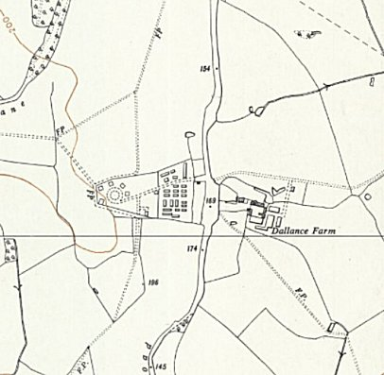

 | 1945 | 7/46 | 8/46 | 2/47 | 3/47 | 7/47 | 8/47 | 10/47 | 11/47 | 3/48 | 3/48 (2)
Breaches |  | 283 | 273 | 140 | 165 | 105 | 106 | 246 | 152

Chelsea Barracks
March 1948 – Just the one listing. Hostel leader, Bube. The 50 pows were described with a pretty appalling joke as; “the most contented I have yet met. They are on British army rations and, receiving two eggs a week, are probably the only Ps/W in Britain who are attracted by the foreign yoke.”

 | 1945 | 7/46 | 8/46 | 2/47 | 3/47 | 7/47 | 8/47 | 10/47 | 11/47 | 3/48 | 3/48 (2)
Chelsea Barracks |  |  |  |  |  |  |  |  |  |  | 50

Chingford – 9 miles from the main camp. NGR TQ 388 950  “I remember a Prisoner of war camp near to the school behind barb wire. inside this, were Italian prisoners of war.” BBC WW2 People’s War  Although the records for German pows start in 1946, the hostel was certainly in use during 1945 – COGA did not review Italian camps.  August 1946 – Hostel leader, Oberwachtm Gogg. Aged 28, B-. “A typical RSM of the tough school. Non-political and unintelligent. The least satisfactory of all hostel leaders.” He was later described as, “Stolid, solid, unimaginative, reliable.” He was listed as leader until August 1947, (possibly up to the closure of this site).  December 1946 – 384 pows. A general education society (Kosmosgesellschaft) was organised by one of the pows, but he complained; “bitterly of a lack of support on the part of the camp authorities. The I.O. has been to visit this hostel once only in 8 months….” A poor supply of books was also recorded, and there was no evidence of other education activities taking place. |  | 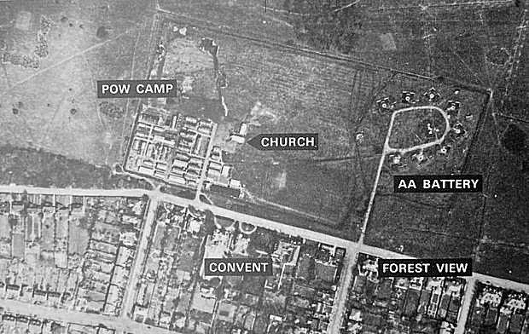  Pictures obtained from guardian-series.co.uk
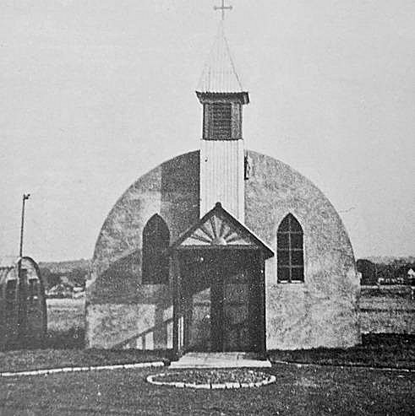
1947 – A high percentage of the pows, about 60%, were under 25.

May 1947 - Some pows attended local Council Meetings.

November 1947 – the hostel was closed, but expected to re-open on 2 December with 650 pows. There was a rumour that the pows would be, “employed in Post Offices to deal with Xmas post etc.” If the hostel did re-open, it was only for a brief time.

March 1948 – it was recorded that Chingford had closed before this date.

 | 1945 | 7/46 | 8/46 | 2/47 | 3/47 | 7/47 | 8/47 | 10/47 | 11/47 | 3/48
Chingford |  | 401 | 364 | 325 | 321 | 314 | 308 | 7

< Camp chapel built from adapted Nissen hut.

The site now – Chingford Golf Course.

Edmonton – 8 miles from the main camp.  Location – probable - there was a pow camp at Firs Farm, alongside Edmonton Cemetery – NGR 327 936  August 1946 - Hostel leader, Mueller Karl Heinz, B+, Aged 27. “A decent type, and a competent hostel leader. Anti-Nazi, but politically immature. Speaks some English and likes England very much.” Karl Mueller later became the main camp leader.  There was a theatre group.  February 1947 – Hostel leader, Buschold (B+) – “A typical ‘B’ and unlikely to influence re-education either way.”  May 1947 – Hostel leader. Gefr. Hubert Nelles (B+) – he was here until the hostel closed. About 30% of the pows were under 25.  1945 7/46 8/46 2/47 3/47 7/47 8/47 10/47 11/47 3/48  Edmonton 400 390 360 337 319 10 | 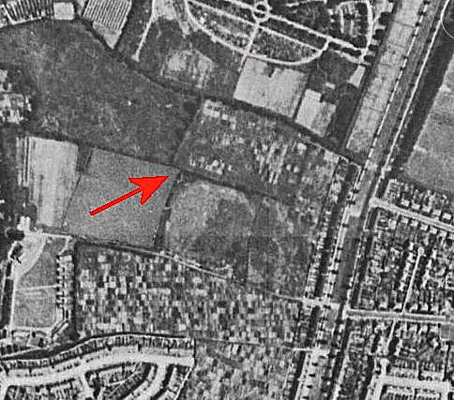
 | Possible Firs Farm Site - 1945

Fairlop – 10 miles from the main camp. Fairlop is a district in the north of Ilford.  Location – See map - The Fairlop Plain local history website places an Italian pow camp at A and the German pow hostel at site B, (previously an accommodation site for RAF Fairlop). Fairlop Plain Times (wordpress.com)  The German hostel may have opened before August 1946 and been attached to a different HQ camp.  February 1947 – Hostel leader, Wernicke (B+) – “Shows little initiative or enthusiasm; due for repatriation in March.”  May 1947 – a new hostel leader Uffz. Julius Giewaldt (B), aged 47 – he was there until the hostel closed down. The previous leader had been repatriated. About 50% of the pows were under 25.  1945 7/46 8/46 2/47 3/47 7/47 8/47 10/47 11/47 3/48  Fairlop 171 311 263 259 8  After the camp – used to accommodate displaced persons. | 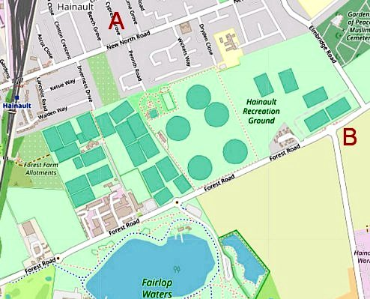
 | OpenStreetMap®

Lippitts Hill – 8 miles from the main camp. NGR TQ 398 969  Previously Heavy Anti Aircraft Battery London Ze7.  Believed to have opened in 1945 with Italian pows, later Germans.  August 1946 – Hostel leader, Feldw Kramer Fritz (B) [sic Fritz – his name was Bernhard]. Aged 33 – “Competent and good hostel leader, but completely non-political… He was formerly hostel leader in Woodford and Breeches Hostels.”  December 1946 – “No re-educational efforts whatever. PsW have organised 2 English courses and 1 shorthand course. This hostel happens to be the home of the Commandant and his officers.” This was considered to be a much more pleasant and healthy site than the main camp at Carpenters Road.  Christmas 1946 – pows were invited into local homes, organised by the Quakers and the Peace Pledge Union. The local church held a Christmas service to which pows were invited. [Further details in “The Germans we Trusted” – Pamela Howe Taylor – Lutterworth Press – 2003]. |  | 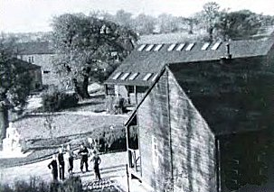
 |  | Pows in the camp c.1946 – the statue can also be seen
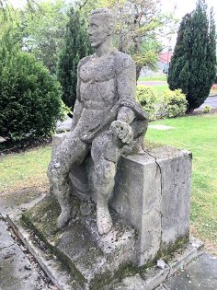 | < A concrete statue, carved in 1946 by pow Rudi Webber stands at the main gate.  February 1947 to March 1948 – Same hostel leader with continuing good reports. About 45% of the pows were under 25.  July 1947 – no English classes as the teachers had been repatriated.  1945 7/46 8/46 2/47 3/47 7/47 8/47 10/47 11/47 3/48 3/48 (2)  Lippits Hill 201 196 133 168 152 125 150 163 165 182  After the camp – acquired in the 1950’s by the Metropolitan Police.

Victoria Park – 1½ miles from the main camp.

Sited along the north east edge parallel to Victoria Park Road. Italian and then German pows.

August 1946 – Most of the Nazi C+ pows were held here. Described as a “black hostel” [Black = political category C]. Many of the pows were ex Africa Corps who had been transferred from the USA/Canada. Many of these were removed during August to a camp in Harrow.

Hostel leader, Oberfeldw Hanf. Aged 32. Despite joining the S.A. in 1933 [Sturmabteilung – aka brownshirts], he was classified as ‘A‘. “A very competent and conscientious hostel leader. Primarily non-political, he represents the better type of NCO.“

February 1947 – Hostel leader, Eder (B+) – “Helpful within the limits of his (very limited) capacity.”

May 1947 – H/L Eder was “deposed as unpopular” by the Commandant. New hostel leader, Fw Erich Loew (B) stayed here until the site closed. About 50% of the pows were under 25.

July 1947 - no English classes as the teachers had been repatriated. However, they were trying out an experiment of teaching English for 15 minutes each day over the loudspeakers.

8 July 1947 – The hostel was raised in the House of Commons:

“Mr H Hynd (MP for Hackney Central) - asked the Secretary of State for War whether camp regulations permit German prisoners of war at Victoria Park to attend the weekly Fascist meetings held at the gate of that park.

Mr Bellenger - There are no regulations forbidding prisoners of war to attend any public meetings which may be held in parks during their off-duty hours.

Mr Hynd - Does not my right hon. Friend agree that his very excellent efforts to educate these German prisoners of war into the British way of life are being frustrated by allowing them to attend such meetings?

Mr Bellenger - I should have thought that part of the education into the British way of life was to allow free speech, and to permit them to attend all meetings. I can only hope that their powers of discrimination will enable them to go along to more appropriate meetings.” HC Deb 08 July 1947 vol 439 c2011

 | 1945 | 7/46 | 8/46 | 2/47 | 3/47 | 7/47 | 8/47 | 10/47 | 11/47 | 3/48 | 3/48 (2)
Victoria Park |  | 265 | 304 | 240 | 241 | 158 | 11

Wanstead Flats  Various locations were used around the Flats for Italian / German sites. On map – ‘A’ area identified by Leyton and the Leytonstone Historical Society / B extensive area identified from 1944 Aerial photograph. |  | 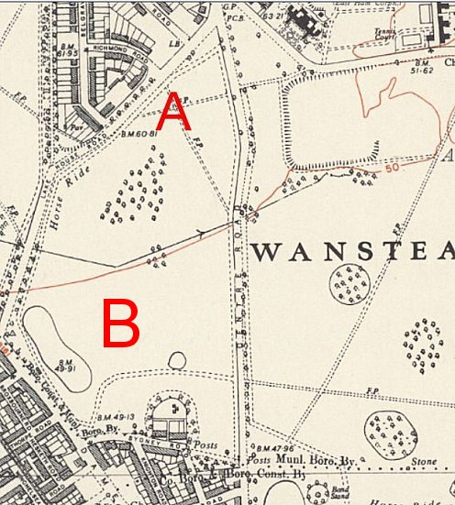
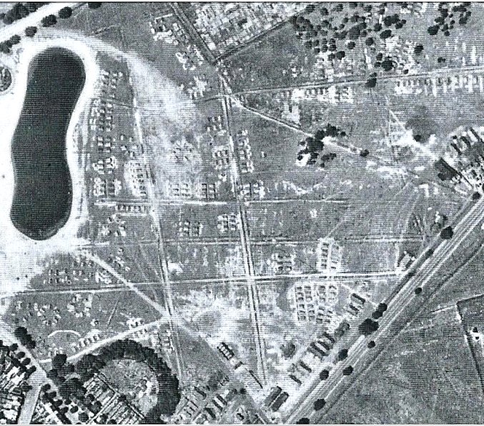 | This is listed as a hostel for Camp 30. However, various reports indicate that there were Italian pows held before Camp 30 opened. It was possibly a short-term, temporary site used as a transit camp, or it may have been linked to another main camp.  Information from the website; E7-NowAndThen.org and ‘Behind the Wire’:  “Some older local residents remember Italian PoWs being held there from December 1940... One local resident… recalls bus trips to see them on the Flats, early in 1941.  Prisoners were initially housed in Nissen huts… while others were held in tents on Tower Hamlets Road, following bomb damage to the area.”
 | < Wanstead Flats, 1944. | Ordnance Survey 1951.
From 1944, Germans were held prisoner on Wanstead Flats and it was then administered by Camp 30. The camp expanded rapidly and up to 200 tents were erected, later replaced by huts. For a short while there were both Italian and Germans at the camp. The Stratford Express reported hostilities between them in 1944.

There was a good deal of curiosity about the pow camps. “There were crowds of sightseers visiting Wanstead Flats during the weekend of 7-8 October [1944]. Press reports reveal that, at times, the crowds stood six-deep as they pressed close to the barbed wire. Military guards and specially detailed police kept moving the people along. On Saturday passers-by saw the inmates playing football with a ball made of rolled-up rags, and on Sunday evening the Germans could be heard singing inside the camp. For local residents, the proximity of the camps to their homes was resented.” (From ‘British Attitudes towards German Prisoners of War’, recording various newspaper stories).

After the initial novelty had worn off, local attitudes towards the pows were mixed. The Stratford Express reported, “…in 1944, that local girls would go to the site and throw sweets over the wire to them, much to the chagrin of local, jealous, young men. In a slightly different account, on the Newham Story website, however, one local resident recalled going down to the camp regularly and throwing stones and rocks at it.”

1945 - The pre-fabs along Capel Road at the southern edge of the Flats were built by German pows from the hostel. [I have also seen that they were built by Italian pows].

There is some confusion over how long the hostel lasted.

Its proximity to a residential area was raised in the House of Commons when the Secretary of State for War was asked, “if he is aware that people living close to these camps have protested against them being there; and how long these Germans will remain in those camps?
Sir J Grigg - The camps referred to by my hon. Friend are temporary, and I hope they will be closed by the end of this month.” (House of Commons, 10 October 1944, Volume 403 – written answers).

In ‘British Attitudes towards German prisoners of war’, it is recorded that; “The camp at Wanstead was closed on 28 October [1944] after protests were made by residents, who complained for the 'brilliance of the searchlights' illuminating the camp at night, and of the singing of the POWs.” – this would match the House of Commons statement. It was also reported in the Sunday Post on 29 October 1944 under the headline: ‘Germans Sang Too Loudly’.

However, the site was recorded with just 10 men linked to Camp 30 during 1946.

August 1946 – “This is a very small hostel with only 10 men.”

Hostel leader, Obgefr Hoppe (B+), aged 25, a former electrician – “He is a pleasant type, anti-Nazi but has as yet no constructive political ideas.”

Behind The Wire: Prisoner of War Camps on Wanstead Flats - the Wanstead Flats Working Group - 2013 - Leyton and Leytonstone Historical Society.

http://www.e7-nowandthen.org/2014/07/prisoners-of-war-on-wanstead-flats.html

 | 1945 | 7/46 | 8/46 | 2/47 | 3/47 | 7/47 | 8/47 | 10/47 | 11/47 | 3/48 | 3/48 (2)
Wanstead Flats |  | 10 | 10

Woodford Park – 10 miles from the main camp.
August 1946 – Hostel leader, Hauptfeldw Wolf, Helmuth, A+, aged 32. He had previously been held as a pow in the USA. Hostel leader for 2 months. “An outstanding personality, and by long way the best hostel leader. A very sound and intelligent man with progressive and humane ideas…. A traveller in stockings.”

December 1946 – 190 pows. No English newspapers. No interest shown by Commandant.

February 1947 – Hostel leader, Bornemann (B) – promised to promote re-education activities.

 | 1945 | 7/46 | 8/46 | 2/47 | 3/47 | 7/47 | 8/47 | 10/47 | 11/47 | 3/48 | 3/48 (2)
Woodford Park |  | 203 | 200 | 161 | 130

