Camp 58 & 248 - Nether Heage Camp, Belper, Derbyshire (aka Firs camp / Belper)

Included in the 1945 ICRC Camp list – Labour Camp. Belper Camp, Belper, Derby.

1947 Camp List
58(G.W.C.) | Nether Heage Camp, Nr Belper, Derbyshire | N. | Priswar, Belper | Ambergate 156 & 41 | Butterley | Lt.Col.W.A.Dickens M.C. | v/1453/2

Prisoner of War Camps (1939 – 1948) - Project report by Roger J.C. Thomas - English Heritage 2003
OS NGR | Sheet | No. | Name & Location | County | Cond’n | Type 1945 | Comments
SK 36 50 | 119 | 58 | Nether Heage Camp, Belper | Derbyshire | 5

Location: NGR SK 357 506. About 3 km N of Belper.  Before the camp: Farmland  Pow camp: Names seen – Nether Heage / Belper / Firs (from Heage Firs shown on map).  The site was accepted as a pow camp in December 1941. An Italian pow construction gang was allocated from Garenden Park Camp 28 to work with the Pioneer Corps.  1942 - The camp opened for Italian pows.  March 1942 – British staff of 4 Officers and 77 OR attached to The Hayes Camp 13 for training.  1943 – Hostels for Italian pows; Huthwaite; Biggin.  May and November 1944 - The camp was listed as an Italian Labour Battalion under the Northern Command area, (WO 32/10737). The Italians were recorded as co-operators.  Italian pows up until at least 1945, then German pows.  1 August 1945 - an urgent memorandum was sent to this camp, and others, about maintaining records of Italians who were classed as ‘co-operators’. At this point many, sometimes all, of the Italian pows were in hostels / billets.  September 1947 - Hostel at Derby Old Race course was transferred from Camp 58 to Knighthorpe Camp 28. Report that pows worked on local farms and a nearby flax factory. (British Hemp and Flax Development Company Ltd, Heage Road, Ripley). | 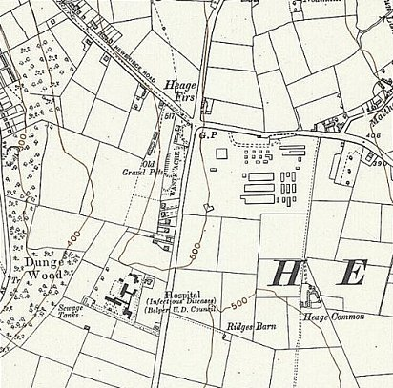
 | Ordnance Survey 1955
Camp Number changed from 58 to 248: C248 was Drill Hall, Derbyshire up to at least September 1946 - and then Norton.

November 1947 – The IWM hold a copy of a camp magazine - Blinkfeuer (Signal Fire?) – described as published by PWW Camp 248, Nether Heage, Derbyshire. Dated November 1947. https://www.iwm.org.uk/collections/item/object/1506002420 An earlier camp magazine for Camp 58 was called, Aufbau Nether Heage Camp (Construction).

Oversight and development of re-education activities and English teaching for German pows was carried out by PID (Political Intelligence Department of the Foreign Office) / COGA (Control Office for Germany and Austria – UK). Visits and reports were made. The standard of the reports varied greatly. The visitors took little interest, if any, in activities other than re-education. They rarely mentioned welfare, sports, games, pastimes, crafts, etc of the pows.

December 1947 – Many families hosted German pows during Christmas 1947. Letter granting permission for a family to host a pow. >>>  Just two reports are contained in a National Archive file (see below). The first was recorded as being the 9th visit to the camp.  16-19 December 1947 – Re-educational survey. Strength 4 officers; 1859 Other Ranks at main + 7 hostels and billets.  Commandant: Lt Col R R Dauban, RA. Camp leader: Wm. Willi Hall (B+)  Interpreter: S/Sgt L Kamp Deputy C/L: Fw. Phillip Alfons (B+)  German M.O. St.Arzt Dr F Behling (B); O.Arzt Dr U Reuter (B); O.Arzt Dr G Grommes (A)  The new Commandant showed “some” interest in re-education, (it was not compulsory). It was stated that he was stricter than his predecessor, but handled all pow problems with the greatest justice and understanding.  Assistant Commandant, Major Graham, was helping to develop outside contacts. He held weekly sessions where pows were able to raise any grievances. He was a personal friend of the Mayor at Buxton who was helping to develop contacts.  The interpreter was new and showed great interest in the work of PID.  The Camp Leader was regarded as very good, enjoying the confidence of the British staff and pows. “He is pleasant, a good organiser, and holds moderate political views.”  Study Leader, Willi Heidelberg, aged 27, was “active and enterprising.” He was involved with the camp magazine and concerts by the orchestra.  Morale was generally low, the main reason being the desire for repatriation. Bad news from home exacerbated the longing to go home. Many of the pows had been transferred from camps in the US – they felt aggrieved as they had been misinformed that they were being sent home, but instead found themselves in British working camps. Despite the low morale it was stated that the relationships with British staff were excellent. | 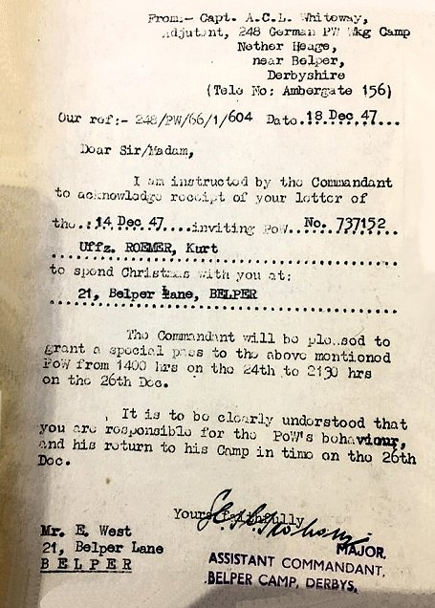

Some of the pows had been transferred from camps in Canada. Having been captured earlier in the war, many still held Nazi opinions. There was a definite antagonism towards the Western powers amongst many of these pows. Some did not believe Germany had started the war and saw the Nuernberg trials as unfair as the Russians carried out far worse crimes. The numbers slaughtered in concentration camps were doubted. Many did not wish for democracy. The visitor stated that these views may have been counteracted if PID had been more active at this camp.

36% of the pows were ‘youth’ – this was usually under-25, though the report stated ‘under-24.’ Only three had attended courses at the youth camp.

Varied work was carried out by the pows and relationships with employers were generally good. Other employment was carried out including “uncongenial” quarrying. Some worked at the ICI quarry where there were difficulties (?) which were being sorted by the Commandant.

The civilian population at Belper were described as “hostile.” At Buxton however, relations were particularly good, especially with the new mayor.

The standard list of re-education activities was given. It demonstrated that this camp had been neglected by PID.

Lectures – In most camps, interest in visiting lecturers varied according to the time of the year (poor in Summer when pows could walk out) and the title / presenter of the lecture. In this camp they had been discontinued completely – it is the only camp I have seen this occur at this late date. The reason stated was “lack of attendance.” The visitor added a more sinister reason that the pows in this camp still mistrusted the lecturers because they were paid for by the British government. This type of attitude was displayed in other camps in 1944 and 1945, but soon disappeared – not here. A suggestion was made that a female lecturer from Germany might re-awaken interest.

Discussion groups – none.

Camp magazine – monthly and well liked.

Press review – oral reviews held in huts.

Newspapers – most British dailies received. No mention of German papers.

Wochenpost & Ausblick – many negative comments and much distrust in the publications.

Library – well stocked, but many old and damaged. 3 month exchanges for the hostels.

Information room – no displays, these should have been sent by PID.

Wireless – very satisfactory.

Fims – YMCA and Travelling Films fortnightly.

Other camp activities –

Education – No courses listed for the main camp. 4 pows transferred to a different camp to attend courses at Sheffield university.

Religion – Poor attendance at camp services, but good for outside services. Paster Reinhard Schmidt had previously been at Kingsfold Camp 46 where he had been highly regarded. He had deferred his repatriation. He carried out his religious activities with zeal, developed outside contacts with Quakers and Methodists and contributed to the camp magazine.

Entertainments – 16 piece orchestra which had played at Buxton Town Hall. Football had fallen off due to dark evenings.

Overall, this report shows a failure of PID with too many pows still retaining Nazi attitudes.

8/9 April 1948 – Final Impressions and Re-educational Survey. Strength 3 officers; 925 OR at main and 6 hostels. No billets are mentioned, they may have been withdrawn back to the main camp.

Commandant: Lt Col R R Dauban, RA. Camp leader: Owm Otto Peppel.
Interpreter: Capt Stemmer Deputy C/L: Not listed.

The interpreter was new, transferred from Flaxeley Green Camp 175 (c.f. 16). He was supportive of re-education activities.

There was more rapid repatriation – November 47 to March 1948, 1203 pows; April to date, 416. Despite this, no Resettlement Officers had visited the camp.

The visitor stated that on first impression the camp appeared “happy and contented” due to the humane treatment by the British staff. He then went on to state that all pows had been in captivity for over 3½ years. He found having a discussion with them was “tough” and they were reticent to give opinions. Complaints were raised against –

Screening – pows considered it favoured Nazis and opportunists.

Lectures – placing all the war guilt on Germany.

Harsh treatment – physical mistreatment received in the US and widespread looting by the British. It was stated that previous pows being repatriated had their belongings looted by British escorts in Holland. The visitor had heard similar reports from Camp 280. A special report on the matter had been submitted and it was pointed out that it was having a bad effect on morale and bitterness towards the British. The number of complaints made about British looting of kit bags were very extensive, and sadly most likely true.
Attitudes to the British in general were mixed. Many pows had formed friendships with local families – but there was also mistrust and accusations of the kind that the local cinema was showing an anti-German film (1947 film ‘Golden Earrings’). The visitor estimated that 90% were friendly disposed towards the British, and only 10% anti. Considering previous comments, I think he was extremely optimistic with his estimates.

Outside contacts – very little had developed further. Contacts were mainly informal with families. Small groups of pows had visited Buxton’s and Bakewell’s Town Council meetings. There was a link to the Rotary Club, but no information about this.

The meagre re-educational activities had collapsed, including the camp magazine. There had been 1 lecture since the last report – given by Frau Hase, it had been well attended. There was ne mention of any other activities.

It was believed that this camp was to become a satellite for Allington Camp 51 at the end of April. If it did, it would have been for a matter of days, maybe a week or two, as the camps were rapidly closed down.

No further reports – the camp would have closed down within a few weeks.

Known Camp Commandants
c.1947 Lt Col W A Dickens M.C.
1947 Lt Col R R Dauban, Royal Artillery.

Camp and hostels + number of pows where known:
 | Not open |  | Unknown |  | Open |  | With another camp

 | 1942 | 1943 | > | 1947 | 12/1947 | 4/48
Main |  |  |  |  | 540 | 316
Biggin
Huthwaite |  |  |  | With The Hayes C5 (1946)
Derby Old Racecourse |  |  |  |  | With C28
Burbage |  |  |  | With Norton 248 | 195 | 119
Burton Closes |  |  |  |  | 154 | 97
Clay Cross |  |  |  | With Norton 248 | 334
Dove Holes |  |  |  | With Camps 248 | 317 | 217
Norton |  |  |  | Camp 248 | 5
Stoney Middleton |  | With Lodge Moor C17 |  | With Camps 248 | 94 | 34
Swanwick | The Hayes Camp - various No’s – see C5 |  |  |  | 166 | 54
Ticknall |  |  |  | With Camp 28 |  | 91
Billets |  |  |  |  | 58 | ?
Total | ? | ? |  | ? | 1863 | 928

After the camp: Site developed into light industrial area called the Firs Works.

Further information:

National Archive file FO 1120/236 – ‘Re-educational survey visit reports for camps 247 to 251’ – used above.

The Imperial War Museum has a copy of the magazine Aufbau. Dated 24 December 1946, Ref LBY E.J. 335 – Blinkfeuer is Ref LBY E.J. 337.
Hostels

Biggin. NGR SK 160 592  “5 or 6 Ministry of Supply huts for PoWs used as farm labour with Italians from 1943 and Germans by 1945.”  1943 - Listed with C58 holding Italian pows.  1942 1943 > 1947 12/1947 4/48  Biggin | 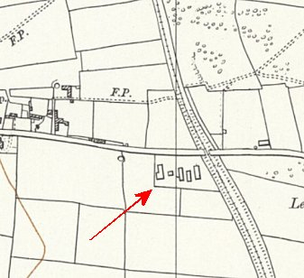
 | Ordnance Survey 1955

Burbage (On the w of Buxton) NGR SK 047 728  Most likely linked to a different main camp before these entries.  12/1947 – Hostel leader; Wm Horst Doering (B). Good contacts with locals developing.  4/1948 – Hostel leader; Uffz Arnold Bischoff  1942 1943 > 1947 12/1947 4/48  Burbage With Norton 248 195 119 | 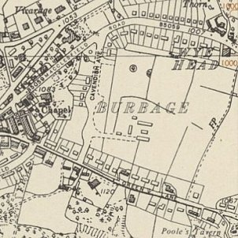
 | Ordnance Survey 1955

Burton Closes (Bakewell). Burton Closes Hall was built in 1848 for John Allcard, a wealthy Quaker banker and stockbroker. The house was unsympathetically treated during wartime requisitioning by the British and Dutch armies and later by prisoners of war. The map shows huts in the grounds as well as the main building.  Would have been administered by a different main camp before these entries.  12/1947 – Hostel leader; Fw Alfred Pusch (B+).  Good contacts with local Quakers noted in report.  4/1948 – Hostel leader; St.Maat Werner Torge  1942 1943 > 1947 12/1947 4/48  Burton Closes 154 97 | 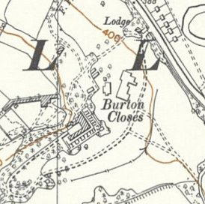
 | Ordnance Survey 1955

Clay Cross

July 1945 - First listed in ICRC report with The Hayes camp 5. Hutted.

Later became independent Clay Cross Camp 248, then a hostel for Norton Camp 248 and then administered by Nether Heage Camp 248.

12/1947 – Hostel leader; Fw Herbert Kleff (B). A carpentry class for just 6 pows.

 | 1942 | 1943 | > | 1947 | 12/1947 | 4/48
Clay Cross |  |  |  | With Norton 248 | 334

Derby Old Race Course

NGR for centre of course – SK 362 372. The course closed in 1939. In 1942 the owners, Derby Racecourse Company, were told by the town council that the lease would not be renewed. Used by the Royal Artillery and as an anti-aircraft gun site.

 | Unknown |  |  |  |  |  | With Nether Heage |  | With Camp 28
 | -/43 | 4/46 | 7/46 | 9/46 | 10/46 | 12/46 | 4/47 | 7/47 | 9/47 | 11/47 | 12/47 | 3/48
Derby ORC |  |  |  |  |  |  | With Camp 58 |  | 150 | 236 | 222

Dove Holes  Previously a hostel with Drill Hall Camp 248, then Norton Camp 248  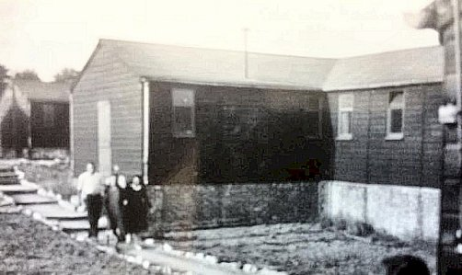  “At Dove Holes outside Buxton there was a prisoner of war camp for Italians and all the POWs as they were called, were allowed into Buxton at the weekends. With their Latin features they were easy to spot because they wore brown battledress tunics and trousers with POW across their backs.”  https://www.bbc.co.uk/history/ww2peopleswar/stories/68/a2334368.shtml  12/1947 – Hostel leader; Uffz. Paul Hombrecher (B). Good contacts with locals developing.  Winter 1947 – many photos of pows clearing deep snow in the area.  4/1948 – Hostel leader; Uffz Hans Mueller | 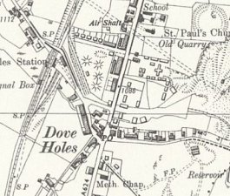
 | OS 1955 – huts by ‘Old Quarry’

 | 1942 | 1943 | > | 1947 | 12/1947 | 4/48
Dove Holes |  |  |  | With Camps 248 | 317 | 217

Photo from Facebook – “courtesy of Mr Terry Buivids , whose Father was a prisoner here...” As there are women in the photo, this may have been taken just after the site closed as a pow camp, when quarry workers were housed there. https://www.facebook.com/groups/500448800541207/search/?q=pow

[There are some web entries about a large number of Germans dying from flu at Dove Dales – this was at Peak Dale and occurred just after WW1].

Huthwaite

Location: around SK 4683 5842 - on the B6027 (Common Road). It is about 6 miles NE of Swanwick.

1943 - Listed with Camp 58 holding Italian pows. Wooden huts (possibly 6, including 1 used for cooking / eating). Area enclosed by barbed wire fencing with an entrance gate almost opposite Pit Road. Transferred to The Hayes (see camp 5).

 | 1942 | 1943 | > | 1947 | 12/1947 | 4/48
Huthwaite |  |  |  | With The Hayes C5 (1946)

Norton

Previously independent Camp 248.

12/1947 – small group left, possibly to dismantle camp or to deter squatters.

 | 1942 | 1943 | > | 1947 | 12/1947 | 4/48
Norton |  |  |  | Camp 248 | 5

Stoney Middleton

1943 - listed as a hostel for Lodge Moor Camp 17 with Italian pows. See C17 for map and details.

1945 – no longer listed as a hostel with Lodge Moor.

1946 / 1947 – With New Drill Camp 248, then Norton Camp 248.

12/1947 – Hostel leader; Uffz Heinrich Mueller (B) – regarded as no more than just adequate.

4/1948 – same leader.

 | 1942 | 1943 | > | 1947 | 12/1947 | 4/48
Stoney Middleton |  | With Lodge Moor C17 |  | With Camps 248 | 94 | 34

Swanwick

Previously The Hayes Pow Camp with various numbers – see Camp 5.

12/1947 – Hostel leader; Fw Kurt Hess (B)

4/1948 – Hostel leader; Uffz Walter Kremser

 | 1942 | 1943 | > | 1947 | 12/1947 | 4/48
Swanwick | The Hayes Camp - various No’s – see C5 |  |  |  | 166 | 54

Ticknall

With Garenden Park Camp 28 from at least 1945.

4/1948 – Hostel leader; Uffz Heine Peltz.

 | 1942 | 1943 | > | 1947 | 12/1947 | 4/48
Ticknall |  |  |  | With Camp 28 |  | 91

