Camp 76 - Dymond's Farm, Clyst Honiton, Exeter, Devon

Prisoner of War Camps (1939 – 1948) - Project report by Roger J.C. Thomas - English Heritage 2003
OS NGR | Sheet | No. | Name & Location | County | Cond’n | Type 1945 | Comments
SX 986 927 | 192 | 76 | Dymond's Farm, Clyst Honiton, Exeter | Devon | 4

Location: Bishop Courts Lane. 2km to the E of Exeter.  Before the camp: A farm  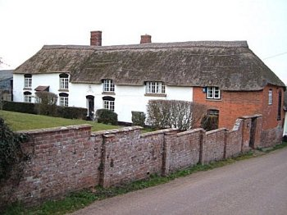  Pow Camp: Entries for Devon and Dartmoor HER: MDV52962: “Dymond’s Farm Prisoner of War Camp is visible as a range of structures on aerial photographs of 1944 onwards, off Bishop’s Court Lane. The site occupies an area of approximately 2.62 hectares of agricultural land and is accessed from Bishop’s Court Lane to the north. It comprises a concentration of Nissen huts arranged in a rectangular pattern, as well as a number of other huts and structures dispersed to the west and north of these and interconnected by a series of trackways. The Prisoner of War camp remains relatively unchanged on aerial photographs of 1947, although by 1957 the site of the former camp has been largely cleared and has been partly given over to a plantation, although three Nissen huts remain extant. The ordnance Survey 2015 MasterMap show two Nissen huts are extant at the former entrance into the camp and now lie within the grounds of Oakview house. A third Nissen hut to the southeast of the plantation and mentioned elsewhere in this record has been demolished and replaced by a new agricultural building. | 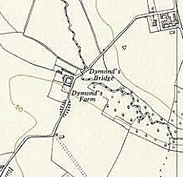
 | Ordnance Survey 1963

…Originated as additional accommodation for bomber crews operating from RAF Exeter during D-Day operation. Then became POW camp for German prisoners during the Normandy campaign. Still in use in 1948 with POWs labouring on nearby farms.”

October 1947 – Recorded as a hostel for Nissen Creek Camp 276 with 234 pows.

March 1948 - the camp had just 7 Pows remaining at the farm and it had become a hostel for Bampton Road, Tiverton, Camp 92.
After the camp: A farm.

Further information:

Imperial War Museum - Documents.16615 - Private Papers of W H Torr - …dating mainly from 1946 - 1948 (circa 40 items) concerning William Torr's work as a Society of Friends (Quaker) Welfare Visitor at POW camps in the Exeter area, in particular Camp 276 at Dymonds Farm, Honiton Clyst (later at Pinhoe), including: official letters and documents from the Friends Committee for Refugees and Aliens regarding Visitor access to POW camps and information for the guidance of local clergy in dealings with POW chaplains and the provision of church services to POWs; letters written to Torr and his family by German former POWs and their families, expressing their gratitude to him and the Society of Friends generally for the friendship and support given to POWs in the camps and after their return to Germany; with some miscellaneous related papers and photographs. Not seen.

