Camp 250 Thorpe Hall, Rudston, Yorkshire

Prisoner of War Camps (1939 – 1948) - Project report by Roger J.C. Thomas - English Heritage 2003
OS NGR | Sheet | No. | Name & Location | County | Cond’n | Type 1945 | Comments
TA 1051 6787 | 101 | 250 | Thorpe Hall, Rudston | Yorkshire | 4 |  | Former Army Divisional HQ re-occupied as a PoW Camp. Foot footings remain extant

Location: Memory of camp stated that the camp was “in the wood opposite the main entrance.”  Before the camp: Country estate and house.  Pow Camp:  1946 – recorded that the RC padre from this camp (Muenstermann) visited Eden Camp 83 once a month for confession and communion.  2nd half 1946 – Thorpe Hall (and hostels) became a satellite camp to Eden Camp. Eden changed its number from 83 to 250.  When it became a satellite camp, it continued to administer some hostels, these were called the ‘Rudston Group’ in a couple of reports: HQ Thorpe Hall – Hostels; Bath House, Dawson’s Plantation, North Burton, and Rudston CRS. (This was set out in the October 1947 ICRC report for Eden Camp).  17 September 1947 – For details of the lorry collision with a train at Burton Agnes Level Crossing – see Eden Camp 83/250.  There were camp magazines – Die Pflugschar (The ploughshare) and Unsere Lagerzeitung (Our Camp Newspaper).  After the camp: Working estate.  Further Information:  The German Federal Archives have copies of the camp magazines. | 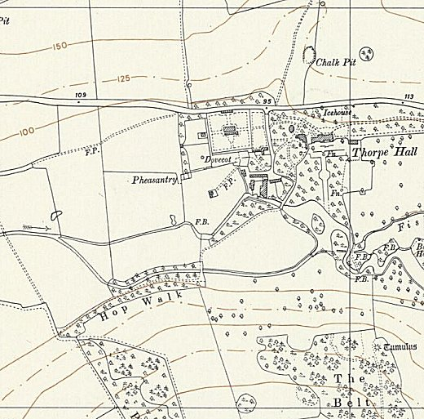
 | Ordnance Survey 1956

