POW CAMP NUMBERS.

The duplication of camp numbers and names in modern lists of WW2 pow camps in the UK is confusing; however, this confusion arose after the time of the camps. Between 1939 to 1948, at any particular time, the numbers and names for pow camps were unique.

Camp Numbers were issued to identify each site without having to indicate an actual address. This reluctance to release locations came from a fear that paratroopers might attempt to land at the camps and release prisoners to aid an invasion.  Censorship Rules stated: “Any letter which is found by the P/W Censorship to contain untrue or offensive statements or information about the camp or its occupants, or other matters which it is considered should not be communicated to the addressee, will be returned to the Commandant, who will hand the letter to the writer with a explanation as to why the letter has not been allowed to go forward. Copies of comment slips will, in such cases, be sent to M.I.12.”  (My emphasis – Ref: ‘Censorship Rules For Prisoners Of War And Internment Camps In Great Britain - Paragraph 6.’ M.I.12 were responsible for overseeing censorship).  Until 1945, “information about the camp”, included the address. Postal stationery issued to pows did not even include a space for a return address, only for a camp number. Application of this rule was eased after D-day, and then removed after VE day. | 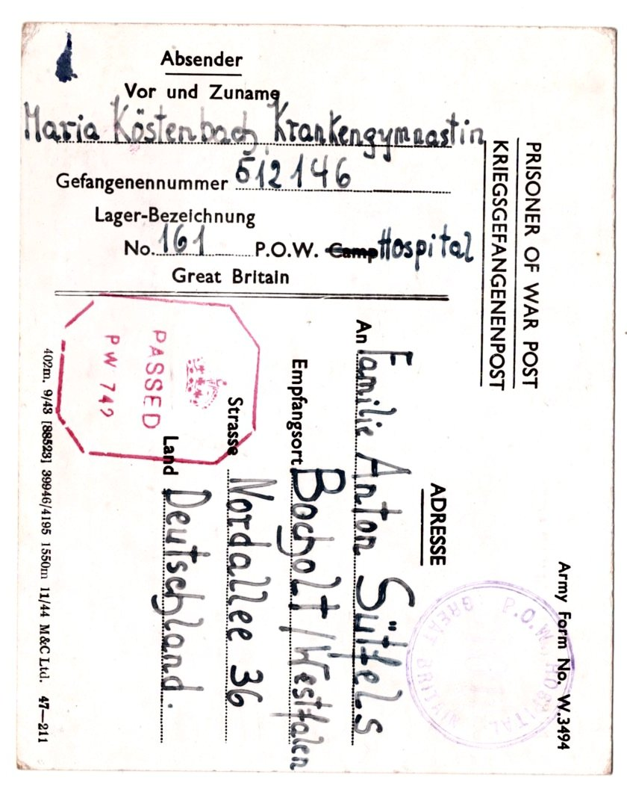
 | No address, just a number - even from a hospital (Belfast Military Hospital – 1945).

A Master List of camp numbers and addresses was maintained by The Prisoner of War Information Bureau (PWIB) in London and sent out to those who needed it. Contemporary copies of that changing list made at various times showed a unique number and name for each camp*. Mail to pows was sent to one of the ‘Postal and Telegraph Censorship Departments’ for censorship, sorting and sending on to the correct address. If numbers and names were duplicated in the list, where would mail be sent to?

(*A very small number of duplications in a few lists can largely be explained by delays in sending information. This was not the computer age; information needed to be collected, typed, sent by mail/courier, received and sent to the correct department for the list to be revised and re-typed.)

Confused Lists showing duplications of numbers and names occur in compiled lists drawn up at later dates. This is the case for the camp list in ‘Zur Geschichte der Deutschen Kriegsgefangenen…’ (1974), the English Heritage list from 2003, the index I use on my site, and others.

These lists appear confused because they show the same camps, but at different times, during which details changed for various reasons - but all the changes are merged together into the single compiled list.

A simplified example of how compiled lists appear confused: take three camps in say, early 1944 with unique numbers / names (list 1 below). Over the next few months Camp 2 changes from a transit camp to a German working camp and is renumbered as Camp 4 - and Halberry Camp 3 closes so its number is utilised by a new camp called, Topscrap. The revised list in July 1945 (2) still has unique numbers and names - BUT, a list compiled from (1) and (2) by historians (3) is confused with duplicated names and numbers:

(1) Early 1944 list | (2) Revised July 1945 | (3) Compiled camp list
Camp 1 Grizzlyvale  Camp 2 Tuffty Hall  Camp 3 Halberry | Camp 1 Grizzlyvale  Camp 3 Topscrap  Camp 4 Tuffty Hall | Camp 1 Grizzlyvale  Camp 2 Tuffty Hall  Camp 3 Halberry  Camp 3 Topscrap  Camp 4 Tuffty Hall

Additional notes on names and numbers.

Camp Numbers Changed for several reasons, the main ones were:

If a camp closed, its number was sometimes re-allocated to a new one, e.g. Camp 165 at Kirkwall on Orkney closed after the Churchill Barriers were completed in late 1944; and then a new camp, Watten, was given that number when it opened in May 1945.

A change in the status of a camp, e.g. Camp 23 Le Marchant, became German Working Camp 410.

A camp was relocated. Pioneer Corps Companies often took the camp number with them when they changed location according to demand for pow labour in different places.

There were many exceptions, when camps did not change their number at all despite their status being changed in one way or another.

One of the most confusing camps was The Hayes, Swanwick. It started off as Internment Camp 17. In 1940 it became POW Camp 13. It closed for a short time after pows were shipped to Canada, re-opening in 1942 as Camp 5. During 1944 it was American Transit Camp 7, and when returned to UK control it was re-numbered as Camp 179. In 1946 it was listed as Camp 58, and then finally, by 1948 Camp 297.

So, in compiled lists it appears as 5 / 13 / 58 / 179 / 297 – BUT, at any particular time it only had ONE number.

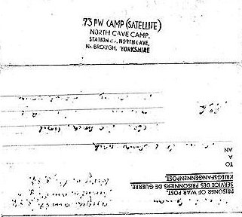
Satellite Camps – these often started out as independent camps with their own number. When they were taken over they usually took the number of the HQ site. Eg Hornby Camp 155 was taken over by Merrythought Camp 76 – so Hornby appears as 155 and then 76.

One case shows an exception – Thorpe Hall was independent camp 250 and Eden Camp was independent camp 83. Thorpe Hall became a satellite to Eden Camp 83, yet Eden took on the number 250.

< POW Lettersheet - relaxed rules with the address rubber stamped, and showing North Cave satellite using the camp number for the main Storwood Camp 73.

Hostels – there are often comments that a ‘camp’ is missing from a list. This is sometimes true as camps are still being ‘discovered,’ but it is more often the case that the ‘camp’ was in fact a hostel to a main camp. Some camps had no hostels, others had MANY, e.g. Racecourse Camp 74 had 25 hostels.

Mail was delivered to the main camp and then distributed to the hostels and billets – so they only needed the main camp number. Hostels were often transferred between camps and so they exist with different numbers over time.

Suffix use. A few camps used suffixes to distinguish their hostels, so camp 500 might have hostel 1 as 500a, hostel 2 as 500b, etc.

