Camp 92 - Bampton Road Camp, Bampton Road, Tiverton, Devon

Included in the 1945 ICRC camp list – Labour Camp. 92. Bampton Road Camp, Tiverton, Devon.

1947 Camp list
92(G.W.C.) | Bampton Road Camp, Tiverton, Devon | S. | Priswar, Tiverton | Tiverton 2115 | Tiverton | Lt.Col.J.A.Macdonald | v/1453/2

Prisoner of War Camps (1939 – 1948) - Project report by Roger J.C. Thomas - English Heritage 2003
OS NGR | Sheet | No. | Name & Location | County | Cond’n | Type 1945 | Comments
SS 952 134 | 18 | 92 | Bampton Road Camp, Bampton Road, Tiverton | Devon | 4 | German Working Camp | STANDARD type. Site occupied by a school

Location: Just to the NW of Tiverton. It was off the A396, which, although it runs towards Bampton, is labelled as Bolham Road on the maps I have seen. The River Exe runs alongside.  Before the camp: Farmland. Part of a hare racing field in Victorian times. An oval track can be seen at the back of the camp in the 1946 photograph.  Some articles state it was built as a US troop camp. But lists show it was open in at least 1943 for Italian pows and the site layout is that of a ‘standard’ pow camp.  Pow Camp:  1942/3 – Built / opened with Italian pows.  The site had a standard layout with a main pow compound and guards’ huts and offices at the front by the road. Buildings included water tower, offices, officer's mess, a canteen, guard rooms, barrack huts, ablution blocks, cell blocks, a camp reception station (medical facility/hospital), a cookhouse, dining rooms, recreation rooms and living huts.  1943 and 5 May 1944 - Two hostels listed for Italian pows, (WO 32/10737): Chudleigh and Waterloo Cross. | 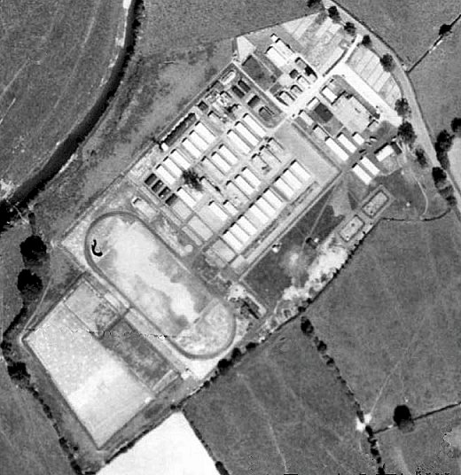 | 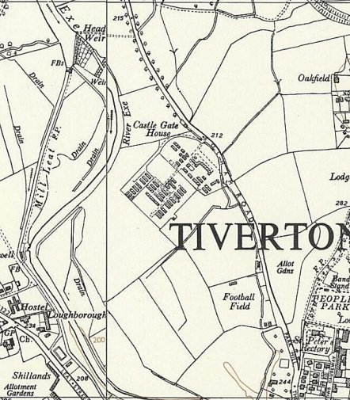
 | RAF Aerial photograph 1946. | Ordnance Survey 1954
May and November 1944 - The camp was listed as an Italian Labour Battalion under the Southern Command area and then as an Italian POW Working Camp (+ Pioneer Corps Group), (WO 32/10737). The Italians were listed as non-co-operators.

During 1944 the HQ Camp held Italian pows with ‘subversive tendencies’ – presumably ‘non-co-operators’ as co-operators are detailed as being in billets. In July 1944, all 650 pows went on strike in sympathy against a punishment of 28 other pows who had refused to unload coal at Exeter Railway Station. The camp was placed on short rations for 3 days. They are also reported to have caused some disruption in the neighbourhood:

“Lieut.-Colonel Acland-Troyte [M.P. for Tiverton] asked the Secretary of State for War what action he has taken with regard to the bad behaviour of Italian prisoners of war in Tiverton and the neighbouring districts; whether any disciplinary action has been taken against the men involved in the incident in Tiverton on 25th October; and if he will take steps to ensure that discipline is maintained among these prisoners and that they are prevented from wandering about the country and frightening respectable women, particularly near Tiverton and Sampford Peverell.

Sir J. Grigg - The camp at Tiverton houses Italian prisoners who have been removed from other camps because of their subversive tendencies. I have no information of an incident on 25th October. An incident did, however, take place on the night of 27th-28th October when crude pamphlets bearing fascist slogans were distributed in a small area of the town, but so far, the perpetrators have not been discovered, although investigations are still proceeding. A small number of Italian co-operators are billeted in the area who are allowed to exercise within defined limits, and any complaints against their behaviour should be reported to the Commandant, who will deal with them. In this connection I would refer my hon. and gallant Friend to the reply I gave my hon. Friend the Member for Tamworth (Sir J. Mellor) on 14th November.”
(House of Commons, 16 November 1944, Vol 404 – the reference to 14 November was a reply about decreased security measures for Italian co-operator pows).

1945 – Camp gradually changed from an Italian to a German Camp.

Oversight and development of re-education activities and English teaching for German pows was carried out by PID (Political Intelligence Department of the Foreign Office) / COGA (Control Office for Germany and Austria – UK). Visits and reports were made. The standard of the reports varied greatly. The visitors took little interest, if any, in activities other than re-education. They rarely mentioned welfare, sports, games, pastimes, crafts, etc of the pows. If there were still Italian pows in hostels, they were usually ignored by PID.

18 April 1945 – Segregation Section of PID, Progress Report 66 – 120 pows had been interviewed and 59 were found to be “undesirables.” These were transferred to a different camp and 59 anti-Nazis were brought in. The camp was considered to be ‘white’ – anti-Nazi.

20 April 1945 - English Education Visit to the main camp. English inspectors met teachers, gave talks, checked teaching texts and resources, and tested the pow pupils.

Camp Commandant: Lt. Col. Becker.

2-3 July 1945 – English Education Visit. A change of Camp Commandant was noted and there was a brief outline of English lessons.

September 1945 - Appendix to HQ Southern Command War Diary– Bampton Road, Tiverton – German labour camp – capacity 950
Italian hostels – Waterloo Cross, Pinhoe, Dulverton, Axminster – total cap 500
German hostels – Chudleigh, Chumleigh, Crediton, Little Bray, Nadderwater, Silverton – total cap 400

10 December 1945 - English Education Visit to the main camp + Chulmleigh and Crediton, (stated to be 2 of 3 hostels, but the third is not listed). The 2nd in command did not appreciate the visit as insufficient information had been provided. Comment by the visitor – “One has the impression of great efficiency in the management of this camp.”

3-5 May 1946 – ‘Brief Education Survey’. HQ + six hostels (un-named). Austrian pows were held at Silverton – they were expecting to be repatriated in the near future. The Camp Commandant was praised as he, “takes the keenest interest and has the greatest sympathy.”

15 June 1946 – English Inspector’s Report. Strength; 1709 in HQ + 6 hostels and billets. 295 pupils in 11 classes at all sites.

11-15 July 1946 – Report on Re-education and Progress. Strength – Officers 3 / OR’s 2075 in HQ + 8 hostels and billets.

Commandant: Lt Col J A McDonald DSO, MC. Camp leader: Uffz W. Wiedemann (A)
Interpreter: Trooper Addison Deputy C/L: Gren Hugo Bechheim (B)
German M.O.: S/Arzt Dr Philip Lachenicht (B-)

The Commandant (J.A. McDonald) was praised – “His personal interest and care for the welfare and well-being of Ps/W in his charge together with his good and just treatment are recognised and appreciated by the men.”

Political screening: | A+ | A | A- | B+ | B | B- | C+ | C | C- | Unknown | Unrecorded
 | 2 | 64 | 6 | 198 | 741 | 228 | nil | 76 | - | 14 | 749

Overall, the camp was categorized as ‘B’ / Grey. Negative factors included lack of information about repatriation, bad news from home, restrictions on leaving the camp, censorship of letters, postal delays (5 weeks from US and French zones, 6 weeks from Russian zone). Positive factors included the attractive area and camp facilities, entertainments and education classes.

The presence of C grade / ‘black’ pows caused problems for the camp as the War Office had issued a directive that they were to be segregated. This decision had been made back in early 1945 after a series of disturbances and at least one murder in other camps. It was not considered to be suitable to have camps with only category C pows, so the order was made to have segregated areas within camps. The commandant at Camp 92 placed the C grade pows in Dulverton hostel. Issues arose from having a site with all Nazis, and how to include them in re-education and democratic activities.

Other issues were raised. The competence of the British interpreter officers was questioned as their language skills were not seen to be good enough. [There was an Italian Interpreter in the camp as well as Trooper Addison]. Some of the German re-education leaders within the camp included Nazis. Another War Office instruction was questioned instructing that military rank badges should be worn; this was considered to be counter to the democratic and non-militaristic nature the camp was attempting to promote.

Many of the pows had previously been held in pow camps in the USA. Most had very low morale as they had been misinformed in the US that they were being repatriated. Instead, they found themselves in working camps in the UK. Another group arrived from the Channel Islands – they were graded as ‘C’ (Nazi’s), but most would soon have this upgraded.

26% of the pows were ‘youth’ (under-25). There had been an attempt to segregate them in separate huts but with so many intakes this proved to be unworkable.

The standard list of re-education activities was given:

Wochenpost / Ausblick – 685 / 221 copies monthly.

Newspapers – a very wide range of British papers were received. 12 copies of le Monde. About 18 Swiss or German papers monthly.

Library – 1600 books, but many were duplicates. More requested.

Films – PID and YMCA films fortnightly at HQ – 4 hostels did not have any shows, (Chulmleigh, Crediton, Dulverton and Little Bray).

Wireless – at all sites, but sets at Crediton and Silverton had broken down. It was difficult to receive German stations.

Lectures – regular.

Press reviews – to be set up.

Camp magazine – ‘Die Eule’ (The Owl) - continued, but was not considered to be very good.

English Instruction – separate report.

Other camp activities –

Religion – Protestant padre, Zahlmeister Emil Tag (A), “lacks all initiative or incentive,” he rarely visited the hostels. No RC priest. Pows were able to visit some local churches.

Education – many and well attended.

There was a theatre and orchestra.
Camp 92 in the bleak winter of 1945 >  There are a few Nissen huts to be seen, but most buildings are wooden huts.  The centre section of the photograph shows the water tower and compound for guards’ huts and offices next to the road.  On the left of the picture appears to be a guard tower and part of the pow compound.  9-12 September 1946 – English Inspector’s Report. Numbers of pow = 2325. 333 pupils in 19 classes.  19 November 1946 - Report on Camp 92 (Dulverton Hostel). | 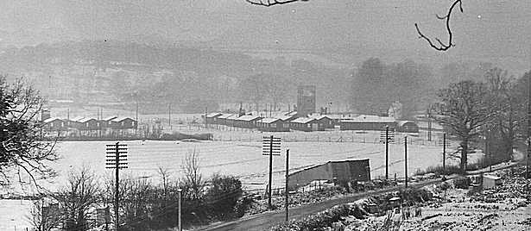
Presumably this separate report was made as this hostel contained Grade C pows. The hostel leader, Sommerfield, had been upgraded from B- to B+, (the better the grade, the sooner repatriated, in theory). Complaints were made the Nazi Party members had been repatriated, otherwise, no issues were recorded.

5-6 December 1946 - Short Report on Visit to No.92 Camp (Honiton Hostel). See below.

25 January 1947 – English Inspector’s Report. Strength; 1841 in HQ, 7 hostels and billets. 209 pupils in 14 classes at all sites + some studying privately.

New camp leader: Fritz Willfűhr.

22 February 1947 – English Inspector’s Report. Strength; 1691 in HQ, 7 hostels and billets. Due to very poor winter weather conditions, only HQ and 2 hostels were visited.

12 and 17 April 1947 - English Inspector’s Report. Strength; 1566 in HQ, 7 hostels and billets. 157 pupils in 11 classes at all sites. Steady decline in numbers as initial interest waned, shown in most camps.

13-15 June 1947 – Introductory and re-educational survey. Strength; 3 Officers, 1475 OR.

Commandant: Lt Col J A McDonald DSO, MC. Camp leader: Fritz Willfűhr (B+)
2nd i/c: Major Blomfield Deputy C/L: Erich Stauch (B+) or Staugh.
Interpreter: Sgt Sales R.E.M.E. German M.O.: S/Arzt Dr Philip Lachenicht (B-) / S/Arzt Dr Torge (B-)

The senior staff were found to be very supportive, but both Commandant and 2nd i/c were due to leave.

The camp leader was stated to be; “given to fits of moroseness, but he conscientiously and ably does his work.”

Simplified screening was in use: A 8; B 1470. 634 pows repatriated to date.

Morale was good with the usual concerns over repatriation. The Commandant was highly praised.

400 youth pows; no special difficulty. There was a Youth Group.

The standard list of re-education activities was given. Similar to July 1946, changes -

Press reviews – A brief printed daily review was displayed in the Information Room. Weekly oral reviews with up to 400 attending. Hostels held their own reviews.

Discussion groups – occasionally held, but other activities often interfered.

Other camp activities –

Religion – Protestant padre, Zahlmeister Emil Tag (A), received a very different report to the last negative one; “a wholesome influence on the camp.” RC pows were cared for by the local priest and by Fr. Hugo Zettel of Buckfast Abbey.

Entertainments: “The camp possesses a maginificent concert, cinema and theatre hall and good shows are put on. I heard many musicians practising and unerstand that music plays a large part in camp life. Prime interest when the weather is good is sport in many varieties.”

Education: Fewer classes held due to long work hours and freedom to walk out of camp. “Two years ago the camp bought a motor car engine and practical instruction was given in motor mechanics.”

Formal links were set up with - Toc H, Tiverton Art School, Salvation Army, The Society of Friends (gave occaisional gramophone concerts and talks), YMCA. Mrs. Josephine Prettejohn, radio star and singer gave a recital in the camp and wished to return.

22-24 June 1947 - English Inspector’s Report. Strength; 1460 in HQ, 6 hostels and billets. 93 pupils in 8 classes at all sites.

16-17 July 1947 – English Inspector’s Reports. Very brief details were given.

All camp reports under Commandant J.A. McDonald praised his work and attitude towards the pows. A new camp commandant, Lt Col G.W.V. Ladds was appointed in August 1947. He was at first reported to be overly militaristic and a disciplinarian, and attitudes within the camp were soured. The Inspectors had no control over this, they were from the Foreign Office, the camps were under the control of the War Office. The main reason for retaining pows in the UK was to maintain them as a much-needed additional workforce, not to provide re-education – and one inspector commented that Ladds’ aim was; “to have every available PW out to work.”

19-20 September 1947 – English Inspector’s Report. Strength; 1300 in HQ, 6 hostels and billets. 49 pupils in 6 classes at all sites. Some pows took a correspondence course for English.

29 September and 4-6 October 1947 – Routine re-educational survey visit. Strength; 2 Officers, 1362 OR 1362 - all screened as category ‘B’.

New Commandant: Lt Col G W V Ladds – “friendly and helpful as he has always been; re-education is tolerated as a measure laid down and a regulation to be carried out, but the camp’s main function is discipline and work.”

New Interpreter: Lt Grenville G S C.; previously at Camp 295 – “admirable as regards our aims; is informed and capable, though his style is hampered by the Commandant’s super-efficiency.”

Morale – “Is going to pieces; and this camp was a short while ago the happiest in the S.W. area. It is doubtless passing through a period of depression, brought on by the present phase of violent militarism and smartness that is running through the camp and hostels. The indications are that the mood will pass or the camp accustom itself to the new measures and regulations; the actual process is giving rise to some discontent. The area is somewhat friendless and the hostels are set in lonely surroundings. On the whole, morale in the camp is not entirely satisfactory.”

Changes to re-education activities –

Pows able to visit local cinemas, if available. Some activities were in suspended due to reorganizations at the camp.

Entertainments continued to thrive. Football matches were held between the hostels and some civilian teams. Table tennis was very popular. “The pows, ‘distinguished themselves at Tiverton’s Floodlit Water Gala’.”

Outside contacts - Contacts from outside; YMCA; Tiverton Toc H opened a second social centre for PsW; Tiverton Youth Club; WEA. The camp choir and orchestra took part in local fêtes.

“It must be stated that the atmosphere of Tiverton… is against fraternisation as a general rule (though evidence of personal contacts is there); Tiverton is a British Legion town which has not yet recovered from the Great War which they still attempt to keep up.”

14 November 1947 - Camp number included in an ‘Urgent Memorandum’ (FO 939/270) regarding inspection of food parcels.

18-20 November 1947 - Progress Report. Strength; 2 Officers, 1348 OR.

The excellent Interpreter Officer Lt Grenville left for Camp 157 and a further deterioration in re-education activities was noted.

December 1947 – noted in report for Goathurst Camp 44, that pows from Camp 92 were visiting to see films.

11/13 December 1947 – Re-educational report. Strength; 1 officer, 1447 OR. This was mis-filed under National Archive FO 939/134.

A new interpreter officer: Lt J Fryer, K.R.R.C. – he did NOT speak German, (IO’s were often employed as Intelligence Officers rather than Interpreters).

A new German M.O.: Dr Heimann (B)

A different perspective of the Commandant was given stating that the pows had adjusted and learned to respect him. Camp discipline was “strict but not exaggerated.” Morale had improved with faster repatriations. Preparations for Christmas were underway and many pows had received invites to visit families. The pows often received news abot poor conditions in Germany and this left them frustrated and feeling helpless.

Entertainments had declined due to repatriations of leading members. The theatre group had ended completely.

5-6 February 1948 - Re-education check. Strength; 2 Officers, 585 OR.

The recently appointed Interpreter had left and not been replaced.

Activities were being closed down as repatriation continues. 1200 pows repatriated to date.

The orchestra, choir, and education classes had all ended due to repatriations.

20 February 1948 – A visit from a Resettlement officer. The majority of pows found this pointless, the visitor knew very little, and many pows believed they had more information than he did. This was the general opinion in most camps.

4 March 1948 - English Inspector’s Report. Strength; 442 in HQ and 4 hostels. 11 pupils in 1 class at HQ only.

A new Interpreter Officer; Captain Adams.

The new camp leader was Erich Stauch, he had previously been the deputy.

The Inspector commented – “The hostels exist little more than in name – the present strengths represent merely anti-squatter parties and the Main Camp numbers are rapidly diminishing.”

9-11 March 1948 - ‘Final Check’ Education Inspection report. Strength; 476 at HQ + 6 hostels and billets.

The Inspector noted that; “In the past six months grumbling and dislike have grown in the camp, one hundred percent” – he put this down to the regime established by the new Commandant. It is noted that some of the remaining pow came from the Channel Islands and their, not surprising, resentment that others have been repatriated before them.

The editor of the camp magazine had been removed from that post due to articles he had published regarding the unfairness of continued captivity.

Outside contacts with the local population varied – many had formed close relationships with families, mainly of those civilians they worked with, but the majority had found a hostility from Tiverton.

The camp closed soon after this report.

Memories - This account was submitted to the BBC People's War website by ‘Storygatherer’ Alison Lear on behalf of Gerald Frankpitt:

“I was eleven at the start of the war. My father was a farmer and I had one brother and three sisters. My father owned a field which was nearly twenty-four acres in size. It was used as a horse racing field in Victorian times. In the war it was requisitioned as a POW camp.

Firstly, there were Italians, and later on Germans as well as displaced people e.g. Yugoslavians. The POWs worked on the land - they were all hardworking except the Italians!
I remember the Italians used to catch wild birds in a trap and eat them. The Germans were so well disciplined they almost ran the camp themselves.”

Known Camp Commandants:
C1944 – Major Monico (linked to Monico Restaurant in London).
? – July 1945 Lieutenant Colonel Becker (or Becher).
July 1945 - ? Lieutenant Colonel Oliphant
c1946 to July 1947 Lieutenant Colonel J.A. McDonald DSO., M.C. from the Royal Artillery.
August 1947 to closure 1948 - Lieutenant Colonel G.W.V. Ladds from ‘The Glosters’. Previously at High Garrett Camp 98.

After the camp: By 1966 the camp had been completely cleared and the site is now occupied by Petroc College and Tiverton High School.

Further Information:

National Archive FO 939/134 – 52 Working Camp, Nether Headon Camp, East Retford, Nottinghamshire and 92 Working Camp, Bampton Road, Tiverton, Devon. Dated 1945-1947. Used above.

FO 939/172 – 92 Working Camp, Bampton Road Camp, Tiverton, Devon. Dated 1945-1948. Many of the reports offer very little detail of the camp. Used above.

Tiverton Museum has a copy of ‘Die Eule’, dated September 1946. They also hold photographs of the camp taken in 1947, and several artefacts. The Imperial War Museum has a copy dated 1947, Ref LBY E.J.350. The German Federal Archives also has a copy of the camp magazine, unknown date.

Catalogue entries -
27 - Church Register of the Evangelical congregation at Tiverton - 1945-1946

28 - Church Register of the Evangelical congregation at Tiverton - 1946-1948

29 - Minutes of Committee meetings of the Camp Church Council at Tiverton - 1946-1948

Numbers of pows in Camp 92

 | Known to be open |  | No record |  | Not open |  | With another camp

 | 1943 | 5.44 | 9.45 | 12.45 | 6.46 | 7.46 | 9.46 | 1.47 | 2.47 | 4.47 | 6.47 | 6.47 | 9.47 | 9.47 | 12.47 | 2.48 | 3.48 | 3.48
Main HQ | It | It | G |  | 849 | 817 | 900 | 745 | 721 | 699 | 677 | 673 | 650 | 695 | 675 | 325 | 350 | 318
Chudleigh | It | It | G | ǂ |  |  |  |  |  |  |  |  | 100 |  | 79 | 35 | 22 | 25
Waterloo Cross | It | It | It | ǂ | 120 | 111 | 110 | 91 | 89 | 88 | 97 | 107 | 105 | 71
Chulmleigh | ǂ | ǂ | G |  | 66 | 81 | 90 | 73 | 74 | 74 | 81 | 80 | ? | 70 | 88 | 37 | 15 | 14
Crediton | ǂ | ǂ | G |  | 70 | 67 | 70
Silverton | ǂ | ǂ | G | ǂ | 240 | 233 | 235 | 101 | 93 | 74 | 95 | 93 | 43 | 42 | 45 | 26 | ? | 5
Axminster |  |  | It | ǂ | 175 | 176 | 170
Little Bray |  |  | With C42 |  | 181 | 169 | 200 | 168 | 142 | 135 | 138 | 136 | 100 | 105 | 143 | 46 | 24 | 21
Dulverton | ǂ | ǂ | It | ǂ | ǂ | Nil | 90 | 81 | 77 | 76 | 73 | 71 | 80 | 82 | 69
Cruwys M. |  |  | Camp 645/669 |  |  | 208 | 280 | 274 | 200 | 191 | 172 | 155 | 163 | 165 | 123
Honiton | ǂ | ǂ | ǂ | ǂ |  |  |  | 177 | 163 | 155
Nadderwater |  |  | G |  |  |  |  |  |  |  |  |  |  |  | 70 | 41 | 31 | 28
Pinhoe | ǂ | ǂ | It
Dymond’s Farm |  |  | Camp 76 |  |  |  |  |  |  |  |  |  |  |  |  |  |  | 7
Billets |  |  |  |  |  | 203 | 180 | 131 | 132 | 124 | 145 | 145 | ? | 134 | 156 | 77 | ? | 58
Total |  |  | 950 cap |  | 1709 | 2078 | 2325 | 1841 | 1691 | 1566 | 1478 | 1460 | 1300+ | 1364 | 1448 | 587 | 442+ | 476

ǂ May have held Italian pows.

Hostels

Axminster – hutted camp.  Location – part of Millwey Rise / Chard Road ex-US Army Medical Corps 315th Station Hospital. NGR SY 306 991.  10 August 1945 – Early considerations for use of the site as pow camp / emergency housing. “Axminster Council's Public Health Committee reported the receipt of a letter from the Ministry of Health stating that the Minister was not in a position at present to express any opinion regarding the future use of the Chard Road Hospital, (used by the American Army during the European War).  The committee recommended the Council to ask Mr. Cedric Drewe. MP to make inquiries with a view to obtaining information as to the future use of the hospital, it being suggested that a portion should be utilized for occupation by persons inadequately housed, pending the erection of post-war houses. Col. D. J. Greenshields said even supposing quite a number of German prisoners went to the hospital they would still not occupy half of it. He was certain that, with a little pressure part of the premises could be obtained to help the council over the building period.”  https://axminster.nub.news/news/local-news/a-squatter39s-write-part-two-of-dick-sturch39s-life-at-39the-camp39-in-millwey-rise  9/1945 – soon after the notes above, a War Diary entry recorded the site as a hostel for Italian pows.  17 April 1946 - Opened for German pows. “…a hutted camp with electric light. The Ps/W are mainly from USA.”  The site was short lived:  10 September 1946 - the Pulman`s Weekly News reported: "Several families have taken occupation of the empty wards at Chard Road Hospital, Axminster which has not been used since the Americans vacated it some months ago.” | 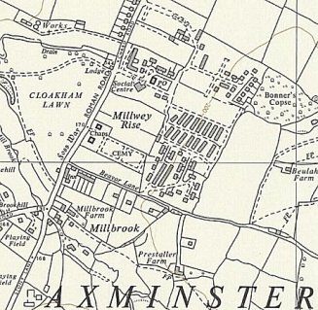
 | Possible site - Ordnance Survey 1963
[Axminster Heritage have published a booklet; ‘Millwey Rise: A Short History’ which shows the hospital buildings – go to ‘Youtube Millwey Rise’].

 | 1943 | 5.44 | 9.45 | 12.45 | 6.46 | 7.46 | 9.46 | 1.47 | 2.47 | 4.47 | 6.47 | 6.47 | 9.47 | 9.47 | 12.47 | 2.48 | 3.48 | 3.48
Axminster |  |  | It | ǂ | 175 | 176 | 170

Chudleigh, (Newton Abbott, Devon)

1943 / May 1944 - listed as a hostel for Italian pows

9/1945 – hostel for German pows.

Long gap – probably administered by a different HQ Camp.

12/1947 – Hostel leader; Robert Winter (B). 2/1948 – same

3/1948 – Hostel leader; Winkel.

 | 1943 | 5.44 | 9.45 | 12.45 | 6.46 | 7.46 | 9.46 | 1.47 | 2.47 | 4.47 | 6.47 | 6.47 | 9.47 | 9.47 | 12.47 | 2.48 | 3.48 | 3.48
Chudleigh | It | It | G | ǂ |  |  |  |  |  |  |  |  | 100 |  | 79 | 35 | 22 | 25

Chulmleigh.  Location - now the Playing Field and Community Centre in Leigh Road, Chulmleigh – NGR SS 680 143.  Hutted camp.  Information supplied by Ian Jury, a local resident:  “All the buildings top right in the field are the Camp as it was in 1947… the first Community Building was not erected until the early 1980s.  I can remember the wire fence and huts plus going over as a boy to watch the water/watch tower blown up in the early 1950s. All that remains visible is part of the concrete roadway into the camp from Leigh Road. I am told, but have not seen, that in very dry summers you can see the outlines of the foundations of the huts in the grass. If you are trying to find the site on an OS Map it is on the left of the road that runs from the town to the A377 just after the |council houses named Leigh Villas…  - After the war in the early 50s one of the huts was bought by the local Roman Catholics and moved to | 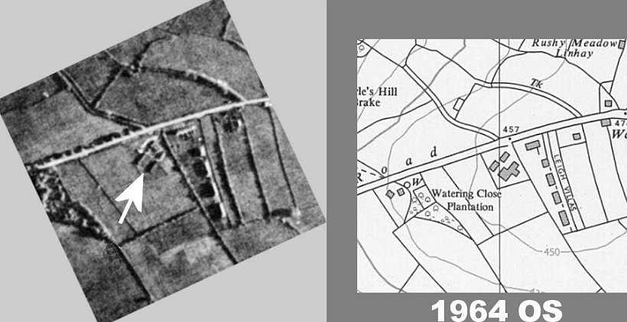
a site at the top of South Molton Street in the town to become their Church. That has now been pulled down... I guess the huts were a standard design and this one looks very like the ones in a photo I have seen of the Tiverton Camp. I have been told that another hut was bought by a local businessman for his chicken processing plant.

- I have back in Devon a notebook kept by a local man who worked at the Camp which lists which farms etc prisoners were allocated to work at - it is a sort of rota but does
not contain details of the prisoners. Some were bussed to farms in other villages several miles away EG Lapford and North Molton.

- One of the prisoners, Emile? Arthur? from Porz, a suburb of Cologne, was allocated to work with my father who ran a Market Garden. I can just remember him and being
carried on his shoulders up the hill into the village. On 28/5/1947 when he had returned to Germany he wrote (typed) a letter to my parents thanking them for a parcel they had sent to him – there was clearly a very good relationship with him.

- I also have a cutting from the Exeter and Plymouth Gazette dated 11/10/1946 with details of a Harvest Festival Service held in the local Congregational Church during which
“a double quartet was rendered by the German prisoners residing in the Camp at Chulmleigh”.

Early 1947 - there was a Catholic Youth Club for pows aged under 25.

12/1947 – Hostel leader; Daniels (B+)

2/1948 – Hostel leader; Peter (B)

After the camp, it is reported to have housed displaced person.

 | 1943 | 5.44 | 9.45 | 12.45 | 6.46 | 7.46 | 9.46 | 1.47 | 2.47 | 4.47 | 6.47 | 6.47 | 9.47 | 9.47 | 12.47 | 2.48 | 3.48 | 3.48
Chulmleigh | ǂ | ǂ | G | ? | 66 | 81 | 90 | 73 | 74 | 74 | 81 | 80 | ? | 70 | 88 | 37 | 15 | 14

Crediton - listed as a house. NGR SX 835 978.  Information from John Heal / creditonhistory.org.uk: the camp was located at Trobridge House. It held Italian and German pows.  7/1946 – German MO: S/Arzt. Dr Karl Uhlmann (B) | 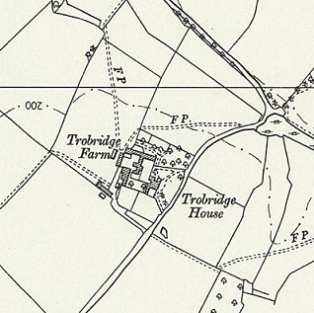
 | Ordnance Survey 1963

 | 1943 | 5.44 | 9.45 | 12.45 | 6.46 | 7.46 | 9.46 | 1.47 | 2.47 | 4.47 | 6.47 | 6.47 | 9.47 | 9.47 | 12.47 | 2.48 | 3.48 | 3.48
Crediton | ǂ | ǂ | G |  | 70 | 67 | 70

Cruwys Morchard – previously Camp 645/669 – see separate details. Cruwys Morchard House is at NGR SS 874 122.

11 July 1946 – became hostel for camp 92; “with Ps/W ex-USA, is a hutted camp, having its own power plant. There is ample accommodation at present for all purposes.”

9 September 1946 - English Inspector’s comment; “The PsW at Cruwys Morchard are all SS personnel including the teachers.”
6/1947 – Hostel leader; Dr. (Biol) Zinkernagel (B). Same 12/1947.

 | 1943 | 5.44 | 9.45 | 12.45 | 6.46 | 7.46 | 9.46 | 1.47 | 2.47 | 4.47 | 6.47 | 6.47 | 9.47 | 9.47 | 12.47 | 2.48 | 3.48 | 3.48
Cruwys M. |  | Camp 645/669 |  |  |  | 208 | 280 | 274 | 200 | 191 | 172 | 155 | 163 | 165 | 123

 | 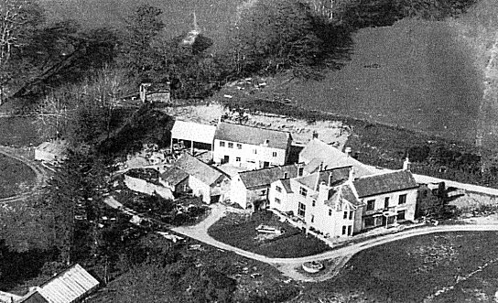  Dulverton (Barronsdown House – correct spelling Baronsdown). NGR SS 9327 2889.  Previously a large private house.  Opened as an Italian hostel. There is a memory that the Italian pows made ‘withy baskets and bowls’ – I expect these were for sale.  July 1946 – became a German hostel, described as; “a private house with its own dynamo. It is being opened on 13th July [1946] to accommodate the C grade Ps/W arriving on this date. The hostel leader his deputy and the re-education staff have been selected by the Commandant from the main camp. Two small dining rooms serve also for re-education and recreational purposes.”  19 November 1946 - “MORALE – Repatriation of party members has caused dissatisfaction. Morale otherwise fair.”  6/1947 – Hostel leader; Sommerfeld (B). 12/1947 – same leader.  Above, the house in the mid-1950’s. Baronsdown House was demolished in the 1960’s. |  |  |  |  |  |  |  |  |  |  |  |  |  | 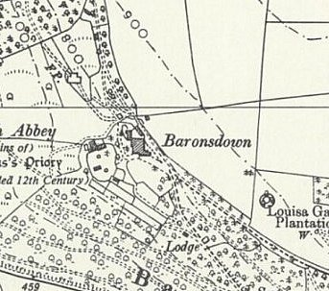
 |  |  |  |  |  |  |  |  |  |  |  |  |  |  | Ordnance Survey 1962
 |  | 1943 | 5.44 | 9.45 | 12.45 | 6.46 | 7.46 | 9.46 | 1.47 | 2.47 | 4.47 | 6.47 | 6.47 | 9.47 |  | 9.47 | 12.47 | 2.48 | 3.48 | 3.48
Dulverton |  | ǂ | ǂ | It | ǂ | ǂ | Nil | 90 | 81 | 77 | 76 | 73 | 71 | 80 |  | 82 | 69

Dymond’s Farm – previously Camp 76 – see separate details. SX 986 927.

 | 1943 | 5.44 | 9.45 | 12.45 | 6.46 | 7.46 | 9.46 | 1.47 | 2.47 | 4.47 | 6.47 | 6.47 | 9.47 | 9.47 | 12.47 | 2.48 | 3.48 | 3.48
Dymond’s Farm |  |  | Camp 76 |  |  |  |  |  |  |  |  |  |  |  |  |  |  | 7

Honiton. Possibly opened to re-house the pows held at Axminster Hostel?  Location; probable site within square ST 150 000 – and huts shown to the front of St Rita’s in the NE corner of the map (ST 1541 0037) - based on two sources:    1. Article by Jemima Laing, BBC Devon, 24 September 2010: “PoW story behind Devon wooden carving”  The carving made by German pow Otto Krasch had a date inscribed; ‘Christmas 1946’ - it was a gift to the family at the farm where he worked. It was later donated to Honiton’s Allhallows Museum. Otto was recorded as being held at Heathfield Camp in Honiton. Heathfield was an army camp and housed US troops until D-day. The Camp is shown on the map.  http://news.bbc.co.uk/local/devon/hi/people_and_places/history/newsid_9026000/9026698.stm  2. Information received from Margaret Lewis B.E.M., Curator Allhallows Museum, Honiton.  “Many years ago, a visitor from Australia came into the museum. He told me he was evacuated to Honiton from London, but never attended school. He spent most of his time with Italian POWs who were housed in a hut in a field close to where the St Rita’s Centre/Catholic Church is now - and he learnt how to roll cigarettes for them.  20 September 1946 - Exeter and Plymouth Gazette:  “GERMAN P.O.W. Help In Service At Honiton - Sixteen German prisoners of war camp at Broomhill attended the harvest festival service at the Honiton Congregational Church on Sunday evening. They read the Lessons and sang a hymn in their own language, and the Deputy Camp Warden translated the sermon, delivered by the minister (Rev. J. A. Jones) and accompanied the hymn on the organ a most impressive service.” | 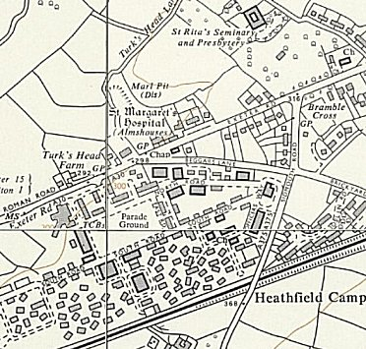
Probable site - Ordnance Survey 1963
Heathfield Camp & Broomhill House/St Rita’s Centre

5-6 December 1946 - a short report on this hostel. No reason given for this separate report.

Hostel leader; Uffz Erich Stauch. Screening A: 11 / B+: 41 / B: 79 / B-: 18 / C: 3.

Pows were from camps in the US – resentful at being relocated in the UK. They made little use of exit passes and films were poorly attended. Many of the younger pows still held Nazi views.

 | 1943 | 5.44 | 9.45 | 12.45 | 6.46 | 7.46 | 9.46 | 1.47 | 2.47 | 4.47 | 6.47 | 6.47 | 9.47 | 9.47 | 12.47 | 2.48 | 3.48 | 3.48
Honiton | ǂ | ǂ | ǂ | ǂ |  |  |  | 177 | 163 | 155

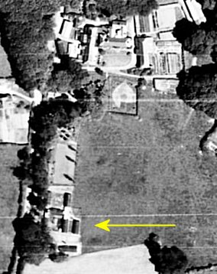  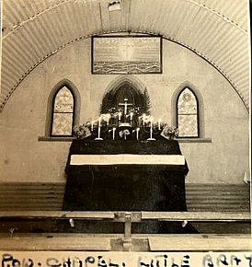  Little Bray – hutted camp. NGR SS 686 356. Aerial photo 1946.  Previously Devon Searchlight HQ. Nissen huts.  1945 - with Exhibition Field Camp 42.  1 April 1946 - Hostel transferred to Camp 92 – “a hutted camp pleasantly situated, electrically lit by its own power unit. The Ps/W are partly es-USA and British prisoners. It has 2 dining huts which serve also for re-educational and recreational purposes.”  7/1946 – A request was made by the Commandant to transfer the hostel leader, Hfw Karl Daniels (B-) to a different camp – no reason given.  12/1947 – Hostel leader; Horn (B+)  2/1948 – Hostel leader; Messmer (B+)  You can go glamping at this beautiful location in a converted pow Nissen hut - https://www.littlebray.co.uk/#main | 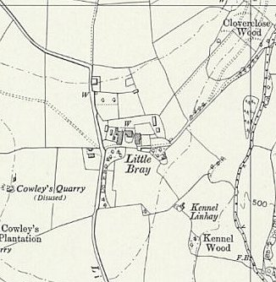
 | Ordnance Survey 1963

 | 1943 | 5.44 | 9.45 | 12.45 | 6.46 | 7.46 | 9.46 | 1.47 | 2.47 | 4.47 | 6.47 | 6.47 | 9.47 | 9.47 | 12.47 | 2.48 | 3.48 | 3.48
Little Bray |  |  | With C42 |  | 181 | 169 | 200 | 168 | 142 | 135 | 138 | 136 | 100 | 105 | 143 | 46 | 24 | 21

Nadderwater.

Hostel at Nadderwater opened during 1945 (before September) with 100 pows (Progress Report 154 - FO939/383)

Gap in records – possibly administered by a different HQ.

12/1947 – Hostel leader; Bellershelm (B)

2/1948 – Hostel leader; Loesche (B)

 | 1943 | 5.44 | 9.45 | 12.45 | 6.46 | 7.46 | 9.46 | 1.47 | 2.47 | 4.47 | 6.47 | 6.47 | 9.47 | 9.47 | 12.47 | 2.48 | 3.48 | 3.48
Nadderwater |  |  | G |  |  |  |  |  |  |  |  |  |  |  | 70 | 41 | 31 | 28

Pinhoe

Possibly became the enlarged Nissen Creek Camp 276, Pinhoe.

 | 1943 | 5.44 | 9.45 | 12.45 | 6.46 | 7.46 | 9.46 | 1.47 | 2.47 | 4.47 | 6.47 | 6.47 |  | 9.47 | 9.47 | 12.47 | 2.48 | 3.48 | 3.48
Pinhoe | ǂ | ǂ | It
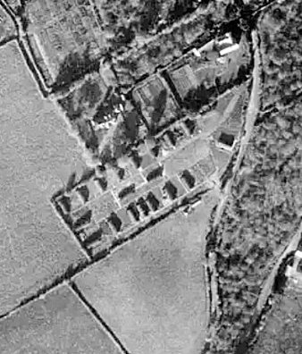  Silverton – hutted camp. NGR SS 955 027. Just S of the Three Tuns Inn and the cottage next door – some huts still showing on the 1962 OS map.  Information provided by Graham Parnell of the Silverton Local History Society; “it was in huts situated in the field in Exeter Road, Silverton, next to a property named “Cockhayne”, after the area was vacated by the 953rd Field Artillery Battalion of the US Army, when they left prior to D-Day.”  In early May 1946 this hostel was recorded as holding Austrian pows who were expecting to be repatriated in the near future. (The camp may have held Italian pows earlier than this). Later described as: “formerly for Austrians, accommodates Germans since 13th June 1946 and is a hutted camp, electrically lit, composed of Ps/W from the Channel Islands. There are two dining huts only, necessitating the serving of meals in two reliefs. These together with half a hut allocated as a reading room serve all re-educational and recreational purposes.”  Some additional information from Graham Parnell ties in with the visit report about Ps/W from the Channel Islands: “One German prisoner married a lady from Guernsey here in the Methodist chapel on 9th August |  |  |  |  |  |  |  |  |  |  |  |  | 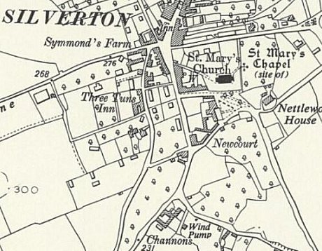
 |  |  |  |  |  |  |  |  |  |  |  |  | Ordnance Survey 1962
1947. He was Deputy Leader Werner Petri, and gave his address as 92 POW Hostel, Silverton. Presumably stationed on Guernsey where he was captured when Germany surrendered, he had met this female named Eugenie Le Poidevin there.”
The German pows from the Channel Islands had been held at other camps and hospitals before this. During the last months of the Islands’ occupation there were major food shortages – including for the German troops – many needed medical treatment before being sent to Camp 92.

6/1947 – Hostel leader; Riepe (B). 2/1948 - Same leader.
 | 1943 | 5.44 | 9.45 | 12.45 | 6.46 | 7.46 | 9.46 | 1.47 | 2.47 | 4.47 | 6.47 | 6.47 | 9.47 | 9.47 | 12.47 | 2.48 | 3.48 | 3.48
Silverton | ǂ | ǂ | G | ǂ | 240 | 233 | 235 | 101 | 93 | 74 | 95 | 93 | 43 | 42 | 45 | 26 | ? | 5

Waterloo Cross, Uffculme, Devon – Hutted camp. Memories place it by Waterloo Cross PH – ST 054 139.

1943 – Italian hostel.

17 March 1946 – Opened as a German hostel. Had electric lighting. “Morale – All PW are from the U.S. and are still resentful at their detention by this country. They are listless and do not appreciate the Cmdt’s efforts on their behalf. Symptomatic is the fact that little use is made of exit passes and films are poorly attended.

Although the majority disavow sympathy with National Socialism, the attitude of the younger element is a negative one and is based more often than not on mere disappointment at Hitler’s failure to “deliver the goods” in the form of victory. There is a marked contrast between the younger generation and the older men, who made the best of the third Reich without having expected anything but war from it. Very few of these had any connection with the Party. Among the politically interested there is a strong trend to the left.”

6/1947 – Hostel leader; Hern (B)

 | 1943 | 5.44 | 9.45 | 12.45 | 6.46 | 7.46 | 9.46 | 1.47 | 2.47 | 4.47 | 6.47 | 6.47 | 9.47 | 9.47 | 12.47 | 2.48 | 3.48 | 3.48
Waterloo Cross | It | It | It | ǂ | 120 | 111 | 110 | 91 | 89 | 88 | 97 | 107 | 105 | 71

