Camp 8 - Mile House, Shrewsbury Road, Oswestry, Shropshire

Included in the 1945 ICRC List - Base Camp 8 Mile House Camp, Oswestry, Salop.

Prisoner of War Camps (1939 – 1948) - Project report by Roger J.C. Thomas - English Heritage 2003
OS NGR | Sheet | No. | Name & Location | County | Cond’n | Type 1945 | Comments
SJ 3117 2825 | 126 | 8 | Mile House, Shrewsbury Road, Oswestry | Shropshire | 5 | Base Camp

Location: NGR SJ 309 287. The NGR above is for Mile House, which is just S of the camp.  Previous use: Farming land. A large camp with 6,000 pows was located near here during the First World War.  POW Camp: Opened in 1942. Wooden huts for accommodation. Geophysical surveys of the site showed fence boundaries, former hardcore roads, platforms for buildings, and a gate house or guard room.  Mile House was probably used as the postal address and may have accommodated British staff.  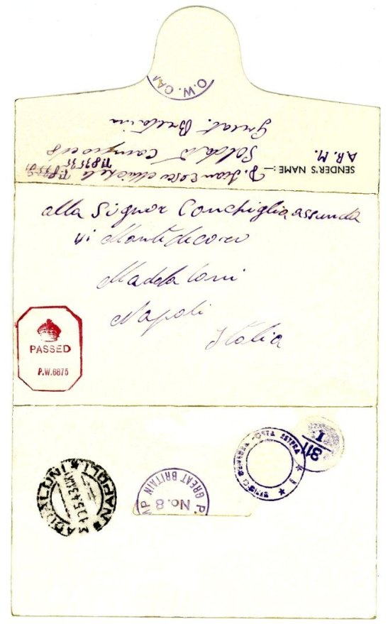  Records show Italian pows in 1942 and 1944 + postal item shown, dated March 1943. At some point it was used to house German pows prior to shipment to the USA. If they were at this site at the same time, Italian and German pows would have been held in separate compounds. Later, (probably 1945) it became a base camp for German pows.  10 March 1942 - ICRC report; only 442 pows with a capacity of 3000.  October 1944 - There is a record of 630 Russian and 111 Polish pows being transferred from No 8 Camp to 905 Camp Scriven  August 1945 - ICRC report – 245 pows. | 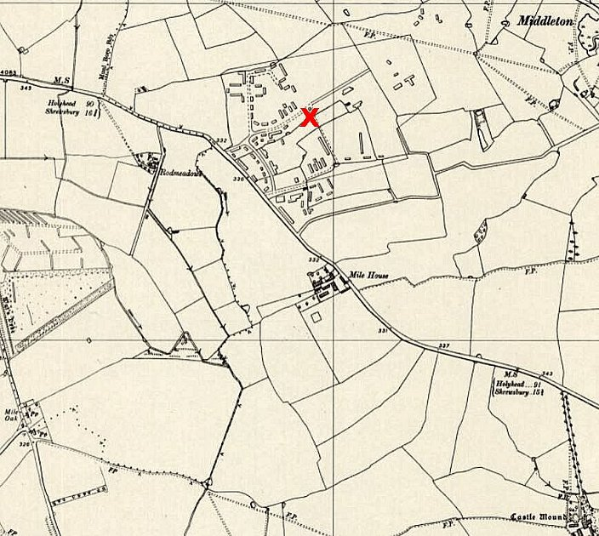
 | Ordnance Survey 1950
11 January 1946 – Report of Mr R D Miller’s English Educational visit. Total strength not given. There was a fairly new Commandant – Lt Col Hayward, who was interested in re-education.

55 pows were studying English with 4 pow teachers. Two of the teachers were political category ‘C’ (Nazis), but they were allowed to continue. Some of the pows gained diplomas for English.  There were several escapes from this camp, including a mass breakout.  Reportedly used up to 1948 – but, it is not listed in a mid-1947 camp list. (It may have become a pow hostel).  Listed as American Transit Camp No.4 located in the UK  The site was excavated by Wessex Archaeology. The camp was recorded as being spacious, made up of scattered barracks. Additional buildings included an infirmary, canteen, church, cookhouse, theatre and library.  There was electric lighting, sufficient toilets, hot and cold showers and wash basins. The pows had a large sports field, there were musical and theatrical performances, educational classes and carpentry workshops. Youth pows (under-25) had some additional provision to study.  Some of the findings included – A lead alloy toy camel, (perhaps Africa Corps link?); beer bottles, shaving brush, Brylcreem, San Izal disinfectant, an aluminium metal identification tag from a German soldier – and mysteriously, a loaded German Sauer 38H pistol commonly issued by the Wehrmacht – found hidden close to one of the buildings. | 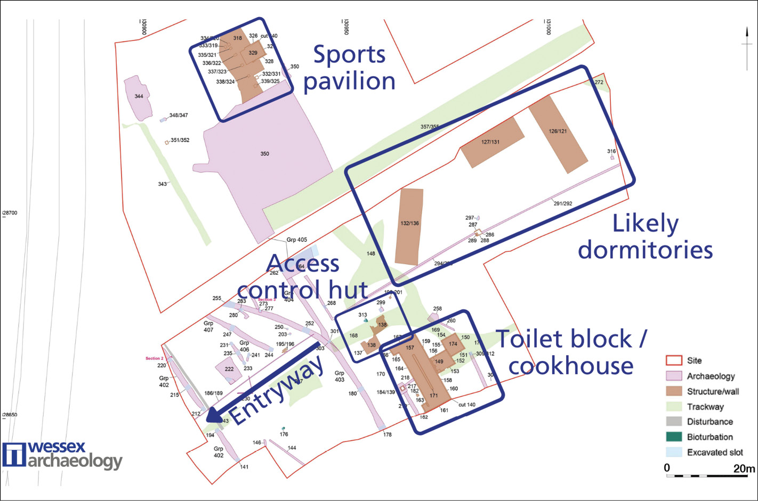
 | Reproduced with permission © Wessex Archaeology

After the camp: Site used as ‘Cae Mawr’ military camp. The land later returned to agriculture. Many camp buildings were demolished during the 1960’s and 1970’s.

The site as it is today - https://repatriatedlandscape.org/england/pow-sites-in-the-west-midlands/pow-camp-8a-mile-house/

Further information:

National Archives reference: FO 939/91 - 8A Working Camp, Mile House Camp, Oswestry, Salop – dated 1946. (Only 2 documents in the file – used above).

Link - Wessex Archaeology

Heritage Talk - https://www.youtube.com/watch?v=gkRAmk3oEoY

