**Camp 98** **- Little Addington Camp, Hill Farm Estate, Irthlingborough Road, Little Addington, Northamptonshire**

Included in the 1945 ICRC camp list – Labour Camp. 98. Little Addington Camp, Kettering, Northants.

|  |  |  |  |  |  |  |  |
| --- | --- | --- | --- | --- | --- | --- | --- |
| **Prisoner of War Camps (1939 – 1948) - Project report by Roger J.C. Thomas - English Heritage 2003** | | | | | | | |
| OS NGR | Sheet | No. | Name & Location | County | Cond’n | Type 1945 | Comments |
| SP 960 731 | 141 | 98 | Hill Farm Estate, Irthlingborough Road, Little Addington | Northamptonshire | 3 | German Working Camp | STANDARD type. |

|  |  |
| --- | --- |
| **Location:** Just S of Little Addington; 10 km SE of Kettering.  **Before the camp:** Farmland  **Pow Camp:** Listed as Italian working camp / labour battalion to at least 1945, then a German Working Camp.  The site had a standard layout with a main pow compound, with guards’ huts and offices at the front towards the road. Buildings included a water tower, offices, officer's mess, a canteen, guard rooms, barrack huts, ablution blocks, cell blocks, a camp reception station (medical facility/hospital), a cookhouse, dining rooms, recreation rooms and living huts.  Aerial photo 1947 >  **1943** – Opened for Italian pows. (Mail to Italy seen, dated May 1943).  **6 January 1944** - International Red Cross visit - Italian prisoners, capacity 560. |  |
| Ordnance Survey 1958 |

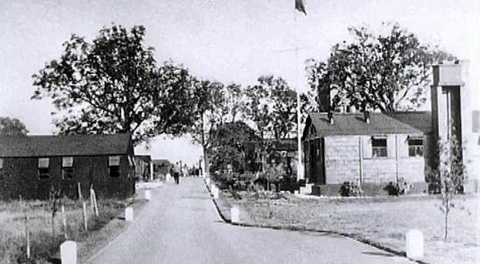**May and November 1944** - The camp was listed as an Italian Labour Battalion under the Eastern Command area, (WO 32/10737). The Italians were listed as co-operators. They were responsible for building a sewer through the village and also helped at the local farms. There was an Italian Chapel built inside one of the huts.

**1 August 1945** - an urgent memorandum was sent to this camp, and others, about maintaining records of Italians who were classed as ‘co-operators’. At this point many, sometimes all, of the Italian pows were placed in hostels / billets awaiting repatriation as German pows arrived.

**15 September 1945** - Hostels listed for pows from this camp, (WO 32/10737): Farndish, Wollaston, Bedfordshire – and, Upper Dean, Risley, Bedfordshire – both were later taken over as hostels for Ducks Cross Camp 72.

From the photographs, (with thanks to Robert Moore) the buildings appear to be mainly wooden construction, with some brick-built buildings requiring a more stable foundation such as the cookhouse.

**July 1946** – Listed as a Satellite camp for Weekley Camp 259 (separate details).

**After the camp:** Camp for European Volunteer Workers. 2019 industrial estate.

|  |  |
| --- | --- |
|  | **Further Information:**  < The Italian Chapel built inside a hut. |