Camp 102 - Llanddarog Camp, Llanddarog, Carmarthenshire

Included in the 1945 ICRC camp list – Labour Camp. 102. Llanddarog Camp, Carmarthen.

1947 Camp list
102(G.W.C.) | Llanddarog Camp, Llanddarog, Carmarthen | W. | Priswar, Porthyrhyd. | Carmarthen 7412 & 3 | Carmarthen | Lt.Col.T.C.L.Redwood | v/1453/2

Prisoner of War Camps (1939 – 1948) - Project report by Roger J.C. Thomas - English Heritage 2003
OS NGR | Sheet | No. | Name & Location | County | Cond’n | Type 1945 | Comments
 |  | 102 | Llanddarog Camp, Llanddarog | Carmarthenshire |  | German Working Camp | Wales

Location: SN 493 165. 1 km W of Llanddarog, 9 km SE of Carmarthen.  Before the camp: Farmland belonging to Cwm-coch.  Pow Camp: Listed as Italian working camp / labour battalion to 1946, then a German working camp. The site had a standard layout with a main pow compound, and with guards’ huts and offices at the front facing the road. Buildings included a water tower, offices, officer's mess, a canteen, guard rooms, barrack huts, ablution blocks, cell blocks, a camp reception station (medical facility/hospital), a cookhouse, dining rooms, recreation rooms and living huts. One hut was converted for use as a chapel.  1943 – hostel listed for Italian pows - Kilgetty  May and November 1944 - The camp was listed as an Italian Labour Battalion under the Western Command area and then as an Italian Working Camp, (WO 32/10737). The Italians were recorded as non-co-operators.  3 September 1945 – PID Progress report 153 recorded a new hostel for Italians at ‘W.L.A. Hostel Llandeilo’, capacity 50. (FO 939/383).  Oversight and development of re-education activities and English teaching for German pows was carried out by PID (Political Intelligence Department of the Foreign Office) / COGA (Control Office for Germany and Austria – UK). Visits and reports were made. The standard of the reports varied greatly. The visitors took little interest, if any, in activities other than re-education. They rarely mentioned welfare, sports, games, pastimes, crafts, etc of the pows. If there were still Italian pows in hostels, they were usually ignored by PID.  15 September 1945 - Hostel listed for this camp, (WO 32/10737): Sketty, Swansea, Glamorganshire. | 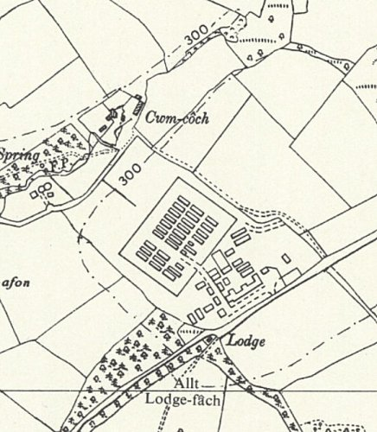
 | Ordnance Survey 1964
Spring 1946 – The camp changed from Italian to a German pow camp. There may have been Italians in hostels awaiting repatriation.

18 July 1946 – General Survey. Strength; 0 Officers, 1801 Other Ranks at HQ + 10 hostels.

Commandant: Lt Col Cooper Camp leader: Stabs.Bootsmann Erwin Dethlefs
Interpreter: S/Sgt F Kirk Deputy C/L: O/Maat Willi Beyer
German M.O.: None

Lt Col Cooper, like most Commandants, was co-operative with the visitor from PID, but had no interest in re-education – “He appears more concerned with the disciplinary efficiency of the camp.”

Morale was considered to be generally ‘good’ – lack of news about repatriation was a major negative factor. Many of the pows had recently arrived from camps in the USA – the report did not state this, but most had very low morale as they had been misinformed in the US that they were being repatriated. Instead, they found themselves in working camps in the UK. Most of the pows were “politically apathetic.” Pows also arrived from camps in Canada, Belgium and Germany as well as other camps in the UK.

At HQ, 80 pows were ‘youth’ (under 25), but they were not considered a problem.

The standard list of re-education activities was given, but little was occurring:

Wochenpost and Ausblick – 50/12 copies respectively.

Camp magazine – ‘Der Leuchtturm’ (The Lighthouse) – taken over from Camp 199 when it became a hostel.

Library – Only 150 books.

Visiting lectures – had started. Well received.

Discussion groups – Not started mainly due to late working at this time of year.

Films – No regular films.

English instruction – 25 pupils attending 2 classes on Saturdays.

Wireless - Set was controlled from the Camp leader’s office. Good reception, able to pick up broadcast from Hamburg.

Other camp activities –

Religion – 1/3 RC, 2/3 Protestant. A hut was used as a chapel.

Education – Classes for book-keeping.

Entertainment – A theatre was being built. An orchestra had newly been set-up using instruments left by the Italians.

18-20 October 1946 - As part of the re-education programme administered by the Control Office for Germany and Austria (COGA), Paul Bondy, a German-speaking refugee gave lectures at the main camp and 7 hostels. He recorded a camp capacity of 2,500.

12 November 1946 – Visit by a member of the Segregation Section of PID to review political screening. Strength 1676.

The camp had an acting Commandant; Major J Neyland. (He continued as 2nd i/c when a new Commandant was appointed).

Political screening: | A+ | A | A- | B+ | B | B- | C | C+ | Unknown/Others
 | - | 301 | - | 562 | 531 | 153 | 58 | - | 71

28-31 January 1947 – Re-educational survey + Hearing appeals against political grades. Strength; 3 officers, 1071 OR at HQ, 7 hostels + billets. Very bad weather prevented visits to all of the hostels.

Commandant: Lt Col T C L Redwood Camp leader: Hgefr Erich Ostermann (A+)
Interpreter: S/Sgt F Kirk Deputy C/L: Hwm Franz Albrecht (B+)
German M.O.: StArzt Josef Kettler (A) [at HQ] & StArzt Leo Rupp (A) [at Cheriton].

The new Commandant was supportive of re-education and other activities and was assisting their development.

Camp leader Ostermann had recently arrived from Camp 118. Very much in favour of re-education, he had attended the special training course at Wilton Park. He was later described as “A first class man. Energetic and intelligent… Is married to a French woman and awaiting repatriation to the Bordeaux area.” He promoted re-education activities.

Deputy Albrecht – “Sound type… a good disciplinarian who at the same time is honest.”

Political screening: | A+ | A | B+ | B | B- | C | Unscreened
 | 1 | 43 | 298 | 492 | 143 | 95 | 2

34 appeals were heard with 18 allowed, (the better the grade, the sooner repatriated, in theory). Another 72 appeals were pending. 583 pows repatriated to date – a very large number in comparison to other camps.

Morale was considered to be “fairly good.”

Some hostels were 50 miles or more from HQ - this had an affect on their activities. One example given was that pows from some hostels had to pay for transport to play football matches – the cost for long distances travelled meant a player had to lose 2 days pay to cover the charges. The Commandant agreed that a monthly camp conference of all the hostel leaders should be held.

Just over 40% of pows were ‘youth.’ This included 160 pows who had been conscripted into the Waffen-SS, (many were given no choice). The visitor believed more should be done to develop their understanding of democracy.

The standard list of re-educational activities was given with many improvements:

Wochenpost and Ausblick – separate appendix.

Newspapers – A wide range of British daily and weekly papers were paid for from the Welfare Fund raised from profits of sales in the canteen. COGA sent copies of The Times and Telegraph. Some German papers were arriving at irregular intervals – two of these were seen to be Communist propaganda.

Library – Very good stock. Books distributed to hostels.

Lectures – regular with mixed reception.

Discussion groups – None. They had started, but many of the leaders had been repatriated or transferred.

Films – The camp had 2 projectors – 1 for silent films and 1 for sound films. Films supplied by COGA and YMCA, charged 2d per pow. Gaumont British also visited, but they charged 6d which many pows thought was far too much. In addition to the charges made to each pow, a further charge of 12/- (12 shillings) was made to the Welfare Fund to pay for heating and lighting – naturally this caused resentment. The films also visited all hostels.

Wireless – sets at all sites. German and BBC news, and dance music were popular.

Camp magazine – rated as “first class.” 220 copies were printed monthly – COGA took 60 copies to distribute to other camps. The Commandant took great interest in the magazine. There was a special press publishing hut. Supplies of paper and stencils from COGA were often delayed.

Press review – twice weekly at HQ. A daily news-sheet was also published, (Tagesspiegel).

Wall Newspaper – These were created in HQ and circulated to the hostels.

Information room – exhibitions on various topics were displayed in a temporary hut and the canteen. It was hoped to build a dedicated information room.

Other camp activities -

Religion – Considerable interest was shown. Weekly services and Bible classes held. RC Padre Major Hans Frense (A) – “Pleasant type, who although always ready to carry out his spiritual duties, is inclined to think of his ‘self-importance.’”

Protestant Padre, Uffz Johannes Hasse (B+) – “Quiet unassuming type rather wrapped up in spiritual affairs.”

Education – no classes other than English and Bible studies.

Entertainments – The theatre group had ended due to repatriations and pow movements. A good orchestra with 8 members at HQ also toured the hostels. Intercamp football matches and some against civilian teams.
23/27/28 May 1947 – Re-educational survey. Strength; 3 officers, 1474 OR.

A new Deputy C/L; Hwm Emil Topol (B).

Political screening: | A+ | A | B+ | B | B- | C | C+
 | 1 | 18 | 316 | 805 | 285 | 47 | 5

62 appeals pending. 789 pows repatriated to date.

Morale was “fairly high” except at Carew-Cheriton. The Commandant was active in developing a variety of activities within the camp.

The standard list of re-education activities was given – more or less a copy of the previous report. The promised Information Room had been opened.

Religion – as well as camp services, pows were able to attend local church services.

Entertainment – Over Whitsun a ‘Sports Gymkhana’ was held with teams from HQ and the hostels. A theatre group had recently been formed, they gave performances at HQ, hostels and at the nearby POW Abergwili Military Hospital Camp 252. The orchestra had expanded to 14 members and was regarded as very good – they gave concerts to HQ, hostels and at some civilian venues.

Outside contacts – Many pows formed informal links with local families. Formal links were very limited; 10 pows attended Sunday meetings at the Carmarthen Followship Society. It was hoped more links would soon be established.

16-18 September 1947 – Re-educational survey. Strength; 149 Officers, 1227 OR.

Two changes to senior personnel, both were German M.O.’s – Dr Heinz Guldin at HQ and Dr Heinrich Stahl at the satellite camp.

Simplified screening was in use: A – 6; B – 1370. 976 pows repatriated to date.

Morale was considered to be, “good on the whole.”

Many activities had been suspended due to harvest work and greater freedom for pows to leave the camp. Two education classes had been set up at HQ for mathematics and book-keeping.

Formal outside contacts continued to be poor – a small group had visited Swansea Town Hall and a council meeting; the Carmarthen meetings continued; and some pows were able to attend Neath Youth Club.

14 November 1947 - Camp number included in an ‘Urgent Memorandum’ (FO 939/270) regarding inspection of food parcels.

15 January 1948 - “Camp 70 is to take over Camp 102 (Llanddarog) as a hostel as from 15th January, 1948. It has been arranged with the C.O. of camp 70 that the camp staff and the press group now at 102 will stay after the take-over and that re-educational activities in 102 will continue undisturbed.” (Extract from a PID report for Henllan Bridge Camp 70). Neath Satellite and its hostels were not recorded as being transferred to Camp 70.

Known Camp Commandants:
1946 Lt Col Cooper
1947 Lt Col T C L Redwood, from the Royal Northumberland Fusiliers.

After the camp: 2019 farm and farmland

Further Information:

National Archives - FO 1120/224 – ‘Re-educational survey visit reports for camps 100 to 106’ – used above.

US 1944 US Aerial Photograph, Medmenham Series M1281; 1017

The Imperial War Museum has copies of the magazine, dated June / Christmas 1947, Ref LBY E.J.388. The German Federal Archives also has a copy, date unknown.

Camp Magazine, August 1947 - Der Leuchtturm : Monatzeitschrift Camp 102 - The Wiener Holocaust Library

Catalogue entry - 22 - Church Records of the Evangelical congregation at camps 199, 102, 252 and 70, all in South Wales - 1946-1948

Numbers of pows

 | Open |  |  | With other camps |  |  | Unknown |  |  | Not open

 | 1943 | 1945 | 7/1946 | 11/1946 | 1/1947 | 5/1947 | 9/1947 | HQ  and hostels
Main |  |  | 336 |  | 292 | 337 | 370
Kilgetty |  | With C70 | 141 |  | 63
Llandeilo WLA |  | Cap 50 | 53 |  | 32
Sketty
Carew-Cheriton |  |  | 274 |  | 208 | 335 | 50
Crosshands |  |  | 37
Llandovery |  |  | 44 |  | 39 | 38
Paskeston |  | With C70 | 66
Steynton |  |  | 329 |  | 106 | 198 | With C70
Trewarren |  |  | 69 |  | 29 | 64 | With C70
Warren |  |  | 219 |  | 106 | 201 | 154
Ystrad |  | Camp 199 | 233
Pen-y-coed |  |  | With C70 |  |  |  | 81
Neath Satellite | Camp 284 |  |  |  |  |  | 118 | Satellite and hostels
Heronstone |  |  |  |  |  |  | 49
Marcross |  |  |  |  |  |  | 66
St Mary Hill |  |  |  |  |  |  | 40
Llantrithyd |  |  |  |  |  |  | 57
Brynhill |  |  |  |  |  |  | 51
Billets |  |  | ? |  | 199 | 254 | 30
TOTALS |  |  | 1801 | 1676 | 1074 | 1477 ⁽¹⁾ | 1376

1. + 50 detached to Recreation Ground, South Littleton Camp 277.

Neath Satellite Camp (previously independent Abbey Road, Neath, Camp 284)

9/1947 – Neath was a satellite for Llanddarog, but it continued to administer its hostels.

Camp leader; Erich Nelles (B+). Morale was affected due to the police refusing to allow pows into Neath except for organised visits.

Had a 6-man orchestra and a theatre group.

16 December 1947 - A brief mention in the House of Commons, 1947:

“Mr. D. J. Williams asked the Secretary of State for War when the buildings at Abbey Road, Neath, Glamorganshire, now used to accommodate prisoners of war, will be vacated; and if he is aware that the Neath Borough Council is anxious to make use of these buildings for housing purposes in view of the serious housing problem locally.

Mr. Shinwell - I am not yet in a position to make a statement about the future use of this accommodation.” (Hansard, 16 December 1947, Vol 445).

January 1948 - NOT listed as being transferred to Henllan Camp 70.

 | 1943 | 1945 | 7/1946 | 11/1946 | 1/1947 | 5/1947 | 9/1947
Neath Satellite | Camp 284 |  |  |  |  |  | 118

Hostels

Brynhill. Possibly near Brynhill Golf Course, Barry – ST 106 698 – NOT confirmed. One memory recorded Italian pows in the area.

9/1947 – Hostel leader; Alfred Neumann (B-)

 | 1943 | 1945 | 7/1946 | 11/1946 | 1/1947 | 5/1947 | 9/1947
Brynhill |  |  |  |  |  |  | 51

Carew-Cheriton.

7/1946 – Hostel leader; HFw. Hans Eslkamp

1/1947 – Hostel leader; Heinrich Witzel (B)

5/1947 – Same leader. Mainly older pows, many of whom were depressed over the slowness of repatriation and seeing other younger pows sent home before them.

9/1947 – Hostel leader; Heinrich Prinz (B+) – “No good. Appears to be an idler.” A replacement was being sought.

After this, listed as a hostel attached to Henllan Bridge Camp 70.

“Rev. Lewis’s own wartime memories were connected to RAF Carew Cheriton where his father was vicar of the Parish Church in the village. He told the Control Tower Group he particularly remembered being ill in bed with measles at Christmas in 1948 when he heard people singing in the drawing room beneath his bedroom. Moments later shabbily dressed men stood beside his bed looking over him. Peter explained they were Germans from the local Prisoner of War Camp who had been invited to his home by his father after rules on fraternisation had been relaxed.
He said he would always remember a German POW telling him how, when he returned to Germany, he would tell of the friendship he found in Carew Cheriton and report that the British were not all bad as they had been led to believe.” https://www.carewcheritoncontroltower.co.uk/blog/raf-robeston-wathen/

 | 1943 | 1945 | 7/1946 | 11/1946 | 1/1947 | 5/1947 | 9/1947
Carew-Cheriton |  |  | 274 |  | 208 | 335 | 50

Crosshands (Cross Hands).

Probably attached to a different main camp before / after this single entry.

7/1946 – Hostel leader; Fw Willi Bottcher

 | 1943 | 1945 | 7/1946 | 11/1946 | 1/1947 | 5/1947 | 9/1947
Crosshands |  |  | 37

Heronstone. (Location ? – Could be Hernstone?).

9/1947 – Hostel leader; Rudolf Spoerl (B)

 | 1943 | 1945 | 7/1946 | 11/1946 | 1/1947 | 5/1947 | 9/1947
Heronstone |  |  |  |  |  |  | 49

Kilgetty At the junction of Rylands Lane / Woodfield Avenue. NGR SN 126 076.  1943 – listed as hostel for Italian pows.  9/1945 – listed as a hostel for Henllan camp 70 (WO 32/10737).  7/1946 – Hostel leader; Ofw. Alfred Gisell  1/1947 – Hostel leader; Stfw Otto Fritz (B+)  “In 1944 I used to deliver milk to the camp, which was in fact built during the Second World War to accommodate Italian prisoners of war. The Italian POWs occupied the camp for a number of years until they were moved out and replaced with German POWs. The Germans also occupied the camp for some time. | 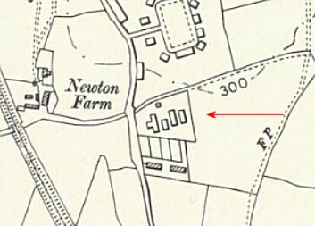
 | Ordnance Survey 1964

When the Germans were taken from the camp, it was then that it was occupied by the Polish male evacuees.

The Italian and German prisoners were given some freedom to roam, being allowed to use the football pitch at Newton Field and permitted to walk unattended as far as Trewern Bridge on Ryelands Lane, where there was a sign informing them that they should pass no further. Terry James, Little Newton, Kilgetty.”

https://www.narberth-and-whitland-today.co.uk/article.cfm?id=74&headline=Memories%20of%20The%20Camp&sectionIs=letters&searchyear=2014

 | 1943 | 1945 | 7/1946 | 11/1946 | 1/1947 | 5/1947 | 9/1947
Kilgetty |  | With C70 | 141 |  | 63

Llandeilo W.L.A. Hostel (Previously a Women’s Land Army Hostel).

No primary sources for the Women’s Land Army hostel have been found, though a hostel at Llandeilo (PRN 50284) is known locally and from a biography of a land army veteran, M Harries, held at the Imperial War Museum (Documents 1411). (http://www.iwm.org.uk/collections/item/object/1030000346) .

7/1946 – Hostel leader; O/Maat Kurt Bruggemann

1/1947 – Hostel leader; Fw Felix Pawlak (B-)

 | 1943 | 1945 | 7/1946 | 11/1946 | 1/1947 | 5/1947 | 9/1947
Llandeilo WLA |  | Cap 50 | 53 |  | 32

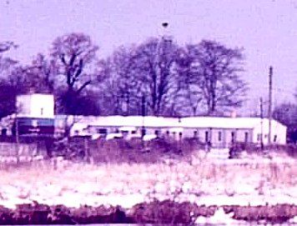  Llandovery. NGR SN 773 345.  Memories of Italian pows - if correct, it was administered by a different HQ before these entries.  7/1946 – Hostel leader; Ofw Herbert During  1/1947 – Hostel leader; Wm Karl Blankenburg (B) 5/1947 – same leader.  A glimpse of the hostel >  1943 1945 7/1946 11/1946 1/1947 5/1947 9/1947  Llandovery 44 39 38 | 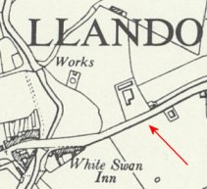
 | Ordnance Survey 1964

Llantrithyd. Within Llantrithyd Park. NGR ST 049 739.  9/1947 – Hostel leader; Karl Studt (B-)  1943 1945 7/1946 11/1946 1/1947 5/1947 9/1947  Llantrithyd 57 | 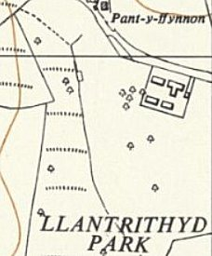
 | Ordnance Survey 1964

Marcross. NGR SS 926 692 – NOT confirmed.  9/1947 – Hostel leader; Georg Nuesslein (B)  1943 1945 7/1946 11/1946 1/1947 5/1947 9/1947  Marcross 66 | 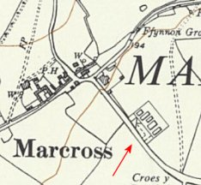
 | Ordnance Survey 1964
Paskeston. Location? Probably near to Paskeston Hall / Farm – SN 02 03

7/1946 – Hostel leader; O/Machinist Georg Aust

 | 1943 | 1945 | 7/1946 | 11/1946 | 1/1947 | 5/1947 | 9/1947
Paskeston |  | With C70 | 66

Pen-y-coed

9/1947 – Hostel leader; Franz Muetherich (B+) – “Quite a good type.”

They were unable to show films as it had a private lighting plant which was AC – the projectors used DC. The local village hall was asked to allow film shows for the pows. The electric supply also meant the hostel only had a weak battery wireless.

After this returned to administration of Henllan Bridge Camp 70.

 | 1943 | 1945 | 7/1946 | 11/1946 | 1/1947 | 5/1947 | 9/1947
Pen-y-coed |  |  | With C70 |  |  |  | 81

Sketty, Swansea, Glamorganshire

 | 1943 | 1945 | 7/1946 | 11/1946 | 1/1947 | 5/1947 | 9/1947
Sketty

St Mary Hill, Garwa Quarry, NGR SS 975 797.  “Modern mapping and aerial photographs reveal the trackways which once served the camp - one running parallel to the road, others running northwest-southeast to create a distinctive square enclosure.  Aerial photographs daring from 1945 show an intricate complex of tents and larger buildings aligned with trackways. The camp hosted US Army troops from December 1943… After the camp had been vacated, lower-ranked German prisoners of war were brought from Island Farm Camp. Repatriation continued until 1948, after which the camp was abandoned.” https://coflein.gov.uk/en/site/415460/  9/1947 – Hostel leader; Artur Gonschorek (B) | 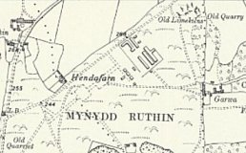
 | Ordnance Survey 1964

 | 1943 | 1945 | 7/1946 | 11/1946 | 1/1947 | 5/1947 | 9/1947
St Mary Hill |  |  |  |  |  |  | 40

Steynton. NGR SM 910 074.  7/1946 – Hostel leader; HFw. Josef Feldmann  1/1947 – Hostel leader; Omaat Rudolf Herzog (B+). 5/1947 – same leader.  1943 1945 7/1946 11/1946 1/1947 5/1947 9/1947  Steynton 329 106 198 With C70 | 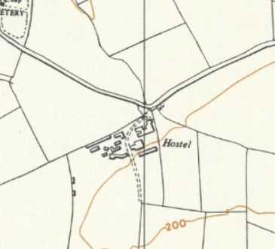
 | Ordnance Survey 1964

Trewarren listed as a house – SM 8293 0703.  Requisitioned 1942 and used as a HQ for a light Anti-aircraft battery.  7/1946 – Hostel leader; F/W Willi Kliem  1/1947 – Hostel leader; Ofw Gerhard Kraemer (B-). 5/1947 – same leader.  Transferred to administration of Henllan Camp 70 late summer 1947.  1943 1945 7/1946 11/1946 1/1947 5/1947 9/1947  Trewarren 69 29 64 With C70 | 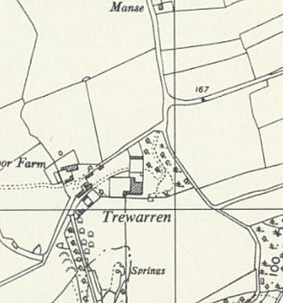
 | Ordnance Survey 1964

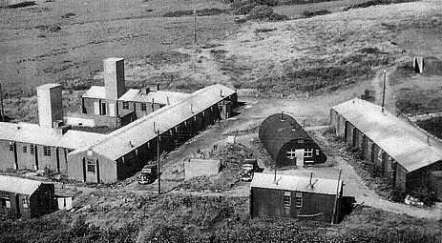  Warren. NGR SR 931 975. Photo:  www.facebook.com/photo/?fbid=1070703504440757&set=pcb.1070706797773761  7/1946 – Hostel leader; HFw Willi Zimmermann. 5/1947 – same leader.  5 May 1947 – Entry in camp magazine – “Our comrade Niels Ploehn from the Warren Hostel died in a tragic accident at the age of 21. He was buried in Carmarthen Cemetery on 9 May 1947.” He was later reinterred at the Cannock Chase German Military Cemetery.  9/1947 – Change in nature of hostel with 146 officers, 8 OR. The officers were volunteer workers.  Hostel leader; Hauptmann Fritz Borsi (B) – “Very capable but inclined to be a little too plausible.” [What does that mean?]. Some friction between the pows and the leader was noted, but not explained. | 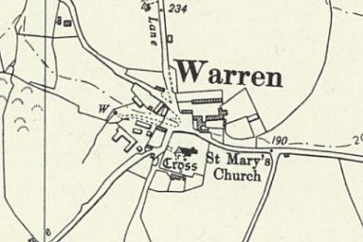
 | Ordnance Survey 1964

Extract from ‘A German Soldier’s Story’;

I have vivid memories of countries where I have been, the country and people where I belonged, Germany, but none more so friendly inhabitants of Warren and Castlemartin. They have demonstrated in the passage of time, that they can accept and make a stranger welcome. An attribute that can all too often fail in everyday life, when put to the test…..

Having been wounded in retreat from Normandy to Holland, I found myself at St. Lawrence Hospital, Chepstow — on the disused race-course, from where a number of us were transferred to Warren camp adjacent to the church.

We then had to learn to integrate with the people and the farming fraternity in the local region. It is at this stage, I feel compelled to bring the people of Warren and Castlemartin into focus, because we were the first German Prisoners of War in the vicinity. At the beginning the language barriers presented some difficulty in forming a foundation for a welcoming and lasting friendship.

Our first task was the involvement in a major draining scheme on the courses of Castlemartin, under the supervision of local selected men from the village who were in charge of a group of fifteen P.O.Ws. The supervisor of the gang I belonged to was Mr Walter Phillips, who lived in the Pound Cottage, Castlemartin, whom we addressed as “Bismark,” this was out of affection rather than malice. I recall one day when it was my turn to be acting tea-boy for the gang, when Mr Phillips gave me a valuable lesson on how to catch eels in the leet, and to construct a spit over a open fire, in order to supply the gang with smoked eel to supplement the camp rations.
The British officer to whom we were responsible for military matters was Major Smith, who had his office in the camp. I cannot recall anyone having to be disciplined by the Major for insubordination or misconduct in the P.O.W camp. Anyone with theological problems could look for guidance to the vicar of the village at that time, the Reverend Whitby James, who would stint no effort to come and visit us at the camp. It was he who extended an invitation to all.

A drinking trough situated in the West Lane adjacent to the churchyard served as a washing facility on account of a failed water supply in the camp, because of atrocious weather.

I was one of many, who moved out of the camp, and into the home, and private dwelling of the then Mr and Mrs W.G Wynne, Mellaston Farm, Hundleton, until Christmas 1948, when I returned home to be officially discharged by the German authorities.

https://www.bbc.co.uk/history/ww2peopleswar/stories/23/a4025323.shtml - WW2 People's War is an online archive of wartime memories contributed by members of the public and gathered by the BBC.

 | 1943 | 1945 | 7/1946 | 11/1946 | 1/1947 | 5/1947 | 9/1947
Warren |  |  | 219 |  | 106 | 201 | 154

Ystrad. Had been independent camp 199.

7/1946 – Hostel leader; S/Fw Hans Kummer

9 August 1946 – additional survey report. The camp/hostel had its own orchestra which toured the hostels, and a library of 650 books.

 | 1943 | 1945 | 7/1946 | 11/1946 | 1/1947 | 5/1947 | 9/1947
Ystrad |  | Camp 199 | 233

