Camp 111 - Deer Park Camp, Monymusk, Aberdeenshire (+Harlaw)

NOTE – there was another Deer Park Camp in Midlothian – Camp 16.

Included in the 1945 ICRC camp list – Labour Camp. 111. Deer Park Camp, Monymusk, Aberdeen.

1947 Camp list
111(G.W.C.) | Deer Park Camp, Monymusk, Aberdeen | Sc. | Priswar, Monymusk | Monymusk 29 | Monymusk | Major T.Smith | v/1452/2
The entry above has been crossed out in blue crayon and the following details handwritten on.
 | Harlaw, Inverurie, Aberdeenshire |  | Inverurie | Inverurie 209 | Inverurie | Name has not been crossed out

Prisoner of War Camps (1939 – 1948) - Project report by Roger J.C. Thomas - English Heritage 2003
OS NGR | Sheet | No. | Name & Location | County | Cond’n | Type 1945 | Comments
 |  | 111 | Deer Park Camp, Monymusk | Aberdeenshire |  | German Working Camp | Scotland

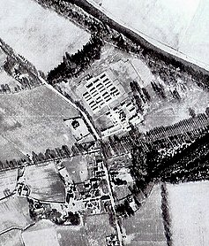  Location: NGR NJ 684 155  Before the camp: Deer Park  Pow Camp: Listed as Italian working camp / labour battalion to at least 1945, then a German Working Camp.  “The huts at Monymusk had a concrete base and frame, and were built from hollow bricks with a pitched corrugated asbestos roof... They were heated by a pot-bellied stove and those at Monymusk housed 35 men sleeping on simple wooden bunks. There were also blocks for the latrines, wash-houses, cook house, boiler house, canteen, stores and medical areas.  Sporting activities, workshops, concerts and lectures were put on inside the camp. Mr Whiteley who was the Dominee of Monymusk School gave Monday evening English lessons to the prisoners. Many of the PoWs worked at the farms in the area and had picked up some of the local Scots’ words, for example when Mr Whiteley was teaching them the English word for 'potato', he was corrected by the PoWs with "na, na, tatties!"  Some of the Catholic refugees built a small chapel in one of the huts. They constructed the altar from wood, cardboard and tin and a Ukrainian artist decorated it with paintings of famous Saints and a copy of Leonardo Da Vinci's Last Supper over the altar. There was also an elaborate chandelier made from biscuit tins. Mrs Whiteley attended the inauguration ceremony for the chapel and later said she was "moved to see those weather beaten faces with tears | 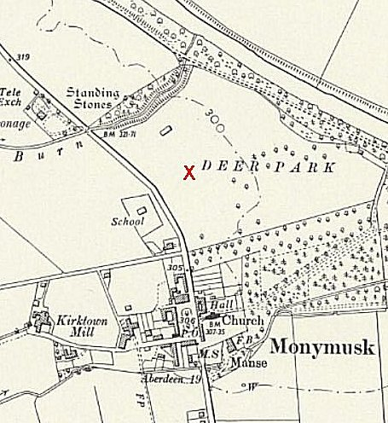
 | Ordnance Survey 1958
on their cheeks." After the ceremony there was a dinner celebration of bortsch which is an eastern European dish made from beetroot.” (from https://www.monymusk.com/ )

1943 – camp opened.

28 May 1943 - There was an International Red Cross inspection - Italian prisoners, capacity 750.

1943 - Hostels listed for Italian pows; Alford, Ballater, Culter.
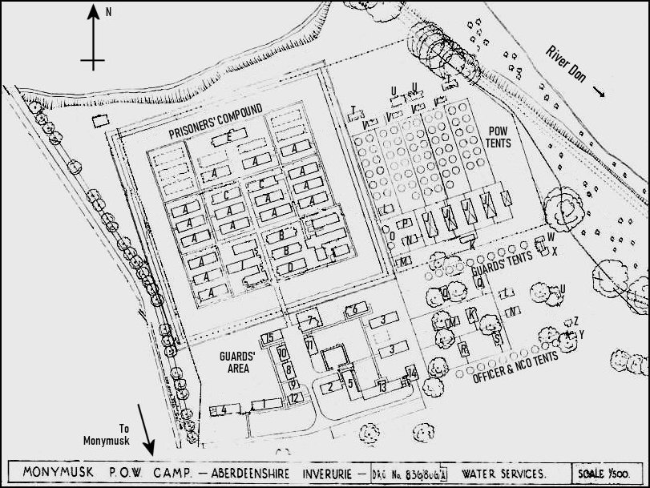 | 1943 Plan of the Camp  Note, I have enhanced the original plan.  Prisoners’ Section  A B C D E F G H I Living hut Dining hut Ablutions & latrines Recreation hut Drying room & showers Cookhouse Workshops (shoemaker, tailor, barber) Grocery & local produce store Reception  Guards’ Section  1 2 3 4 5 6 7 8 9 10 11 12 13 14 15 Officers’ living hut & latrines WOs’ & sergeants’ living hut & mess Guards’ living hut Officers’ mess & ablutions Guards Cookhouse & Showers Guards’ ablutions, latrines & drying room Detention block Quartermaster’s office Water tower & quartermaster’s store Company office & store Guard hut & small arms ammunition Store Tool shed and M/A officer Regimental institute & guards’ dining Commandant’s Office  Tented Area  J K L M N O P Dining Tent Cookhouse Recreation Orderly Drying Office Tent Technical

Q  R  S | Guard Dining  Officer Dining  Warrant Officers & Sergeants Dining | T  U  V | Latrines  Showers  Ablutions | W  X  Y | Guards Ablutions  Guards Latrines  Officers Ablutions & Latrines | Z | Warrant Officers & Sergeants Ablutions & Latrines

At the back of the pow compound there appears to have been plans to build some additional huts – these were not completed as shown in a later 1947 plan. The tented areas were removed later.

5 May 1944 - Hostels listed for Italian pows from this camp, (WO 32/10737): Ballater, Aberdeenshire; Culter (Allers Farm), South Lanarkshire (Incorrect address, see below).
May and November 1944 - The camp was listed as an Italian Labour Battalion under the Scottish Command area and then as an Italian Working camp, (WO 32/10737). The Italians were recorded as non-co-operators.

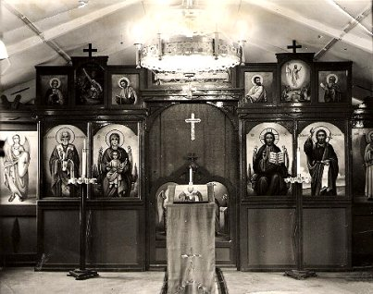 | 15 September 1945 - Hostels listed for pows from this camp, (WO 32/10737): Alford, Aberdeenshire; Insch, Aberdeenshire.  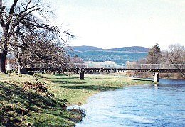  Memories – “Italian POW’s from the nearby camp at Monymusk were also to be seen in the village in the latter war years. These gentlemen provided labour for the local farms and were often transported through the village on lorries to the various farms. They were generally a friendly and amiable lot with little interest in the war, they seemed to have more interest in ogling the local girls. I remember that one of my friends had told me a rather rude and offensive Italian phrase and on the next occasion when the POW’s were being transported through the village, I shouted this phrase at them. My Italian was obviously understood for an enraged Italian jumped from the lorry and rushed towards me. I took off up the main street pursued by the Italian followed in turn by a rather bemused guard. I decided there and then to avoid any further experiments with the Italian language.” (WW II Memories of Alastair Craig - http://www.kemnay.info/history/world-war-ii/?LMCL=on9qDN ).  1 August 1945 - an urgent memorandum was sent to this camp, and others, about maintaining records of Italians who were classed as ‘co-operators’. At this point many of the Italian pows were in hostels / billets.  The bridge over the River Don by Enzean Farm was constructed by German and Italian PoWs from the camp.
Moneymusk Chapel – sadly demolished.

Apparently the two nationalities refused to work together and every second day would change.

24 August 1946 – Camp magazine started – ‘Deer Park Ring.’ Extract; “Our camp has become a little piece of home with its floral decorations and its very important vegetable gardens. Thanks to the willing cooperation of our sports friends, the sports field has been put in good condition. And when it is cold and wet outside - the ping-pong hall is fun for us.
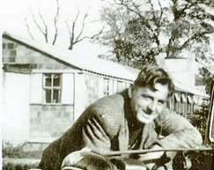 | A small, almost modern theatre room for film and stage plays has been created, a choir has been formed, a small orchestra with instruments is already partly in place and will be strengthened and promoted by additional members.”  The magazine included, a timetable of education classes for; English at various levels, German, maths, commercial studies, shorthand, arithmetic, mechanical engineering, and book-keeping.  8 August 1947 - there was a fatal accident Inquiry at Aberdeen Sheriff Court –  “Erich Behrendt, German prisoner of war, No. 111 Prisoner of War Camp, Monymusk, Aberdeenshire, died on 25 Aug 1947 at the camp from injuries sustained on the same day in the railway station yard at Monymusk when he was struck on the left shoulder and neck with a wooden board.” (Scottish National Records Office – ref SC1/16/1947/13). He was later reinterred at the Cannock Chase German Military Cemetery.  < Picture taken just after the camp had closed – showing the type of buildings in use.

Known Camp Commandants:
1947 Major T Smith

After the camp: Site used to house displaced persons under the European Voluntary Worker scheme. Huts gradually sold. 2019 residential area.

Further Information:

The Monymusk estate website ( https://www.monymusk.com/ ) has plans for:
Monymusk POW Camp, Water Services, Ministry of Works, Sanitary Eng. Branch, Edinburgh, 1943.
Monymusk POW Camp, Layout of S.D. (Sewage) Works, Ministry of Works, Sanitary Eng. Branch, Edinburgh, 1944.
Monymusk Home Farm, Deer Park Field , 1947 (former POW camp)
Ordnance Survey Map of Monymusk Camp, 1977

http://canmore.org.uk/site/107500

Vertical air photograph 58/RAF/1296 F21 0071, dated 15 October 1953

IWM have a copy of the camp newspaper from February 1947 – Reference LBY E.J. 344

Edition No.1 of Camp Magazine - Deer Park Ring : Lagerblatt Monymusk Camp 111 - The Wiener Holocaust Library

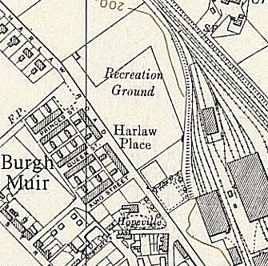 | Harlaw  The alteration to the 1947 camp list for Camp 111 becoming; ‘Harlaw, Inverurie, Aberdeenshire’ - is not resolved.  Inverurie is about 9 miles NE of Monymusk. On the North of Inverurie is Harlaw Place at NGR NJ 771 222 on the 1959 Ordnance Survey map. This would seem a likely location based on the new address details.  The crossing out suggests that Moneymusk camp closed and the administration was transferred to Harlaw – BUT, I cannot find a trace of a camp at Harlaw / Inverurie. (+ Request for information through social media sites – no local knowledge of camp.)

POW NUMBERS

 | Open |  |  | With other camps |  |  | Unknown |  |  | Not open

 | 1943 | 1944 | 1945
Main | Cap 750.
Alford
Ballater
Culter
Insch
Billets
TOTALS

Possible satellite camp / hostel at Kintore, Inverurie, Aberdeenshire

Hostels

Alford, Aberdeenshire. NGR NJ 572 162 (by X).  1943 - Recorded as open.  “…held mainly Italian prisoners, with possibly some German prisoners at a later date. The huts were later used as an egg-packing station, but have now been demolished.” | 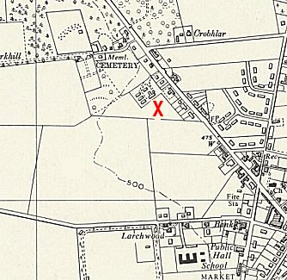
 | Ordnance Survey 1957

Ballater, Aberdeenshire. AKA Dalmochie Camp. NGR NO 3788 9598

Before the hostel - A forestry camp with volunteer workers from Newfoundland. “The camp comprised the cookhouse, a recreation hut and three bunkhouses, each sleeping 20 men. The huts were built from rough hewn logs which were then draught proofed using moss gathered from the forest. Behind them terraced into the hill was a second row of bunkhouses, a wash room, staff room and office, as well as various smaller buildings for tools and stores. Above the camp a water reservoir was built into the Dalmochie Burn with a steel pipe laid to the camp below and beneath the camp an irrigation plant was built to treat waste water. Also, beneath the camp were stables and a blacksmith's shop. By early spring 1940 all the infrastructure was in place and the Newfoundlanders started on the logging work.”

https://online.aberdeenshire.gov.uk/smrpub/master/detail.aspx?tab=main&refno=NO39NE0115

1943 - Most of the felling on Pannanich Hill was finished by winter 1942, the labour force declined as men were transferred to other forests and by 1943 the work was complete and the camp given over to Italian PoWs.

29 September 1947 - Aberdeen Press and Journal; “Wreath Laid on War Memorial. Tribute from Germans at Ballater.

Alongside wreaths from the British Legion and from Service organisations and relatives of the fallen placed on Ballater war memorial yesterday was a tribute from German prisoners of war who are working in the district. "In Memoriam, P.O.W. Hostel, Ballater," read the inscription on a printed card attached to the wreath of spruce sprigs, cones, and wild flowers. The wreath was carried to the memorial by two prisoners who saluted smartly after they had placed their tribute at the base of the monument.”

In 2005 the Ballater Historic Forestry Project was established with the aim of reconstructing the camp on its original site, where the concrete bases of the huts and stoves lie in the forest.

Culter NJ 843 009  The reference to “Culter (Allers Farm), South Lanarkshire” is a mistake. This is over 150 miles away! (There was a similar error in the report with the wrong Prestwick named). It should be; Peterculter, also known as Culter, an outer suburb of Aberdeen.  “On Coronation Road across from the water tower.”  1943 - Recorded as open. | 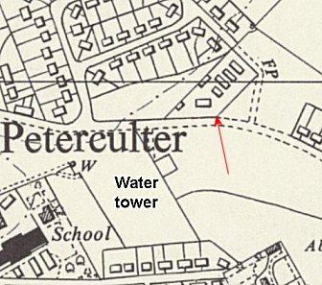
 | Ordnance Survey 1959
Insch, Aberdeenshire. NJ 6329 2822

Defence of Britain Project recorded that during the Second World War there was a POW camp next to the football field, with prisoners housed in pre-fabricated huts. Soldiers were also billeted at many houses in the village.

August 1946 - Mentioned in the camp magazine, hostel football team playing against the main camp.

