Camp 4 (& 288) - Gilling Camp, Hartforth Grange, Hartforth Lane, Gilling, Yorkshire (aka Hartforth).

Prisoner of War Camps (1939 – 1948) - Project report by Roger J.C. Thomas - English Heritage 2003
OS NGR | Sheet | No. | Name & Location | County | Cond’n | Type 1945 | Comments
NZ 1633 0693 | 92 | 4 | Gilling Camp, Hartforth Grange, Hartforth Lane Gilling | Yorkshire | 4 |  | Hut platforms remain extant. See Camp no.288

Location: (Camp 4) NZ 1633 0693 (X) / (Camp 288) NZ 1655 0651 (Y) [Note there was also a pow hostel at Gilling East, some 40m miles away – see details at end.] The Grange is about 2 miles NW of Gilling West, 4 miles N of Richmond.  Previous use: Farmland / estate grounds.  POW Camp: Italian and later German pows.  The camp location was described by Herbert Heinemann, (*see below): “A lovely peaceful spot, clean hut, showers, a shop and a massive farm building containing the dining-hall as well as the rooms of the English and the German staff (Lagerleiter). Below the farm building [there was] a large meadow with very old big trees, flowerbeds and along the small lane to our camp rhododendron [grew] on both sides, lovely when flourishing in springtime 1947, the whole [place] seemed to be like a park.”  Herbert found the camp a pleasant place as far as could be expected by a pow. He recorded that there were 200 pows. The food was satisfactory and the local people treated him well.  British staff were accommodated in The Grange.  17 June 1946 – administration of 2 hostels were transferred from this camp to Harperley Camp 93 – Langton Grange and Windlestone Hall. (Windlestone Hall had previously been listed as independent Camp 4).  13 July 1946 - Werner Deutschmann, German Navy, died of tuberculosis and lung conditions, aged 21, buried at Darlington West Cemetery, Grave W.7N.365. Death certificate stated that Werner’s address at time of death was at the pow camp Kirkbank (Middleton Tyas). The informant was C. Preston who was present at the death, whose address was given as Hartforth Grange in Gilling West. C Preston may have been a British officer at Hartforth  Details from - https://passersbyremember.wordpress.com/  This indicates that Kirkbank was a hostel for Gilling at the time. | 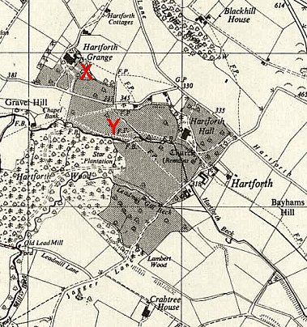
 | Hartforth Grange with two NGR’s shown. The lane between the 2 sites is called Comfort Lane.

Christmas 1946 - the pows were allowed to travel up to 6 miles from the camp. Some went to the nearby village of Gilling. Herbert and a friend were invited into a house where they were given cake and beer.

The winter that year was particularly harsh. The pows helped to clear snow from the local villages and rescued sheep, though many farm animals died that year from the cold.

The pows were employed on farms for several miles around the camp.

During 1947 - as regulations became further relaxed, pows from Gilling would travel to Richmond: “…visiting the famous Richmond Castle and a fish & chips shop at the market square to get a portion for half [a] shilling when we could afford it. [We would] Dance at night in the Town Hall. We dared visiting the overcrowded dance hall with young people. No one ignored us PoW’s, not at all, everyone was in a good temper. Young girls [were] asking us to come into the ballroom to dance with them.”

Herbert made friends with many of the farmers and their families and was actually, “very, very sad when we had to part…”

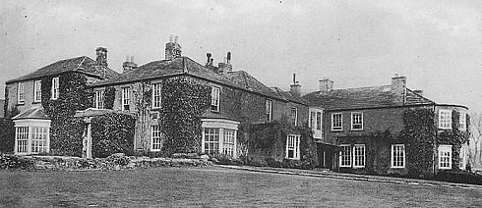 | 1947 – became a hostel to Thirkleby Camp 108.  After the camp: continued as farm land.  Further information:  *Excellent pow memories of Herbert Heinemann who arrived at the camp in September 1946 - https://www.bbc.co.uk/history/ww2peopleswar/categories/c55619/
Hartforth Grange

Note - 1 September 1947 – extract from Thrkleby Camp 108 magazine after Gilling had become one of its hostels; (my underlines) ‘During the most recent tour, most hostels held their events in the surrounding club halls or community rooms. So, the hostel 'Thormanby' in Raskelf, 'Hartforth' in Gilling, 'Stonecross' in Northallerton, 'Finghall' in Bedale, and Boltby, Rounton, [and] Great Smeaton in the community hall on the square itself. Gilling and Cowling hostels apparently weren't ready yet….

This shows that there were two ‘Gilling’ hostels – Hartforth Grange near to Gilling West; and, as it was named in a different document for camp 108, Gilling East, some 40 odd miles away.

Hostels

Kirkbank - NGR NZ 245 051.

1945 – with Gilling Camp 108.

13 July 1946 - entry above.

Langton Grange - Capacity 150. Langton Grange House (NZ 155 199) and nearby site.

Before 1946 – Hostel for Italian pows.

17 June 1946 – administration transferred to Harperley Camp 93

Windlestone Hall. (Had previously been independent Camp 4).

17 June 1946 – administration transferred to Harperley Camp 93

