Camp 116 - Mill Lane Camp, Hatfield Heath, Essex

Included in the 1945 ICRC camp list – Labour Camp. 116. Mill Lane Camp, Hatfield Heath, Bishops Stortford, Herts.

1947 Camp list
116(G.W.C.) | Mill Lane Camp, Hatfield Heath, Bishop’s Stortford, Herts | E. | Priswar, Hatfield Heath | Hatfield Heath 294 | Bishop’s Stortford | Lt.Col.E.A.Barlow | v/1453/2

Prisoner of War Camps (1939 – 1948) - Project report by Roger J.C. Thomas - English Heritage 2003
OS NGR | Sheet | No. | Name & Location | County | Cond’n | Type 1945 | Comments
TL 518 156 | 167 | 116 | Mill Lane Camp, Mill Lane, Hatfield Heath | Essex | 2 | German Working Camp | STANDARD type. Egg packing factory

There are over 20 websites about this camp – about 90% repeat the same incorrect ‘information’. One sentence in particular is repeated – “Camp 116 was set up in 1941 to house Italian prisoners of war, and from 1943-1944 it mainly held German and Austrian prisoners.”  I do not believe this is correct. The camp was listed as holding Italians up to at least 1944, when they were increasingly billeted. German and Austrian pows arrived at the camp in 1944 at the earliest. I think the following article is more accurate:  “Forty people attended the Local History Society talk by Mark Ratcliff on Hatfield Heath POW Camp 116 at the Hailey Centre earlier this year. The camp was set up in 1943 and Mark estimates that 63 per cent of the buildings, remarkably, remain; a unique mixture of wooden and concrete-frame structures…  By September 1946 it was housing 900 Italian, then German, prisoners, plus another 170 billeted on local farms and a further 900 at a linked facility at Hill Hall in Epping… It had seven officers and 40 other ranks managing the camp. Some inmates married local girls (family connections remain), and some died in the camp and were initially buried in Bishop’s Stortford, then in the Cannock Chase War cemetery.”  https://e-magazine.flyeronline.co.uk/p/sawbridgeworth-flyer/30-07-2024/a/sawbridgeworth-local-history-society-hatfield-heath-pow-camp-116/6975/1508233/53977295  Location: Just to the NW of Hatfield Heath.  Before the camp: Farmland | 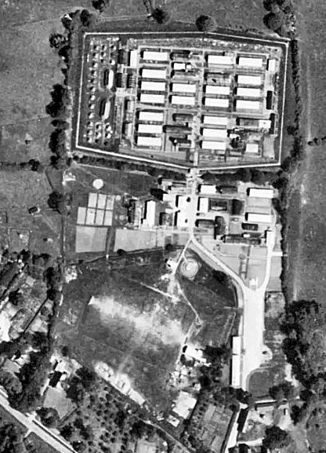 | 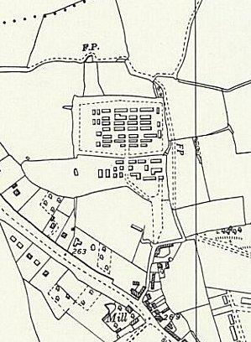
 | 1946 - raf_106g_uk_1565_rp_3189 - Aerial Photo | Historic England | Ordnance Survey 1961

Pow Camp: Italian pows, then a German Working Camp.

The site had a standard layout with a main pow compound, and with guards’ huts and offices at the front. The Pow huts were mainly timber Laing huts, while in the guards’ compound were MoWP huts. Buildings included a water tower, offices, officer's mess, a canteen, guard rooms, barrack huts, ablution blocks, cell blocks, a camp reception station (medical facility/hospital), a cookhouse, dining rooms, recreation rooms and living huts.

1942/3 – Camp constructed and opened.

1943 – hostel listed for Italians at C.S.D. Hertford

May and November 1944 - The camp was listed as an Italian Labour Battalion under the Eastern Command area, (WO 32/10737). It was recorded as holding non-co-operator Italians.

15 September 1945 – a further hostel listed for pows from this camp, (WO 32/10737): Thoby Priory, Ingatestone, Essex

1947 (Unknown exact date) Herts and Essex Observer 1947. “German P.o.W.s’ Alleged Housebreaking / Remanded, with Two Girls, at Harlow Court.

Two German prisoners and two young girls were charged at Harlow Petty Sessions on Saturday with breaking into Mr Cecil Beswick’s residence, Latton House, Harlow, between July 27 and 29 and stealing a wireless set, rifle, suit of clothes, two pairs of flannel trousers, a bottle of brandy and a quantity of lady’s clothing and cosmetics.

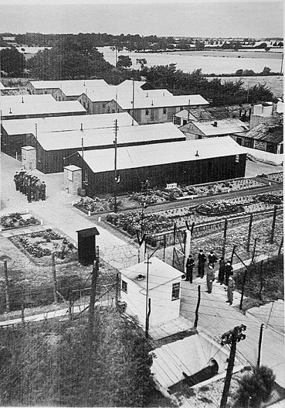  www.essexlive.news/news/i-met-husband-through-fence-1548318 | Detective-sergeant Stanley stated that on the previous day he saw the two prisoners at Hatfield Heath camp. Through an interpreter he told them they would be arrested. Neither of them made any reply when charged at Harlow police station.  In court all the defendants asked for legal aid. This was granted to the two girls, and the Adjutant of the P.o.W. Camp undertook to see if the Germans could be defended.  On this evidence the defendants were remanded in custody until a special court this (Friday) afternoon.”  October 1947 – edition of the German camp magazine, Das Echo. It records that Wilhelm Sechausen was the camp leader up to his repatriation on 2 October. Also gives details of recent football matches played against The Wynches Camp 411 and Radwinter Camp 180.  Das Echo : Lagerzeitung des P.O.W. Camp 116 Hatfield Heath - The Wiener Holocaust Library  14 November 1947 - Camp number included in an ‘Urgent Memorandum’ of (FO 939/270) regarding inspection of food parcels.  Known Camp Commandants  1947 Lieutenant Colonel E A Barlow. I think he was from the Royal Artillery.  After the camp: In 2018 there was a large campaign to list the site as a ‘community asset’ in order to stop, or at least limit, its demolition. 2019 ‘Camp Farm’.  Further Information:  https://assets.publishing.service.gov.uk/media/65d35c9b0f4eb1ec90a98192/HERITAGE_IMPACT_ASSESSMENT-3838290_Redacted.pdf  Facebook group that tried to save the site – with docs & pics https://www.facebook.com/groups/944715785691718/
Hostels

Hertford C.S.D. (Command Supply Depot)

1943 – Hostel listed for Italian pows.

Hill Hall, near Epping. TQ 489 994.  1 October 1947 - Article in Camp magazine written by a pow from this hostel.  Now run by English Heritage.  Various building appearing to be huts appear in the grounds in the aerial photo. | 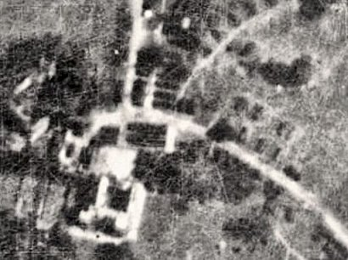 | 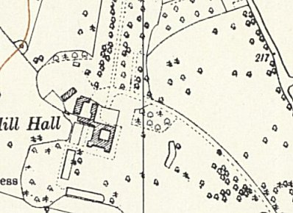
 | Aerial photo 1946 | Ordnance Survey 1960

Thoby Priory, Ingatestone, Essex, TQ 626 988

This is on the west side of Ingatestone – c3 km away, on the east side, is Ingatestone Hall, which also recorded pows.

