Camp 123 - Dalmahoy Camp, Kirknewton, Midlothian (aka Kirknewton)

Included in the 1945 ICRC camp list – Labour Camp, Dalmahoy Camp, Kirknewton, Midlothian.

1947 Camp list
123(G.W.C.) | Dalmahoy Camp, Kirknewton, Midlothian | Sc | Prislab, Edinburgh | Ratho 20 | Edinburgh, Waverley or Princes Street | Major O.Murray-Lyon M.C. | v/1452/2

Prisoner of War Camps (1939 – 1948) - Project report by Roger J.C. Thomas - English Heritage 2003
OS NGR | Sheet | No. | Name & Location | County | Cond’n | Type 1945 | Comments
 |  | 123 | Dalmahoy Camp, Kirknewton | Midlothian |  | German Working Camp | Scotland

Location: NGR NT 114 650. 2 km SE of Kirknewton.  Before the camp: Farmland / accommodation camp for service personnel at Kirknewton airfield.  Pow Camp: Listed as Italian collaborator working camp / labour battalion to at least 1945, then a German Working Camp. Up to 39 huts of varying sizes spread over three fields to the W of the airfield.  1943/1944 – Camp opened.  November 1944 - The camp was listed as an Italian Labour Battalion, (WO 32/10737).  1 August 1945 - an urgent memorandum was sent to this camp, and others, about maintaining records of Italians who were classed as ‘co-operators’. At this point many, sometimes all, of the Italian pows were in hostels / billets.  Late 1946 – transfer of new Commandant Major O Murray-Lyon from Sandyhillock Camp 67.  14 November 1947 - Camp number included in an ‘Urgent Memorandum’ (FO 939/270) regarding inspection of food parcels.  Known Camp Commandants;  c.1946/7 Major O.Murray-Lyon M.C. Royal Artillery / Pioneer Corps. Previously at Sandyhillock Camp 67.  After the camp: 2019 residential estate.  Further Information:  Ordnance Survey aerial photograph 65/50/114. RAF aerial photograph (NLA 71, 4010-4011, flown 9 September 1943). | 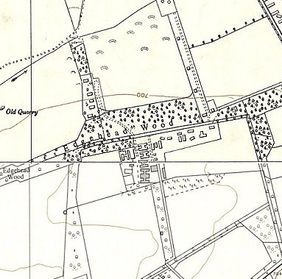
 | Ordnance Survey 1958/1962

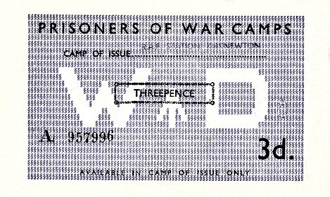 | Hostels  Mortonhall  NGR NT 258 680.  Hostel at Mortonhall in 1945 then administered by Gosford camp 16, and later by Deer Park camp 16.  Sighthill  Location – memories place it at Calder Road / Bankhead Avenue area. NGR NT 190 706  Memories - Reported to be 31 Nissen huts and 11 wooden huts for accommodation. | 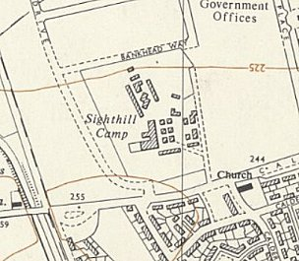
Camp ‘money’ could only be used in the camp of issue and was stamped on the back after each use. |  | Ordnance Survey 1957
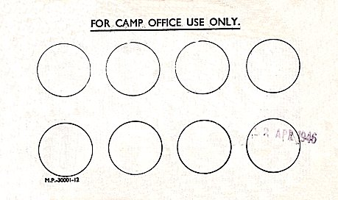 | 1945 Italian pows.  One Commandant recorded as Major Craighie, (from ‘Leben und Lernen hinter Stacheldraht’).  Collected information:  https://www.edinburghcollected.org/scrapbooks/stuart-laidlaws-history-of-the-prisoner-of-war-camp-sighthill-1940-1955/

