Camp 124 - Wapley Camp, Yate, Bristol, Gloucestershire

Prisoner of War Camps (1939 – 1948) - Project report by Roger J.C. Thomas - English Heritage 2003
OS NGR | Sheet | No. | Name & Location | County | Cond’n | Type 1945 | Comments
ST 71 79 | 172 | 124 | Wapley Camp, Yate, Bristol | Gloucestershire (Avon) | 5

Location: NGR above is a general location. Possible small site at ST 714 793?  Before the camp:  Pow Camp: Italian collaborator Pows listed from at least 1944, later a German Working Camp.  “An Italian pow camp was set up in tents in Cadbury Heath. They were put to work on farms in the area and were distinguished by their chocolate coloured uniforms with coloured patches. They were considered harmless; in the evenings, they were allowed out of the camp into the local area, and on Sunday mornings, were able to go to church.  As the weather grew colder the pows were transported to the Wapley Camp near Yate.”  https://beta.southglos.gov.uk/static/682128a092b47e80fc2203b38e3421ff/SGC-WW2_Stories_Exhibition-Panels.pdf  November 1944 - The camp was listed as an Italian Labour Battalion, (WO 32/10737).  September 1945 - Appendix to HQ Southern Command War Diary:  Wapley Camp, Yate – Italian labour battalion – capacity 450 – 103/155034  Italian hostels – Southmead Bristol, Earthcott – total cap 450  German hostels – Yate, Falfield – total cap 350 | 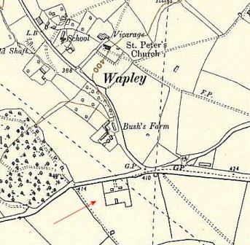
 | Ordnance Survey 1955
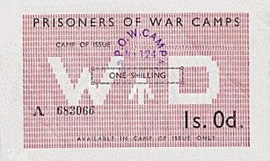 | Late 1945 - The camp number taken by Bedminster Camp – so likely that either this site closed, or became a hostel. Sunnyside hostel also taken over Bedminster.  After the camp:  Further Information:  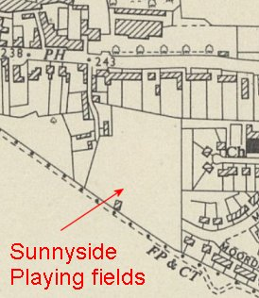  Hostels  106, Sunnyside Lane, Yate (Later just called Sunnyside when administered by Bedminster Camp).  Probably located at the back of 106 Sunnyside Lane, in a recreation ground. However, there is a description of it being; “directly on the edge of the river” – there was another sports ground just along the road at ST 712 828 which is next to the River Frome.  3 September 1945 – a new Italian hostel recorded at this site, capacity 80. (Progress Report 153 – FO 939/383).  ST 704 824 - Ordnance Survey 1955 >>>  1946 – administered by Bedminster camp 124.
Camp ‘money’ – used in the canteen and stamped. Only to be used in the issuing camp.

Earthcott (Probably Earthcott Green)

September 1945 – Italian hostel

Falfield

September 1945 – German hostel

Southmead, Bristol

September 1945 – Italian hostel

Yate

September 1945 – German hostel

